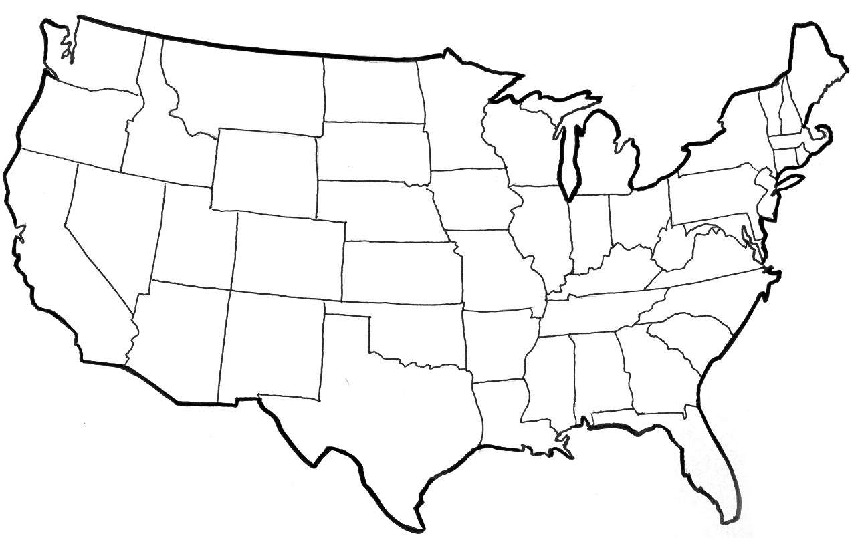

First and Last Name Period Teacher’s Name