Name __________________________________________ Period ________
Teacher ________________________________________ Date _____________
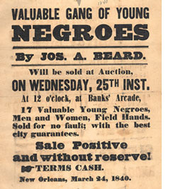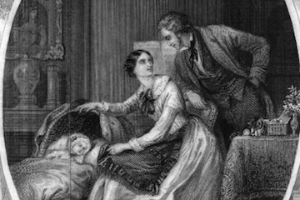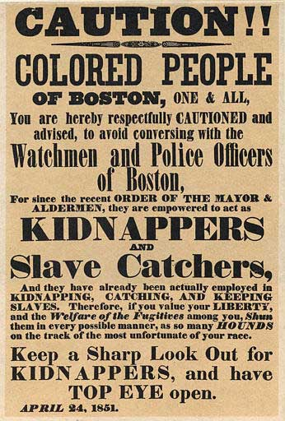
Prompt: The mid-1800s was a time of many reforms. Women were finding their voice for the first time. Also, at this time, abolitionists were speaking out about the evils of slavery and demanding its demise. Given the lengthy list of people involved in these movements, there are a lot of people you could speak about. Write about the person you chose and what made them the most important person in their movement. Be detailed in your reasons why you selected this person and explain thoroughly what this person did to earn your lavish praise. This essay may be no less than one page in length. Use this page to plan your writing and the back to write the essay. Use notebook paper for additional pages.

