8th Pre-AP U.S. History
Second Semester – Course Reader

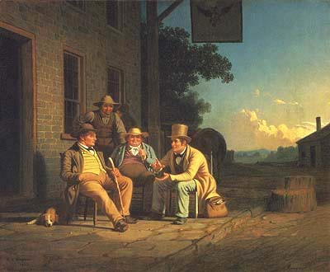

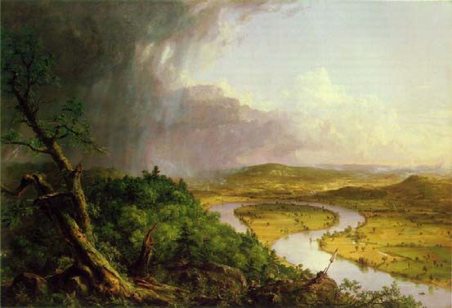

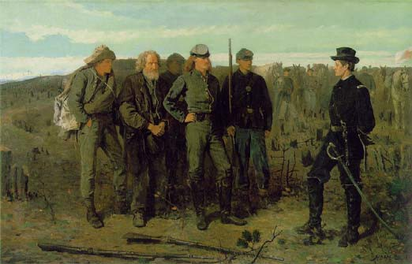

AP U.S. History Course Reader
Table of Contents

Reading | Page #’s | Due Date
Second Semester Reading Schedule | 1
Andrew Jackson – “A Political Testament” | 2 - 21
Opposing Viewpoint 26 A/B “Immigrants Endanger America” “Immigrants Do Not Endanger America” | 22 - 28  21 – 27
“Transcendentalism”  Ralph Waldo Emerson – Excerpts Henry David Thoreau – Excerpts | 29 - 60
Abraham Lincoln -  - First Inaugural Address  - Speech at Gettysburg  - Second Inaugural Address | 61 - 68
Opposing Viewpoints 32 A / B  - Roger Taney – Constitutional Rights Do Not Extend to Blacks  - Benjamin R. Curtis – Constitutional Rights Do Extend to Blacks | 69 - 80
Opposing Viewpoints 34 A / B  - South Carolina Declaration – Secession Is Justified  - Abraham Lincoln – Secession Is Not Justified | 81 - 88
Jefferson Davis – Excerpts  - Farewell Address to the U.S. Senate  - Inaugural Address as the President of the C.S.A. | 89-100

ANDREW JACKSON

A POLITICAL TESTAMENT 1

EING ABOUT to retire finally from public life, I beg leave to offer you my grateful thanks for the many proofs of kindness
B
has
It
and confidence which I have received at your hands.
been my fortune, in the discharge of public duties, civil and military, frequently to have found myself in difficult and trying situations where prompt decision and energetic action were necessary and where the interest of the country required that high responsibilities should be fearlessly encountered; and it is with the deepest emotions of gratitude that I acknowledge the continued and unbroken confidence with which you have sustained me in every trial. My public life has
)>
-u been a long one, and I cannot hope that it has, at all times, been free
c
Vl from errors. But I have the consolation of knowing that, if mistakes
I
have been committed, they have not seriously injured the country I
0
so anxiously endeavored to serve; and, at the moment when I sur­
Vl render my last public trust, I leave this great people prosperous and
I
happy; in the full enjoyment of liberty and peace; and honored and
respected by every nation of the world.
If my humble efforts have, in any degree, contributed to preserve to you these blessings, I have been more than rewarded by the honors you have heaped upon me; and, above all, by the generous confidence with which you have supported me in every peril, and with which you have continued to animate and cheer my path to the closing hour of my political life. The time has now come when advanced age and a broken frame warn me to retire from public concerns; but the recol­ lection of the many favors you have bestowed upon me is engraven upon my heart, and I have felt that I could not part from your service without making this public acknowledgment of the gratitude I owe you. And if I use the occasion to offer to you the counsels of age and experience, you will, I trust, receive them with the same indulgent
/

1 [From Farewell Address of Andrew Jackson to the People of the United States: and the Inaugural Address of Martin Van Buren, President of the United States (Washington, 1837), pp. 3-16- Text complete.]

2 SOCIAL THEORIES OF JACKSONIAN DEMOCRACY

kindness which you have so often extended to me; and will, at least, see in them an earnest desire to perpetuate, in this fav.ored land, the blessings of liberty and equal laws.

[THE STATE OF THE NATION)
We have now lived almost fifty years under the Constitution framed by the sages and patriots of the Revolution. The conflicts in which the nations of Europe were engaged during a great part of this period; the spirit in which they waged war against each other; and our inti­ mate commercial connections with every part of the civilized world, rendered it a time of much difficulty for the Government of the United States. We have had our seasons of peace and of war, with all the evils w;hich precede or follow a state of hostility with powerful nations. We encountered these trials with our Constitution yet in its infancy, and under the disadvantages which a new and untried Gov­ ernment must always feel when it is called upon to put forth its whole
)> strength, without the lights of experience to guide it or the weight of
-u
c
Vl precedents to justify its measures. But we have passed triumphantly
I
through all these difficulties. Our Constitution is no longer a doubtful experiment; and, at the end of nearly half a century, we find that it
Vl has preserved unimpaired the liberties of the people, secured the rights of property, and that our country has improved and is flourish­ ing beyond any former example in the history of nations.
I
In our domestic concerns there is everything to encourage us; and if you are true to yourselves, nothing can impede your march to the highest point of national prosperity. The States which had so long been retarded in their improvement by the Indian tribes residing in the midst of them are at length relieved from the evil; and this ,unhappy race -the original dwellers in our land- are now placed in a situa­ tion where we may well hope that they will share in the blessings of civilization and be saved from that degradation and destruction to which they were rapidly hastening while they remained in the States; and while the safety and comfort of our own citizens have been greatly promoted by their removal, the philanthropist will rejoice that the remnant of that ill-fated race has been at length placed beyond the reach of injury or oppression, and that the paternal care of the Gen­ eral Government will hereafter watch over them and protect them.
If we turn to our relations with foreign powers, we find our con-
ANDREW JACKSON 3
dition equally gratifying. Actuated by the sincere desire to do justice to every nation and to preserve the blessings of peace, our inter­ course with them has been conducted on the part of this Government in the spirit of frankness, and I take pleasure in saying that it has generally been met in a corresponding temper. Difficulties of old standing have been surmounted by friendly discussion and the mutual desire to be just; and the claims of our citizens, which had been long withheld, have at length been acknowledged and adjusted, and satis­ factory arrangements made for their final payment; 2 and with a limited and, I trust, a temporary exception, our relations with every foreign power are now of the most friendly character, our commerce continually expanding, and our flag respected in every quarter of the world.

[THE NEED FOR UNITY IN THE UNION)
These cheering and grateful prospects and these multiplied favors we owe, under Providence, to the adoption of the Federal Constitu­ tion. It is no longer a question .whether this great country can remain happily united and flourish under our present form of govern­ ment. Experience, the unerring test of all human undertakings, has shown the wisdom and foresight of those who formed it; and has proved that in the union of these States there is a sure foundation for the brightest hopes of freedom and for the happiness of the people. At every hazard and by every sacrifice, this Union must be preserved.
The necessity of watching with jealous anxiety for the preservation
of the Union was earnestly pressed upon his fellow citizens by the Father of his country in his farewell address. He has there told us that "while experience shall not have demonstrated its impractica bility, there will always be reason to distrust the patriotism of those who, in any quarter, may endeavor to weaken its bonds"; and he has cautioned us, in the strongest terms, against the formation of parties on geographical discriminations, as one of the means which might disturb our union, and to which designing men would be likely to resort.
The lessons contained in this invaluable legacy of Washington to
his countrymen should be cherished in the heart of every citizen to the latest generation; and, perhaps, at no period of time could they
2 [This refers to the Spoliation Claims against France

be more usefully remembered than at the present moment. For when we look upon the scenes that are passing around us, and dwell upon the pages of his parting address, his paternal counsels would seem to be not merely the offspring of wisdom and foresight, but the voice of prophecy foretelling events and warning us of the evil to come. Forty years have passed since this imperishable document was given to his countrymen. The Federal Constitution was then regarded by him as an experiment, and he so speaks of it in his address; but an experiment upon the success of which the best hopes of his country depended, and we all know that he was prepared to lay down his life, if necessary, to secure to it a full and a fair trial. The trial has been made. It has succeeded beyond the proudest hopes of those who framed it. Every quarter of this widely extended nation has felt its blessings and shared in the general prosperity produced by its adop­ tion. But amid this general prosperity and splendid success, the dangers of which he warned us are becoming every day more evident
)>
-u and the signs of evil are sufficiently apparent to awaken the deepest
c
Vl anxiety. in the bosom of the patriot. We behold systematic efforts publicly made to sow the seeds of discord between different parts of the United States and to place party divisions directly upon geo­
I
Vl graphical distinctions; to excite the south against the north and the
I
north against the south; and to force into the controversy the most
delicate and exciting topics, topics upon which it is impossible that a large portion of the Union can ever speak without strong emotion. Appeals, too, are constantly made to sectional interests in order to influence the election of the Chief Magistrate, as if it were desired that he should favor a particular quarter of the country instead of fulfilling the duties of his station with impartial justice to all; and the possible dissolution of the Union has at length become an ordinary and familiar subject of discussion. Has the warning voice of Wash­ ington been forgotten? or have designs already been formed to sever the Union? Let it not be supposed that I impute to all of those who have taken an active part in these unwise and unprofitable discus­ sions a want of patriotism or of public virtue. The honorable feeling of State pride and local attachments find a place in the bosoms of the most enlightened and pure. But while such men are conscious of their own integrity and honesty of purpose, they ought never to forget that the citizens of other States are their political brethren;
ANDREW JACKSON 5
and that, however mistaken they may be in their views, the great body of them are equally honest and upright with themselves. Mutual suspicions and reproaches may in time create mutual hostility, and artful and designing men will always be found, who are ready to foment these fatal divisions and to inflame the natural jealousies of different sections of the country. The history of the world is full of such examples and especially the history of republics.
What have you to gain by division and dissension? Delude not yourselves with the belief that a breach once made may be after­ wards repaired. If the Union is once severed, the line of separation will grow wider and wider, and the controversies which are now debated and settled in the halls of legislation will then be tried in fields of battle and determined by the sword. Neither should you deceive yourselves with the hope that the first line of separation would be the permanent one, and that nothing but harmony and concord would be found in the new associations formed upon the dissolution. of this Union. Local interests would still be found there, and unchas­ tened ambition. And if the recollection of common dangers in which the people of these United States stood side by side against the com­ mon foe; the memory of victories won by their united valor; the prosperity and happiness they have enjoyed under the present Con­ stitution; the proud name they bear as citizens of this great republic; if all these recollectiOns and proofs of common interest are not strong enough to bind us together as one people, what tie will hold united the new divisions of empire, when these bonds have been broken and this Union dissevered? The first line of separation would not last for a single generation; new fragments would be torn off; new leaders would spring up; and this great and glorious republic would soon be
,broken into a multitude of petty states, without commerce, without
credit; jealous of one another; armed for mutual aggression; loaded with taxes to pay armies and leaders; seeking aid against each other from foreign powers; insulted and trampled upon by the nations of Europe, until, harassed with conflicts and humbled and debased in spirit, they would be ready to submit to the absolute dominion of any military adventurer and to surrender their liberty for the sake of repose. It is impossible to look on the consequences that would inevitably follow the destruction of this Government and not feel indignant when we hear cold calculations about the value of the

6 SOCIAL THEORIES OF JACKSONIAN DEMOCRACY
Union and have so constantly before us a line of conduct so well cal­ culated to weaken its ties.
There is too much at stake to allow pride or passion to influence your decision. Never for a moment believe that the great body of the citizens of any State or States can deliberately intend to do wrong. They may, under the influence of temporary excitement or misguided opinions, commit mistakes; they may be misled for a time by the suggestions of self-interest;. but in a community so enlightened and patriotic as the people of the United States, argument will soon make them sensible of their errors; and, when convinced, they will be ready to repair them. If they have no higher or better motives to govern them, they will at least perceive that their own interest requires them to be just to others as they hope to receive justice at their hands.

[NULLIFICATION AND STATES' RIGHTS]
But in order to maintain the Union unimpaired, it is absolutely
)>
necessary that the laws passed by the constituted authorities should be faithfully executed in every part of the country, and that every good citizen should, at all times, stand ready to put down, with the
c
I
combined force of the nation, every attempt at unlawful resistance,
Vl under whatever pretext it may be made or ·whatever shape it may
I
assume. Unconstitutional or oppressive laws may no doubt be passed
by Congress, either from erroneous views or the want of due considera­ tion; if they are within the reach of judicial authority, the remedy is ·easy and peaceful; and if, from the character of the law, it is an abuse of power not within the control of the judiciary, then free dis­ cussion and calm appeals to reason and to the justice of the people will not fail to redress the wrong. But until the law shall be,declared void by the courts or repealed by Congress, no individual or combi­ nation of individuals can be justified in forcibly resisting its execu­ tion. It is impossible that any Government can continue to exist upon any other principles. It would cease to be a Government and be unworthy of the name if it had not the power to enforce the exe­ cution of its own laws within its own sphere of action.
It is true that cases may be imagined disclosing such a settled pur­ pose of usurpation and oppression on the part of the Government as would justify an appeal to arms. These, however, are extreme cases, which we have no reason to apprehend in a Government where the
ANDREW JACKSON 7
power is in the hands of a patriotic people; and no citizen who loves his country would in any case whatever resort to forcible resistance, unless he clearly saw that the time had come when a freeman should prefer death to submission; for if such a struggle is once begun and the citizens of one section of the country arrayed in arms against those of another in doubtful conflict, let the battle result as it may_, there will be an end of the Union and, with it, an end to the hopes of freedom. The victory of the injured would not secure to them the blessings of liberty; it would avenge their wrongs, but they would themselves share in the common ruin.
But the Constitution cannot be maintained nor the Union preserved
in opposition to, public feeling by the mere exertion of the coercive powers confided 'to the General Government. The foundations must be laid in the affections of the people; in the security it gives to life, liberty, character, and property, in every quarter of the country; and in the fraternal attachment which the citizens of the several States bear to one another as members of one political family, mutu­ ally contributing to promote the happiness of each other. Hence the citizens of every State should studiously avoid everything calculated to wound the sensibility or offend the just pride of the people of other States; and they should frown upon any proceedings within their own borders likely to disturb the tranquillity of their political brethren in other portions of the Union. In a country so extensive as the United States and with pursuits so varied, the internal regulations of the several States must frequently differ from one another in important particulars; and this difference is unavoidably increased by the vary­ ing principles upon which the American colonies were originally planted; principles which had taken deep root in their social relations before the Revolution, and, therefore, of necessity influencing their policy since they became free and independent States. But each State has the unquestionable right to regulate its own internal con­ cerns according to its own pleasure; and while it does not interfere with the rights of the people of other States or the rights of the Union, every State must be the sole judge of the measures proper to secure the safety of its citizens and promote their happiness; and all efforts on the part of people of other States to cast odium upon their institu­ tions, and all measures calculated to disturb their rights of property or to put in jeopardy their peace and internal tranquillity are in direct

)>
-u
c
Vl
I

-1>.

Vl
I
8 SOCIAL THEORIES OF JACKSONIAN DEMOCRACY
opposition to the spirit in which the Union was formed, and must endanger its safety. Motives of philanthropy may be assigned for this unwarrantable interference; and weak men may persuade them­ selves for a moment that they are laboring in the cause of humanity and asserting the rights of the human race; but everyone, upon sober reflection, will see that nothing but mischief can come from these improper assaults upon the feelings and rights of others. Rest assured that the men found busy in this work of discord are not worthy of your confidence and deserve your strongest reprobation.
In the legislation of Congress, also, and in every measure of the General Government, justice to-.every portion of the United States should be faithfully observed. No free Government can stand without virtue in the people, and a lofty spirit of patriotism; and if the sordid feelings of mere selfishness shall usurp the place which ought to be filled by public spirit, the legislation of Congress will soon be con­ verted into a scramble for personal and sectional advantages. Under our free institutions, the citizens of every quarter of our country are capable of attaining a high degree of prosperity and happiness without seeking to profit themselves at the expense of others; and every such attempt must in the end fail to succeed, for the people in every part of the United States are too enlightened not to understand their own rights and interests and to detect and defeat every effort to gain undue advantages over them; and when such designs are discovered, it naturally provokes resentments which cannot always be easily allayed. Justice, full and ample justice, to every portion of the United States should be the ruling principle of every freeman and should guide the deliberations of every public body, whether it be State or national.

[LIMITS OF FEDERAL POWER]

It is well known that there have always been those amongst us who wish to enlarge the powers of the General Government; and experi­ ence would seem to indicate that there is a tendency on the part of this Government to overstep the boundaries marked out for it by the Constitution. Its legitimate authority is abundantly sufficient for all the purposes for which it was created; and its powers being expressly enumerated, there can be no justification for claiming anything beyond them. Every attempt to exercise power beyond these limits should
ANDREW JACKSON 9
be promptly and firmly opposed. For one evil example will lead to other measures still more mischievous; and if the principle of construc­ tive powers, or supposed advantages, or temporary circumstances, shall ever be permitted to justify the assumption of a power not given by the Constitution, the General Government will before long absorb all the powers of legislation, and you will have, in effect, but one consolidated Government. From the extent of our country, its diversi­ fied interests, different pursuits, and different habits, it is too obvious for argument that a single consolidated Government would be wholly inadequate to watch over and protect its interests; and every friend of our free institutions should be always prepared to maintain unim­ paired and in full vigor the rights and sovereignty of the States and to confine the action of the General Government strictly to the sphere of its appropriate duties.
There is, perhaps, no one of the powers conferred on the Federal
Government so liable to abuse as the taxing power. The most pro­ ductive and convenient sources of revenue were necessarily given to it, that it might be able to perform the important duties imposed upon it; and the taxes which it lays upon commerce being concealed from the real payer in the price of the article, they do not so readily attract the attention of the people as smaller sums demanded from them directly by the tax gatherer. But the tax imposed on goods enhances by so much the price of the commodity to the consumer; and, as many of these duties are imposed on articles of necessity which are daily used by the great body of the people, the money raised by th.ese imposts is drawn from their pockets. Congress has no right, under the Constitution, to take money froll! the people unless it is required to execute some one of the specific powers intrusted to the Government; and if they raise more than is necessary for such purposes, it is an abuse of the power of taxation and unjust and oppressive. It may, indeed, happen that the revenue will sometimes exceed the amount anticipated when the taxes were laid. When, however, this is ascertained, it is easy to reduce them; and, in such a case, it is unquestionably the duty of the Government to reduce them, for no circumstances can justify it in assuming a power not given to it by the Constitution nor in taking away the money of the people when it is not needed for the legitimate wants of the Government.

10 SOCIAL THEORIES OF JACKSONIAN DEMOCRACY

Plain as these principles appear to be, you will yet find that there is a constant effort to induce the General Government to go beyond the limits of its taxing power and to impose unnecessary burdens upon the people. Many powerful interests are continually at work to procure heavy duties on commerce and to swell the revenue beyond the real necessities of the public service; and the country has already felt the injurious effects of their combined influence. They succeeded in obtaining a tariff of duties bearing most oppressively on the agri­ cultural and laboring classes of society and producing a revenue that could not be usefully employed within the range of the powers con­ ferred upon Congress; and, in order to fasten upon the people this unjust and unequal system of taxation, extravagant schemes of internal improvement were got up in various quarters to squander the money and to purchase support. Thus, one unconstitutional measure was intended to be upheld by another, and the abuse of the power of taxation was to be maintained by usurping the power of
)> expending the money in internal improvements. You cannot have
-u
c forgotten the severe and doubtful struggle through which we passed
Vl
I
when the Executive Department of the Government, by its veto, endeavored to arrest this prodigal scheme of injustice, and to bring back the legislation of Congress to the boundaries prescribed by the
U1
Vl
I Constitution.• The good sense and practical judgment of the people, when the subject was brought before them, sustained the course of
the Executive; and this plan of unconstitutional expenditure for the
purpose of corrupt influence is, I trust, finally overthrown.
The result of this decision has been felt in the rapid extinguishment of the public debt and the large accumulation of a surplus in the treas­ ury, notwithstanding the tariff was reduced and is now very far below the amount originally contemplated by its advocates. But, rely upon it, the d sign to collect an extravagant revenue and to burden you with taxes beyond the economical wants of ,the Govern­ ment is not yet abandoned. The various interests which have com­ bined together to impose a heavy tariff and to produce an overflowing treasury are too strong and have too much at stake to surrender the contest. The corporations and wealthy individuals who are engaged

a [The reference here is to Jackson's 1830 veto of a bill which authorized the government to purchase stock in a private company to build a road from l\Iaysville
-to Lexington, Kentucky- the Maysville Road Veto.]
ANDREW JACKSON II

in large manufacturing establishments desire a high tariff to increase their gains. Designing politicians will support it to conciliate their favor and to obtain the means of profuse expenditure for the purpose of purchasing influence in other quarters; and since the people have decided that the Federal Government cannot be permitted to employ its income in internal improvements, efforts will be made to seduce and mislead the citizens of the sevetal States by holding out to them the deceitful prospect of benefits to be detived from a surplus revenue collected by the General Government and anriually divided among the States. And if, encouraged by these fallacious hopes, the States should disregard the principles of economy which ought to charac­ terize every republican Government and should indulge in lavish expenditures exceeding their resources, they will, before long, find themselves oppressed with debts which they are unable to pay, and the temptation will become irresistible to support a high tariff in order to obtain a surplus for distribution. Do not allow yourselves, my fellow citizens, to be misled on this subject. The Federal Government cannot collect a surplus for such purposes witho.ut violating the prin­ ciples of the Constitution and assuming powers which have not been granted. It is, moreover, a system of injustice, and, if persisted in, will inevitably lead to corruption and must end in ruin. The surplus revenue will be drawn from the pockets of the people, from the farmer, the mechanic, and the laboring classes of society; but who will receive it when distributed among the States, where it is to be disposed of by leading State politicians who have frie1.1ds to favor· and political partisans to gratify? .It will certainly not be returned to those who paid it and who have most need of it and are honestly entitled to it. There is but one safe rule, and that is to confine the Generaf Govern­ ment rigidly within the sphere of its appropriate duties. It has no power to raise a revenue or impose taxes except for the purposes enu­ merated in the Constitution; and if its income is found to exceed these wants, it sho1,1ld be forthwith reduced, and the burdens of the
people so far lightened.

[CURRENCY AND BANKING PoLicY I
In reviewing the conflicts which have taken place between different interests in the United States and the policy pursued since the adop­ tion of our present form of government, we find nothing that has

12 SOCIAL THEORIES OF JACKSONIAN DEMOCRACY
produced such deep-seated evil as the course of legislation in relation to the currency. The Constitution of the United States unquestionably intended to secure to the people a circulating medium of gold and silver. But the establishment of a national bank by Congress with 'the privilege of issuing paper money receivable in the payment of the public dues, and the unfortunate course of legislation in the several States upon the same subject, drove from general circulation the con­ stitutional currency and substituted one of paper in its place.
It was not easy for men engaged in the ordinary pursuits of busi­
ness, whose attention had not been particularly drawn to the subject, to foresee all the consequences of a currency exclusively of paper; and we ought not, on that account, to be surprised at the facility with which laws were obtained to carry into effect the paper system. Honest and even enlightened men are sometimes misled by the spe­ cious and plausible statements of the designing. But experience has now proved the mischiefs and dangers of a paper currency, and it
)> rests with you to determine whether the proper remedy shall be
-u
c
Vl applied.
I
The paper system being founded on public confidence and having
a-
of itself no intrinsic value, it is liable to great and sudden fluctuations;
Vl thereby rendering property insecure and the wages of labor unsteady I and uncertain. The corporations which create the paper money can­ not be relied upon to keep the circulating medium uniform in amount.
In times of prosperity, when confidence is high, they are tempted by the prospect of gain, or by the influence of those who hope to profit by it, to extend their issues of paper beyond the bounds of discretion and the reasonable demands of business. And when these issues have been pushed on from day to day until public confidence is a,t length shaken, then a reaction takes place, and they immediately withdraw the credits they have given; suddenly curtail their issues; and produce an unexpected and ruinous contraction of the circulating medium which is felt by the whole community. The banks by this means save themselves, and the mischievous consequences of their imprudence or cupidity are visited upon the public. Nor does the evil stop here. These ebbs and flows in the currency and these indiscreet extensions of credit naturally engender a spirit of speculation injurious to the habits and character of the people. We have already seen its effects in the wild spirit of speculation in the public lands and various kinds
ANDREW JACKSON 13
of stock which, within the last year or two, seized upon such a multi­ tude of our citizens and threatened to pervade all classes of society and to withdraw their attention from the sober pursuits of honest industry. It is not by encouraging this spirit that we shall best pre­ serve public virtue and promote the true interests of our country. But if your currency continues as exclusively paper as it now is, it will foster this eager desire to amass wealth without labor; it will multiply the number of dependents on bank accommodations and bank favors; the temptation to obtain money at any sacrifice will become stronger and stronger, and inevitably lead to corruption which will find its way into your public councils and destroy, at no distant day, the purity of your Government. Some of the evils which arise from this system of paper press with peculiar hardship upon the class of society least able to bear it. A portion of this currency frequently becomes depreciated or worthless, and all of it is easily counterfeited in such a manner as to require peculiar skill and much experience to dis­ tinguish the counterfeit from the genuine note. These frauds are most generally perpetrated in the smaller notes, which are used in the daily transactions of ordinary business; and the losses occasioned by them are commonly thrown upon the laboring classes of society whose situation and pursuits put it out of their power to guard themselves from these impositions and whose daily wages are necessary for their subsistence. It is the duty of every Government so to regulate its currency as to protect this numerous ,class as far as practicable from the impositions of avarice and fraud. It is more especially the duty of the United States where the Government is emphatically the Government of the people, and where this respectable portion of our citizens are so proudly distinguished from the laboring classes of all other nations by their independent spirit, their love of liberty, their intelligence, and their high tone of moral character. Their industry in peace is the source of our wealth; and their bravery in war has covered us with glory; and the Government of the United States will but ill discharge its duties if it leaves them a prey to such dishonest impositions. Yet it is evident that their interests cannot be effectu­ ally protected unless silver and gold are restored to circulation.
These views alone of the paper currency are sufficient to call for immediate reform; but there is another consideration which should still more strongly press it upon your attention.

)>
-u
c
Vl
I

'-I

Vl
I
14 SOCIAL THEORIES OF JACKSONIAN DEMOCRACY

Recent events have proved that the paper money system of this country may be used as an engine to undermine your free institutions; and that those who desire to engross all power in the hands of the few and to govern by corruption or force are aware of its power and prepared to employ it. Your banks now furnish your only circulating medium, and money is plenty or scarce according to the quantity of notes issued by them. While they have capitals not greatly dispro­ portioned to each other, they are competitors in business, and no one of them can exercise dominion over the rest; and although, in the present state of the currency, these banks may and do operate injuri­ ously upon the habits of business, the pecuniary concerns, and the moral tone of society; yet, from their number and dispersed situation, they cannot combine for the purpose of political influence; and what­ ever may be the dispositions of some of them, their power of mischief must necessarily be confined to a narrow space and felt only in their immediate neighborhoods.
But when the charter for the Bank of the United States was obtained from Congress, it perfected the schemes of the paper system and gave to its advocates the position they have struggled to obtain from the commencement of the Federal Government down to the present hour. The immense capital and peculiar privileges bestowed upon it enabled it to exercise despotic sway over the other banks in every part of the country. From its superior strength it could seriously injure, if not destroy, the business of any one of them which might incur its resentment; and it openly claimed for itself the power of regulating the currency throughout the United States. In other words, it asserted (and it undoubtedly possessed) the power to make money plenty or scarce, at its pleasure, at any time, and, in any quarter of the Union, by controlling the issues of other banks and per­ mitting an expansion or compelling a general contraction of the circu­ lating medium according to its own will. The other banking institu­ tions were sen,sible of its strength, and they soon generally became its obedient instruments, ready, at all times, to execute its mandates; and with the banks necessarily went, also, that numerous class of persons in our commercial cities who depend altogether on bank credits for their solvency and means of business; and who are, there­ fore, obliged for their own safety to propitiate the favor of the money power by distinguished zeal and devotion in its service. The result
A:-<DREW JACKSO!\'" I5
of the ill-advised legislation which established this great monopoly was to concentrate the whole moneyed power of the Union, with its boundless means of corruption and its numerous dependents, under the direction and command of one acknowledged head; thus organ­ izing this particular interest as one body and securing to it unity and concert of action throughout the United States and enabling it to bring forward, upon any occasion, its entire and undivided strength to support or defeat any measure of the Government. In the hands of this formidable power, thus perfectly organized, was also placed unlimited dominion over the amount of the circulating medium, giving it the power to regulate the value of property and the fruits of labor in every quarter of the Union and to bestow prosperity or bring ruin upon any city or section of the country as might best comport with its own interest or policy.
We are not left to conjecture how the moneyed power, thus organ­
ized and with such a weapon in its hands, would be likely to use it. The distress and alarm which pervaded and agitated the whole coun­ try when the Bank of the United States waged war upon the people in order to compel them to submit to its demands cannot yet be for­ gotten. The ruthless and unsparing temper with which whole cities and communities were oppressed, individuals impoverished and ruined, and a scene of cheerful prosperity suddenly changed into one of gloom and despondency ought to be indelibly impressed on the mem­ ory of the people of the United States. If such was its power in a time of peace, what would it not have been in a season of war with an enemy at your doors? No nation but the freemen of the United States could have come out victorious from such a contest; yet, if you had not conquered, the Government would have passed from the hands of the many to the hands of the few; and this organized money power, from its secret conclave, would have dictated the choice of your highest officers and compelled you to make peace or war as best suited their own wishes. The forms of your government might, for a time, have remained; but its living spirit would have departed from it.
The distress and sufferings inflicted on the people by the bank are some of the fruits of that system of policy which is continually
striving to enlarge the authority of the Federal Government beyond the limits fixed by the Constitution. The powers enumerated in that instrument do not confer on Congress the right to establish such a

16 SOCIAL THEORIES OF JACKSONIAN DEMOCRACY

corporation as the Bank of the United States; and the evil conse­ quences which followed may warn us of the danger of departing from the true rule of construction and of permitting temporary circum­ stances or the hope of better promoting the public welfare to influ­ ence, in any degree, our decisions upon the extent of the authority of the General Government. Let us abide by the Constitution as it is written or amend it in the constitutional mode if it is found to be defective.
The severe lessons of experience will, I doubt not, be sufficient to
prevent Congress from again chartering such a monopoly, even if the Constitution did not present an insuperable objection to it. But you must remember, my fellow citizens, that eternal vigilance by the people is the price of liberty; and that you must pay the price if you wish to secure the blessing. It behooves you, therefore, to be watchful in your States as well as in the Federal Government. The power which the moneyed interest can exercise, when concentrated under a
)> single head, and with our present system of currency, was sufficiently
-u
c
Vl demonstrated in the struggle made by the Bank of the United States.
I
Defeated in the General Government, the same class of intriguers and
00 politicians will now resort to the States and endeavor to obtain there the same organization which they failed to perpetuate in the Union;
Vl
I and with specious and deceitful plans of public advantages and State interests and State pride they will endeavor to establish, in the dif­ ferent States, one moneyed institution with overgrown capital and exclusive privileges sufficient to enable it to control the operations of the other banks. Such an institution will be pregnant with the same evils produced by the Bank of the United States, although its sphere of action is more confined; and in the State in which it is ,chartered the money power will be able to embody its whole strength and to move together with undivided force to accomplish any object it may wish to attain. You have already had abundant evidence of its power to inflict injury upon the agricultural, mechanical, and laboring classes of society; and over those whose engagements in trade or speculation render them dependent on bank facilities, the dominion of the State monopoly will be al;>solute, and their obedience unlimited. With such a bank and a paper currency, the money power would, in a few years, govern the State and control its measures; and if a sufficient number of States can be induced to create such establishments, the
ANDREW JACKSON 17
time will soon come when it will again take the field against the United States and succeed in perfecting and perpetuating its organization by a charter from Congress.
It is one of the serious evils of our present system of banking that
it enables one class of society, and that by no means a numerous one, by its control over the currency to act injuriously upon the interests of all the others and to exercise more than its just proportion of influ­ ence in political affairs. The agricultural, the mechanical, and the laboring classes have little or no share in the direction of the great moneyed corporations; and from their habits and the nature of their pursuits, they are incapable of forming extensive combinations to act together with united force. Such concert of action may sometimes be produced in a single city or in a small district of country by means of personal communications with each other; but they have no regular or active correspondence with those who are engaged in similar pur­ suits in distant places; they have but little patronage to give to the press and exercise but a small share of influence over it; they have no crowd of dependents above them who hope to grow rich without labor by their countenance and favor and who are, therefore, always ready to exercise their wishes. The planter, the farmer, the mechanic, and the laborer all know that their success depends upon their own industry and economy and that they must not expect to become sud­ denly rich by the fruits of their toil. Yet these classes of society form the great body of the people of the United States; they are the bone and sinew of the country; men who love liberty and desire nothing but equal rights and equal laws and who, moreover, hold the great mass of our national wealth, although it is distributed in moderate amounts among the millions of freemen who possess it. But, with overwhelming numbers and wealth on their side, they are in constant danger of losing their fair influence in the Government and with dif­ ficulty maintain their just rights against the incessant efforts daily made to encroach upon them. The mischief springs from the power which the moneyed interest derives from a paper currency which they are able to control; from the multitude of corporations with exclusive privileges which they have succeeded in obtaining in the different States and which are employed altogether for their benefit; and unless you become more watchful in your States and check this spirit of monopoly and thirst for exclusive privileges, you will, in the

)>
-u
c
Vl
I

..0

Vl
I
18 SOCIAL THEORIES OF JACKSONIAN DEMOCRACY

end, find that the most important powers of Government have been given or bartered away, and the control over your dearest interests has passed into the hands of these corporations.
The paper money system and its natural associates, monopoly and exclusive privileges, have already struck their roots deep in the soil; and it will require all your efforts to check its further growth and to eradicate the evil. The men who profit by the abuses and desire to perpetuate them will continue to besiege the halls of legislation in the General Government as well as in the States and will seek, by every artifice, to mislead and deceive the public servants. It is to yourselves that you must look for safety and the means of guarding and perpetu­ ating your free institutions. In your hands is rightfully placed the sovereignty of the country and to you every one placed in authority is ultimately responsible. It is always in your ·power to see that the wishes of the people are carried into faithful execution, and their will, when once made known, must sooner or later be obeyed. And while the people remain, as I trust they ever will, uncorrupted and incor­ ruptible and continue watchful and jealous of their rights, the Govern­ ment is safe, and the cause of freedom will continue to triumph over all its enemies.
But it will require steady and persevering exertions on your part to rid yourselves of the iniquities and mischiefs of the paper system and to check the spirit of monopoly and other abuses which have sprung up with it and of which it is the main support. So many interests are united to resist all reform on this subject that you must not hope the conflict will be a short one nor success easy. My humble efforts have not been spared, during my administration of the Govern­ ment, to restore the constitutional currency of gold and silyer; and something, I trust, has been done towards the accomplishment of this most desirable object. But enough yet remains to require all your energy and perseverance. The power, however, is in your hands, and the remedy must and will be applied, if you determine upon it.

[THOUGHTS oN FoREIGN PoLICY AND NATIONAL DEFENSE]

While I am thus endeavoring to press upon your attention the principles which I deem of vital importance in the domestic co]lcerns of the country, I ought not to pass over, without notice, the important considerations which should govern your policy towards foreign
ANDREW JACKSON 19

powers. It is, unquestionably, our true interest to cultivate the most friendly understanding with every nation and to avoid by every honorable means the calamities of war; and we shall best attain this object by frankness and sincerity in our foreign intercourse, by the prompt and faithful execution of treaties, and by justice and impar­ tiality in our conduct to all. But no nation, however desirous of peace, can hope to escape occasional collisions with other powers; and the soundest dictates of policy require that we should place ourselves in a condition to assert our rights if a resort to force should ever beeome necessary. Our local situation, our long line of seacoast, indented by numerous bays, with deep rivers opening into the interior, as well as our extended and still increasing commerce, point to the navy as our natural means of defense. It will, in the end, be found to be the cheap­ est and most effectual; and now is the time, in a season of peace, and with an overflowing revenue, that we can, year after year, add to its strength without increasing the burdens of the people. It is your true policy. For your navy will not only protect your rich and flour­ ishing commerce in distant seas, but will enable you to reach and annoy the enemy and will give to defense its greatest efficiency by meeting danger at a distance from home. It is impossible by any line of fortifications to guard every point from attack against a hostile force advancing from the ocean and selecting its object; but they are indispensable to protect cities from bombardment, dock yards and naval arsenals from destruction; to give shelter to merchant vessels in time of war, and to single ships or weaker squadrons when pressed by superior force. Fortifications of this description cannot be too soon completed and armed and placed in a condition of the most perfect preparation. The abundant means we now possess cannot be applied in any manner more useful to the country; and when this is done and our naval force sufficiently strengthened and our militia armed, we need not fear that any nation will wantonly insult us or needlessly provoke hostilities. We shall more certainly preserve peace when it is well understood that we are prepared for war.

[CONCLUSION]
In presenting to you, my fellow citizens, these parting counsels, I have brought before you the leading principles upon which I endeav­ ored to administer the Government in the high office with which

20 SOCIAL THEORIES OF JACKSONIAN DEMOCRACY

you twice honored me. Knowing that the path of freedom is con­ tinually beset by enemies who often assume the disguise of friends, I have devoted the last hours of my public life to warn you of the danger. The progress of the United States under our free and happy institutions has surpassed the most sanguine hopes of the founders of the Republic. Our growth has been rapid beyond all former example, in numbers, in wealth, in knowledge, and all the useful arts which contribute to the comforts and convenience of man; and from the earliest ages of history to the present day, there never have been thirteen millions of people associated together in one political body who enjoyed so much freedom and happiness as the people of these United States. You have no longer any cause to fear danger from abroad; your strength and power are well known throughout the civilized world, as well as the high and gallant bearing of your sons. It is from within, among yourselves, from cupidity, from corruption, from disappointed ambition, and inordinate thirst for power, that
)> factions will be formed and liberty endangered. It is against such
-u
c
Vl designs, whatever disguise the actors may assume, that you have
I
N especially to guard yourselves. You have the highest of human trusts
0
committed to your care. Providence has showered on this favored
Vl land blessings without number and has chosen you as the guardians of freedom to preserve it for the benefit of the human race. May He who holds in his hands the destinies of nations make you worthy of the favors He has bestowed and enable you, with pure hearts and pure hands and sleepless vigilance, to guard and defend to the end of time the great charge he has committed to your keeping.
I
My ov1;n race is nearly run; advanced age and failing health warn
me that before long I must pass beyond the reach of hmpan events and cease to feel the vicissitudes of human affairs. I thank God that my life has been spent in a land of liberty and that He has given me a heart to love my country with the affection of a son. And, filled with gratitude for your constant and unwavering kindness, I bid you a last and affectionate farewelL

2

THE DEMOCRATIC REVIEW

AN INTRODUCTORY STATEMENT OF THE DEMOCRATIC PRINCIPLE 1

HE CHARACTER and design of the work of which the first num­ ber is here offered to the public are intended to be shadowed forth in its name, the United States Magazine and Democratic
T
Review. It has had its origin in a deep conviction of the necessity of
such a work, at the present critical stage of our national progress, for the advocacy of that high and holy democratic principle which was designed to be the fundamental element of the new social and political system created by the American experiment; for the vindication of that principle from the charges daily brought against it, of responsi­ bility for every evil result growing out, in truth, of adventitious cir­ cumstances, and the adverse elements unhappily combined with it in our institutions; for its purification from those corruptions and those hostile influences by which we see its beneficent and glorious tend­ encies, to no slight extent, perverted and paralyzed; for the illus­ tration of truth, which we see perpetually darkened and confused by the arts of wily error; for the protection of those great interests, not alone of our country, but of humanity, looking forward through countless ages of the future, which we believe to be vitally committed with the cause of American Democracy. This is, in broad terms, the main motive in which this undertaking has had its origin; this is the object towards which, in all its departments, more or less directly, its efforts will tend.
There is a great deal of mutual misunderstanding between our
parties; but in truth, there does not exist in the people, with reference to its great masses, that irreconcilable hostility of opinions and lead­ ing principles which would be the natural inference from the violence

1 [From the "Introduction" to The United States Magazine and Democratic Review,
I, No. I (October, 1837), pp. I-Is. This statement was probably written by John
L. O'Sullivan, part owner and political editor of the Review. A few quotations have been deleted; otherwise the text is complete.]

21

For Further Reading
Michael D. Green, The Policies of Indian Removal. Lincoln: Uni­ versity of Nebraska Press, 1982.
Gloria Jahoda, Trail of Tears. New York: Holt, Rinehart & Win­ ston, 1975.
Peter Nabokov, ed., Native American Testimony. New York: Viking, 1991.
Michael P. Rogin, Fathers and Children: Andrew Jackson and the Subjugation of the American Indian. New York: Knopf, 1975.
Virgil J. Vogel, This Country Was Ours: A Documentary History of the American Indian. New York: Harper & Row, 1972.

VIEWPOINT 26A

Immigrants Endanger America ( 1845) Native American Party

The decades preceding the Civil War were note­ worthy for a large influx of American immigrants. Between 1840 and 1860, 4.2 million European immi­ grants-primarily from Germany and Ireland­ entered the United States. Not all Americans wel­ comed their arrival. Nativism, a movement devoted to the idea that immigrants threatened the economic and political security of "native" Americans-white, Protestant, established citizens-became entrenched in the American political scene during this time.
The fear and resentment many Americans felt toward immigrants had several causes. Anti-Catholic
prejudice fueled much nativist sentiment. Some Americans, noting that most Irish and many Ger­ mans were Catholic, feared that the Roman Catholic Church might gain unwanted influence in American life and politics. Some American workers worried
bout i migrants' driving down wages and compet­ ng or JObs. M y nativists, viewing newly arrived 1mm1?r ts a.s Ignorant and unpatriotic, opposed granting 1mm1grants the right to vote.
In 1844 a new nativist organization, the American
Republican Party, managed to elect dozens of offi­ cials in the states of New York, Pennsylvania, and Massachusetts. Members of the organization· held
th ir first 1_1ational convention the following year in Philadelphia, where they changed their party's name to e N tive American Party and adopted a platform delin ating the threats they felt immigrants posed to Amenca. The following viewpoint is excerpted from that platform.
How does the Native American Party compare
contemporary immigrants with those of the previous two centuries? What importance does it attach to
From Address of the Delegates of the Native American National Convention, Assemhled at Philadelphia, July 4, 1845, to the Citizens of the United States.

recent democratic reforms (see viewpoints 24A and 24B) giving more people the vote? What ominous future scenarios does it project for America?

e, the d legates elect t? the first National Conventio of the Native American body of the Umted States of America, assem­
W
bled at Philadelphia, on the 4th of July, A.D. 1845,
or the urp se of devising a plan of concerted polit­ ICal action m defence of American institutions against the encroachments of foreign influence, open or concealed, hereby solemnly, and before Almighty God, make known to our fellow citizens our country, and the world, the following incontro vertible facts, and the course of conduct consequent thereon, to which, in duty to the cause of human rights and the claims of our beloved country, we mutually pledge our lives, our fortunes, and our sacred honour.
The danger of foreign influence, threatening the gradual destruction of our national institutions failed not to arrest the attention of the Father of hi Country [George Washington], in the very dawn of American Liberty. Not only its direct agency in ren­ ering the American system liable to the poisonous mfluence of European policy-a policy at war with the fundamental principles of the American Consti­ tution-but also its still more fatal operation in aggravating the virulence of partisan warfare-has awakened deep alarm in the mind of every intelli­ gent patriot, from the days of Washington to the pre­ sent time.

The Dangers of Allowing Immigrants to Vote
The influx of a foreign population, permitted after little more than a nominal residence, to participate in the legislation of the country and the sacred right of suffr ge, produced comparatively little evil during the earlier years of the Republic; for that influx was then limited by the considerable expenses of a transatlantic voyage, by the existence of many whole­ some.restraints upon the acquisition of political pre­ rogatives, by the constant exhaustion of the Euro­ pean population in long and bloody continental wars, and by the slender inducements offered for emigra­ tion to a young and sparsely peopled country, con­ tending for existence with a boundless wilderness, inhabite by savage men. Evils which are only prospective rarely attract the notice of the masses, and until peculiar changes in the political condition of Europe, the increased facilities for transportation, and the adness of p san legislation in removing all effective guards agamst the open prostitution of the right of citizenship had converted the slender

22

current of naturalization into a torrent threatening to overwhelm the influence of the natives of the land, the far-seeing vision of the statesman, only, [was] being fixed upon the distant, but steadily approach­ ing, cloud.
But, since the barriers against the improper exten­
sion of the right of suffrage were bodily broken down, for a partisan purpose, by the Congress of 1825, the rapidly increasing numbers and unblush­
ing insolence of the foreign population of the worst classes have caused the general agitation of the ques­ tion, "How shall the institutions of the country be preserved from the blight of foreign influence, insanely legalized through the conflicts of domestic parties?" Associations under different names have been formed by our fellow citizens, in many States of this confederation, from Louisiana to Maine, all designed to check this imminent danger before it becomes irremediable, and, at length, a National Convention of the great American people, born upon the soil ofWashington, has assembled to digest and announce a plan of operation, by which the grievances of an abused hospitality, and the conse­ quent degradation of political morals, may be redressed, and the tottering columns of the temple of Republican Liberty secured upon the sure foun­ dation of an enlightened nationality.
In calling for support upon every American who
loves his country pre-eminently, and every adopted citizen of moral and intellectual worth who would secure, to his compatriots yet to come amongst us, the blessings of political protection, the safety of per­ son and property, it is right that we should make known the grievances which we propose to redress, and the manner in which we shall endeavour to effect our object.

Imminent Peril
It is an incontrovertible truth that the civil institu­ tions of the United States of America have been seri­ ously affected, and that they now stand in imminent peril from the rapid and enormous increase of the body of residents of foreign birth, imbued with for­ eign feelings, and of an ignorant and immoral char­ acter, who receive, under the present lax and unrea­ sonable laws of naturalization, the elective franchise and the right of eligibility to political office.
The whole body of foreign citizens, invited to our
shores under a constitutional provision adapted to other times and other political conditions of the world, and of our country especially, has been endowed by American hospitality with gratuitous privileges unnecessary to the enjoyment of those inalienable rights of man-life, liberty, and the pur­ suit of happiness-privileges wisely reserved to the Natives of the soil by the governments of all other
civilized nations. But, familiarized by habit with the exercise of these indulgences, and emboldened by increasing numbers, a vast majority of those who constitute this foreign body, now claim as an original right that which has been so incautiously granted as a favour-thus attempting to render inevitable the prospective action of laws adopted upon a principle of mere expediency, made variable at the will of Congress by the express terms of the Constitution, and heretofore repeatedly revised to meet the exi­ gencies of the times.
In former years, this body was recruited chiefly from the victims of political oppression, or the active and intelligent mercantile adventurers of other lands; and it then constituted a slender representa­ tion of the best classes of the foreign population well fitted to add strength to the state, and capable of being readily educated in the peculiarly American science of political self-government. Moreover, while welcoming the stranger of every condition, laws then wisely demanded of every foreign aspirant for political rights a certificate of practical good citi­ zenship. Such a class of aliens were followed by no foreign demagogues-they were courted by no domestic demagogues; they were purchased by no parties-they were debauched by no emissaries of kings. A wall of fire separated them from such a baneful influence, erected by their intelligence, their knowledge, their virtue and love of freedom. But for the last twenty years the road to civil preferment and participation in the legislative anq executive govern­ ment of the land has been laid broadly open, alike to the ignorant, the vicious and the criminal; and a large proportion of the foreign body of citizens and voters now constitutes a representation of the worst and most degraded of the European population-victims of social oppression or personal vices, utterly divest­ ed, by ignorance or crime, of the moral and intellec­ tual requisites for political self-government.

A New Class of Immigrants
Thus tempted by the suicidal policy of these Unit­ ed States, and favoured by the facilities resulting from the modern improvements of navigation, numerous societies and corporate bodies in foreign countries have found it economical to transport to our shores, at public and private expense, the feeble, the imbecile, the idle, and intractable, thus relieving themselves of the burdens resulting from the vices of the European social systems by availing themselves of the generous errors of our own.
The almshouses of Europe are emptied upon our coast, and this by our own invitation-not casually, or to a trivial extent, but systematically, and upon a con­ stantly increasing scale. The Bedlams [insane asy­ lums] of the old world have contributed their share

23

to the torrent of immigration, and the lives of our cit­ izens have been attempted in the streets of our cap­ ital cities by mad-men, just liberated from European hospitals upon the express condition that they should be transported to America. By the orders of Euro­ pean governments, the punishment of crimes has been commuted for banishment to the land of the free; and criminals in iron have crossed the ocean to be cast loose upon society on their arrival upon our shores. The United States are rapidly becoming the lazar house [hospital for the poor with contagious diseases] and penal colony of Europe; nor can we reasonably censure such proceedings. They are legit­ imate consequences of our own unlimited benevo­ lence; and it is of such material that we profess to manufacture free and enlightened citizens, by a process occupying five short years at most, but prac­ tically oftentimes embraced in a much shorter peri­ od of time.

----·----
«The civil institutions of the United States ... now stand in imminent peril from the rapid and enormous increase of the body of residents of foreign birth, imbued with foreign feelings."

----·----

The mass of foreign voters, formerly lost among the Natives of the soil, has increased from the ratio of 1in 40 to that of 1in 7! A like advance in fifteen years will leave the Native citizens a minority in their own land! Thirty years ago these strangers came by units and tens-now they swarm by thousands. For­ merly, most of them sought only for an honest liveli­ hood and a provision for their families, and rarely meddled with the institutions, of which it was impos­ sible they could comprehend the nature; now each newcomer seeks political preferment, and struggles to fasten on the public purse with an avidity, in strict proportion to his ignorance and unworthiness of public trust-having been sent for the purpose of obtaining political ascendancy in the government of the nation; having been sent to exalt their allies to power; having been sent to work a revolution from republican freedom to the divine rights of monarchs. From these unhappy circumstances has arisen an Imperium in Imperio [a state within a state]-a body uninformed and vicious-foreign in feeling, preju­ dice, and manner, yet armed with a vast and often a controlling influence over the policy of a nation, whose benevolence it abuses, and whose kindness it habitually insults; a body as dangerous to the rights of the intelligent foreigner as to the prospect of its
own immediate progeny, as it is threatening to the liberties of the country, and the hopes of rational freedom throughout the world; a body ever ready to complicate our foreign relations by embroiling us with the hereditary hates and feuds of other lands, and to disturb our domestic peace by its crude ideas, mistaking license for liberty, and the overthrow of individual rights for republican political equality; a body ever the ready tool of foreign and domestic demagogues, and steadily endeavouring by misrule to establish popular tyranny under a cloak of false democracy. Americans, false to their country, and led on to moral crime by the desire of dishonest gain, have scattered their agents over Europe, inducing the malcontent and the unthrifty to exchange a life of compulsory labour in foreign lands for relative com­ fort, to be maintained by the tax-paying industry of our overburdened and deeply indebted community. Not content with the usual and less objectionable licenses of trade, these fraudulent dealers habitually deceive a worthier class of victims, by false promises of employment, and assist in thronging the already crowded avenues of simple labour with a host of competitors, whose first acquaintance with Ameri­ can faith springs from a gross imposture, and whose first feeling on discovering the cheat is reasonable mistrust, if not implacable revenge. The importation of the physical necessities of life is burdened with imposts which many deem extravagant; but the importation of vice and idleness--of seditious citi­ zens and factious rulers-is not only unrestricted by anything beyond a nominal tax, but is actually encouraged by a system which transforms the great patrimony of the nation, purchased by the blood of our fathers, into a source of bounty for the promo­ tion of immigration.
Whenever an attempt is made to restrain this fatal
evil, the native and adopted demagogues protest against an effort which threatens to deprive them of their most important tools; and such is the existing organization of our established political parties, that should either of them essay the reform of an abuse which both acknowledge to be fraught with ruin, that party sinks upon the instant into a minority, divested of control, and incapable of result.
From such causes has been derived a body, armed with political power, in a country of whose system it is ignorant, and for whose institutions it feels little interest, except for the purpose of personal advance­ ment ....

A Future of Foreign Control
The body of adopted citizens, with foreign inter­ ests and prejudices, is annually advancing with rapid strides, in geometrical progression. Already it has acquired a control over our elections which cannot

24

be entirely corrected, even by the wisest legislation, until the present generation shall be numbered with the past. Already it has notoriously swayed the course of national legislation, and invaded the purity of local justice. In a few years its unchecked progress would cause it to outnumber the native defenders of our rights, and would then inevitably dispossess our offspring, and its own, of the inheritance for which our fathers bled, or plunge this land of happiness and peace into the horrors of civil war.
The correction of these evils can never be effected by any combination governed by the tactics of other existing parties. If either of the old parties, as such, were to attempt an extension of the term of natural­ ization, it would be impossible for it to carry out the measure, because they would immediately be aban­ doned by the foreign voters. This great measure can be carried out only by an organization like our own, made up of those who have given up their former political preferences.
For these reasons, we recommend the immediate
organization of the truly patriotic native citizens throughout the United States, for the purpose of resisting the progress of foreign influence in the con­ duct of American affairs, and the correction of such political abuses as have resulted from unguarded or partisan legislation on the subject of naturalization, so far as these abuses admit of remedy without encroachment upon the vested rights of foreigners who have been already legally adopted into the bosom of the nation.

VIEWPOINT 26B

say immigrants have bestowed on America? How does he characterize opponents of immigrants?

he questions connected with emigration from Europe to America are interesting to both the old world and the new-are of importance to
T
the present and future generations. They have more consequence than a charter or a state election; they involve the destinies of millions; they are connected with the progress of civilization, the rights of man, and providence of God!
I have examined this subject the more carefully,
and speak upon it the more earnestly, because I have been to some extent, in former years, a partaker of the prejudices I have since learned to pity. A native of New England and a descendant of the puritans, I early imbibed, and to some extent promulgated, opinions of which reflection and experience have made me ashamed ....
But while I would speak of the motives of men with charity, I claim the right to combat their opin­ ions with earnestness. Believing that the principles and practices of Native Americanism are wrong in themselves, and are doing wrong to those who are the objects of their persecution, justice and humani­ ty require that their fallacy should be exposed, and their iniquity condemned. It may be unfortunate that the cause of the oppressed and persecuted, in opinion if not in action, has not fallen into other hands; yet, let me trust that the truth, even in mine, will prove mighty, prevailing from its own inherent power!

Immigrants Do Not Endanger America (1845) Thomas L. Nichols (1815-1901)

In 1845in New York, Thomas L. Nichols delivered a lecture, later published, on immigration and natu­ ralization-controversial topics of that time when the number of immigrants arriving annually in the United States was approaching 300,000 (the total
U.S. population was then about 20 million). Nichols, a doctor, social historian, and journalist, was a sup­ porter of immigration. In the following viewpoint, taken from his lecture, he criticizes the nativist movement to restrict immigration. He cites contri­ butions immigrants have made to the United States, and responds to the arguments made by nativists.
On what basis do people have a "right" to emi­ grate, according to Nichols? What benefits does he

From Lecture on Immigration and Right of Naturalization by Thomas L.
Nichols (New York, 1845).
The Right to Emigrate

The right of man to emigrate from one country to another, is one which belongs to him by his own con­ stitution and by every principle of justice. It is one which no law can alter, and no authority destroy. "Life, liberty, and the pursuit of happiness" are set down, in our Declaration of Independence, as among the self-evident, unalienable rights of man. If I have a right to live, I have also a right to what will support existence-food, clothing, and shelter. If then the country in which I reside, from a super­ abundant population, or any other cause, does not afford me these, my right to go from it to some other is self-evident and unquestionable. The right to live, then, supposes the right of emigration ....
I proceed, therefore, to show that the emigration
of foreigners to this country is not only defensible on grounds of abstract justice-what we have no possi­ ble right to prevent, but that it has been in various ways highly beneficial to this country.
Emigration first peopled this hemisphere with civ­ ilized men. The first settlers of this continent had the

25

same right to come here that belongs to the emigrant of yesterday-no better and no other. They came to improve their condition, to escape from oppression, to enjoy freedom-for the same, or similar, reasons as now prevail. And so far as they violated no private rights, so long as they obtained their lands by fair purchase, or took possession of those which were unclaimed and uncultivated, the highly respectable natives whom the first settlers found here had no right to make any objections. The peopling of this continent with civilized men, the cultivation of the earth, the various processes of productive labor, for the happiness of man, all tend to "the greatest good of the greatest number," and carry out the evident design of Nature or Providence in the formation of the earth and its inhabitants.
Emigration from various countries in Europe to America, producing a mixture of races, has had, and is still having, the most important influence upon the destinies of the human race. It is a principle, laid down by every physiologist, and proved by abundant observation, that man, like other animals, is im­ proved and brought to its highest perfection by an intermingling of the blood and qualities of various races. That nations and families deteriorate from an opposite course has been observed in all ages. The great physiological reason why Americans are supe­ rior to other nations in freedom, intelligence, and enterprize, is because that they are the offspring of the greatest intermingling of races. The mingled blood of England has given her predominance over several nations of Europe in these very qualities, and a newer infusion, with favorable circumstances of cli­ mate, position, and institutions, has rendered Amer­ icans still superior. The Yankees of New England would never have shown those qualities for which they have been distinguished in war and peace throughout the world had there not been mingled with the puritan English, the calculating Scotch, the warm hearted Irish, the gay and chivalric French, the steady persevering Dutch, and the transcenden­ tal Germans, for all these nations contributed to make up the New England character, before the Revolution, and ever since to influence that of the whole American people.

America's Destiny
Itis not too much to assert that in the order of Prov­ idence this vast and fertile continent was reserved for this great destiny; to be the scene of this mingling of the finest European races, and consequently of the highest condition of human intelligence, freedom, and happiness; for I look upon this mixture of the blood and qualities of various nations, and its contin­ ual infusion, as absolutely requisite to the perfection of humanity.... Continual emigration, and a constant
mixing of the blood of different races, is highly con­ ducive to physical and mental superiority.
This country has been continually benefited by the immense amount of capital brought hither by emi­ grants. There are very few who arrive upon our shores without some little store of wealth, the hoard of years of industry. Small as these means may be in
each case, they amount to millions in the aggregate, and every dollar is so much added to the wealth of the country, to be reckoned at compound interest from the time of its arrival, nor are these sums like our European loans, which we must pay back, both principal and interest. Within a few years, especially, and more or less at all periods, men of great wealth have been among the emigrants driven from Europe, by religious oppression or political revolutions. Vast sums have also fallen to emigrants and their descen­ dants by inheritance, for every few days we read in the papers of some poor foreigner, or descendant of foreigners, as are we all, becoming the heir of a princely fortune, which in most cases, is added to the wealth of his adopted country. Besides this, capital naturally follows labor, and it flows upon this country in a constant current, by the laws of trade.
But it is not money alone that adds to the wealth
of a country, but every day's productive labor is to be added to its accumulating capital. Every house built, every canal dug, every railroad graded, has added so much to the actual wealth of society; and who have built more houses, dug more canals, or graded more railroads, than the hardy Irishmen? I hardly know how our great national works could have been carried on without them-then; while every pair of sturdy arms has added to our national wealth, every hungry mouth has been a home market for our agri­ culture, and every broad shoulder has been clothed with our manufactures.

Europe's Most Valuable Members
From the very nature of the case, America gets from Europe the most valuable of her population. Generally, those who come here are the very ones whom a sensible man would select. Those who are attached to monarchical and aristocratic institutions stay at home where they can enjoy them. Those who lack energy and enterprize can never make up their minds to leave their native land. It is the strong mind­ ed, the brave hearted, the free and self-respecting, the enterprizing and the intelligent, who break away from all the ties of country and of home, and brave the dangers of the ocean, in search of liberty and independence, for themselves and for their children, on a distant continent; and it is from this, among other causes, that the great mass of the people of this country are distinguished for the very qualities we should look for in emigrants. The same spirit which

26

sent our fathers across the ocean impels us over the Alleghanies, to the valley of the Mississippi, and thence over the Rocky mountains into Oregon.
For what are we not indebted to foreign emigra­
tion, since we are all Europeans or their descen­ dants? We cannot travel on one of our steamboats without remembering that Robert Fulton was the
son of an Irishman. . . . Who of the thousands who every summer pass up and down our great thor­ oughfare, the North River, fails to catch at least a passing glimpse of the column erected to the memo­ ry of [Polish immigrant and American Revolutionary War officer Thaddeus] Kosciusko? I cannot forget that only last night a portion of our citizens celebrat­ ed with joyous festivities the birthday of the son of Irish emigrants, I mean the Hero of New Orleans [Andrew Jackson]!

----·----
'The emigration of foreigners to this country is not only defensible on grounds of abstract justice ... but ... it has been in various ways highly beneficial to this country."
----·----

Who speaks contemptuously of Alexander Hamil­ ton as a foreigner, because he was born in one of the West India Islands? Who at this day will question the worth or patriotism of Albert Gallatin, because he first opened his eyes among the Alps of Switzer­ land-though, in fact, this was brought up and urged against him, when he was appointed special minister to Russia by James Madison. What New Yorker applies the epithet of "degraded foreigner" to the German immigrant, John Jacob Astor, a man who has spread his canvas on every sea, drawn to his adopted land the wealth of every clime, and given us, it may be, our best claim to vast territories!
Who would have banished the Frenchman,
Stephen Girard, who, after accumulating vast wealth from foreign commerce, endowed with it magnifi­ cent institutions for education in his adopted land? So might I go on for hours, citing individual exam­ ples of benefits derived by this country from foreign immigration ....
I have enumerated some of the advantages which
such emigration has given to America. Let us now very carefully inquire, whether there is danger of any injury arising from these causes, at all proportionable
to the palpable good.
"Our country is in danger," is the cry of Nativism.
During my brief existence I have seen this country on the very verge of ruin a considerable number of
times. It is always in the most imminent peril every four years; but, hitherto, the efforts of one party or the other have proved sufficient to rescue it, just in the latest gasp of its expiring agonies, and we have breathed more freely, when we have been assured that "the country's safe." Let us look steadily in the face of this new danger.
Are foreigners coming here to overturn our gov­
ernment? Those who came before the Revolution appear to have been generally favorable to Republi­ can institutions. Those who have come here since have left friends, home, country, all that man natu­ rally holds dearest, that they might live under a free
government- they and their children. Is there com­ mon sense in the supposition that men would volun­ tarily set about destroying the very liberties they came so far to enjoy?
"But they lack intelligence," it is said. Are the
immigrants of today less intelligent than those of fifty or a hundred years ago? Has Europe and the human race stood still all this time? ...The facts of men pre­ ferring this country to any other, of their desire to live under its institutions, of their migration hither,
indicate to my mind anything but a lack of proper intelligence and enterprize. It has been charged against foreigners, by a portion of the whig press, that they generally vote with the democratic party. Allowing this to be so, I think that those who reflect upon the policy of the two parties, from the time of John Adams down to that of Mayor [James] Harper, will scarcely bring this up as the proof of a lack of intelligence!
The truth is, a foreigner who emigrates to this country comes here saying, 'Where Liberty dwells, there is my country." He sees our free institutions in the strong light of contrast. The sun seems brighter, because he has come out of darkness. What we know by hearsay only of the superiority of our institutions, he knows by actual observation and experience. Hence it is that America has had no truer patriots­ freedom no more enthusiastic admirers-the cause of Liberty no more heroic defenders, than have been found among our adopted citizens ....
But if naturalized citizens of foreign birth had the disposition, they have not the power, to endanger our liberties, on account of their comparatively small and decreasing numbers. There appears to be a most extraordinary misapprehension upon this subject. To read one of our "Native" papers one might suppose that our country was becoming overrun by foreign­ ers, and that there was real danger of their having a majority of votes ....
There is a point beyond which immigration cannot be carried. It must be limited by the capacity of the vessels employed in bringing passengers, while our entire population goes on incre sing in geometrical

27

progression, so that in one centu:ry from now, we shall have a population of one hundred and sixty millions, but a few hundred thousands of whom at the utmost can be citizens of foreign birth. Thus it may be seen that foreign immigration is of ve:ry little account, beyond a certain period, in the population of a coun­ t:ry, and at all times is an insignificant item....
In the infancy of this count:ry the firstborn native found himself among a whole colony of foreigners. Now, the foreigner finds himself surrounded by as great a disproportion of natives, and the native babe and newly landed foreigner have about the same amount, of either power or disposition, to endanger the count:ry in which they have arrived; one, because he chose to come-the other because he could not help it.
I said the power or the disposition, for I have yet to learn that foreigners, whether German or Irish, English or French, are at all disposed to do an inju:ry to the asylum which wisdom has prepared and valor won for the oppressed of all nations and religions. I appeal to the observation of eve:ry man in this com­ munity, whether tlie Germans and the Irish here, and throughout the count:ry, are not as orderly, as industrious, as quiet, and in the habit of performing as well the common duties of citizens as the great mass of natives among us.
The worst thing that can be brought against any portion of our foreign population is that in many cases they are poor, and when they sink under labor and privation, they have no resources but the almshouse. Alas! shall the rich, for whom they have labored, the owners of the houses they have helped to build, refuse to treat them as kindly as they would their horses when incapable of further toil? Can they grudge them shelter from the storm, and a place where they may die in peace?

For Further Reading
Edith Abbott, Historical Aspects of the Immigration Problem: Select Documents. New York: Amo Press, 1969.
Ray Allen Billington, The Protestant Crusade, 1800-1860: A Study of the Origins of American Nativism. New York: Macmil­ lan, 1938.
Maldwyn A. Jones, American Immigration. Chicago: University of Chicago Press, 1992.

VIEWPOINT 27A

Women Hold An Exalted Status in America (1841) Catharine E. Beecher (1800-1878)

The issues of women's rights and the role of women in American society began to gain national
prominence in the decades prior to the Civil War. During this time many people wrote and spoke of the importance of women in managing the house­ hold and installing character in children. One of the most noted advocates of this point of view was Catharine E. Beecher, a noted author and education reformer. She was a member of a prominent New England family; her father and brother were both famous preachers, and her sister was Harriet Beech­ er Stowe, author of Uncle Tom's Cabin. She founded several educational institutions for women, and her books and writings were widely influential. Believing that homemaking and teaching were the true profes­ sions for women, she sought to improve their status by stressing the importance of women in the "domes­ tic sphere." Although active in the abolitionist and other social reform movements (especially women's education), Beecher opposed women's suffrage and other goals of the early feminist movement.
The following viewpoint is taken from the opening
chapter of A Treatise on Domestic Economy, for the Use of Young Ladies At Home, and at School, a how­ to book on homemaking that was a perennial best­ seller in the 1840s and 1850s. Beecher argues that American women have attained respect and true equality with men by remaining in the domestic sphere. She compares the United States favorably with Europe regarding the position and treatment of women, quoting extensively from Democracy in America, an influential book published in 1835 by French social philosopher Alexis de Tocqueville.
What basic principles guide American society,
according to Beecher? What choices does she say women have regarding marriage? What important responsibilities does Beecher argue American women have?

here are some reasons why American women should feel an interest in the support of the democratic institutions of their ·Count:ry,
T
which it is important that they should consider. The great maxim, which is the basis of all our civil and political institutions, is, that "all men are created equal," and that they are equally entitled to "life, lib­ erty, and the pursuit of happiness."
But it can readily be seen, that this is only another
mode of expressing the fundamental principle which the Great Ruler of the Universe has established, as the law of His eternal government. "Thou shalt love thy neighbor as thyself;" and 'Whatsoever ye would that men should do to you, do ye even so to them." These are the Scripture forms, by which the Supreme Lawgiver requires that each individual of our race

From A Treatise on Domestic Econmny by Catharine E. Beecher (Boston: March, Capen, Lyon, and Webb, 1841).

28
Transcendentalism

hapter

Transcendentalism

)>
-u
c
Vl
I
F
N or some Americans the Enlightenment had been a liberating influence because
00 of its emphasis on the benevolence of God and the natural goodness and
rights of man. For others, however, the Enlightenment appeared theologically I dangerous and philosophically irresponsible. Meanwhile, yet another reaction to the Enlightenment was surfacing, but one with a different spirit- transcenden­
Vl
talism. Transcendentalism first appeared as a development within the Unitarian or liberal left wing of the Protestant Congregationalist church. The ministers who initiated the movement had a mixed reaction to the heritage of the Enlightenment. On the one hand they were inspired by the secular morality, the natural religion, and the aura of disciplined rationality that characterized the Enlightenment at its best. On the other hand these ministers generally found Enlightened religion too cold and impersonal, Enlightened ethics and politics too materialistic, and the prevailing scientific view of nature too confining. However, these liberal ministers also opposed the dogmatism and system building that characterized the orthodox ecclesiastical reaction to the Enlightenment. In its place they substituted an idealistic romanticism of an individualistic and naturalistic variety.
To the degree that one can date the origin of any movement, one can pinpoint the beginning of the transcendentalist movement on the date of the first meeting of the so-called Transcendental or Hedge Club in the Boston study of George Ripley on 19 September '1836. Disappointed at the dullness of a Harvard bicentennial address, Ripley, Henry Hedge, and Ralph Waldo Emerson decided to meet by themselves. Their discussions continued for seven or eight years, every time Hedge came to town. They wanted, as they said, to "see
how far it would be possible for earnest minds to meet." If their minds were earnest they were also diverse, as were their ideas on the new views in philosophy, theology, and literature. At times their group also included William Ellery Channing, Theodore Parker, Henry David Thoreau, Bronson Alcott, Orestes Brownson, and Margaret Fuller. They worked together editing a critical journal, the Dial, which collapsed because of financial problems after four years, and they established Brook Farm- a commune to promote human culture, wisdom, justice, and love. Brook Farm failed, some said, because their free spirits would not easily be organized in the way required to run the farm. Some of the minister participants of the group remained within Unitarianism, others became secular preachers. Orestes Brqwnson founded a school for creative education. Margaret Fuller foreshadowed contemporary women's views by her belief that a woman's best friends were to be found among other women and that man would not find his fulfillment until woman found hers. Many in the groyp were also strong abolitionists.
29
The transcendentalists fashioned a new, distinctively American, stream of thought with ideas flowing frorn such diverse sources as Platonism, the English Romantic poets, and German idealism. According to the Platonic tradition, the universe is the expression of mind and is ruled by moral laws. True reality, identified with the good and the one, is known by a type of mystical vision or insight. The transcendentalists also found inspiration in the English Romantic poets Wordsworth and Coleridge, especially in the latter's Aid.s to Reflection which was published in the United States in 1829. In his introduction to this edition, Adam Marsh noted that knowledge was to be found through reflection on the "inward consciousness," and that what each found within his own self would be identical with the intuition of others. Coleridge had been influenced by the German idealist, Schelling, who wrote that we possess an active, creative kind of immediate knowledge -esthetic intuition - that coincides with the active prin­ ciple within nature. Because of this immediate relation to the active principle within nature, Schelling held that each individual consciousness could possess the truth directly. Nature known through sense experience was indirect and often deceptive. Coleridge believed himself to be following Kant when he made his distinction between scientific knowledge (understanding) and feeling know· ledge (reason), the latter being primary; the transcendentalists agreed with Coleridge's view. The word "transcendental" itself and the transcendental method was derived from Kant, but with a' sense that was not Kant's. For Kant the transcendental method was the search for the conditions of knowledge, elements of the mind itself that we bring to experience. Kant, in fact, argued that any attempt to extend human reason beyond the limits of possible experience leads only to error and delusion. The transcendentalists, on the other hand, applied the term to all nonexperiential thought or "whatever belongs to the class of intuitive thought." '
What then is transcendentalism? It is a philosophical method, mood, and temper. The transcendentalists were not technical philosophers. Their writings
30

)>
-u
c
Vl
I

N
..0

Vl
I
are short on argument and long on poetry and sentiment. Nevertheless, three basic themes run through their writings- the divinity of nature, the worth of the individual person, and the capacity of each person to know the truth directly. The nature they worshipped was not the machine world of Newtonian quan­ titative physics, dark, cold, and impersonal. It was a qualitatively alive world, full of novelty, growth, and surprises. Like man, it too possessed soul; in fact nature was the symbol and expression of the one divine spirit that pervades all things. This spirit is within man as an immanent principle of oth being and knowledge. Each person, they believed, has within him and is a spark of the divine. This was the basis for their doctrine of self-trust. However, no attempt was made to explain how all could be one while, at the same time, individuals could remain truly distinct from one another and from the one. Each person possessed divine intuitive powers. Through the exercise of these powers the individual was thought to be able to know nature, not as a collection of facts fragmented by sensation and then reassembled by science, but through a poetic, creative knowledge of nature's underlying conformity to the powers of the mind. Such knowledge transcends sense experience.
The transcendentalists sought to transcend anything that would restrict free, intuitive, individual thought institutions, tradition, and conventional morality. They were antislavery, anti-imperialist, antibureaucratic, and anticultural, but they were also cultivated persons with cultured tastes. While they lauded the abilities of the common people, they associated mostly with their own type and wrote critically of the crowd mentality. Society may promote individual development, but whenever society proves to be a barrier, then it must be shunned. In spite of their advice to each man to read the spirit within himself and nature as he saw it, the transcendentalists did read the classics. A critical retrospective can readily highlight the philosophical limitations and sentimental excesses of this movement. Nevertheless, transcendentalism represents a unique and influential movement in the history of American philosophy. In the selections from Emerson and Thoreau here included, one can glimpse something of the spirit animating the movement they led.

RALPH WALDO EMERSON (1803-82)

Ralph Waldo Emerson was born in Boston on 25 May '1803 into a respected upper-class family of several generations of Protestant clergymen. His father died when he was young, leaving the family with good name but poor finances. Nevertheless, young Emerson attended Boston Latin School and then graduated from Harvard in 1821, after a rather undistinguished academic career. He attended some classes at Harvard Divinity School and, though he never complet'ed the course of studies, was invited to be minister of Old North Church in Boston in 1829. In the same year he married a young woman who died two years later, leaving him much depressed but with a small inheritance from her family. Though the church to which he ministered was on the liberal side of Congregationalism-
31
a Unitarian church- Emerson was too unorthodox for even this parish and resigned after only one year. This personal loss and professional failure precip­ itated a crisis from which he sought relief by traveling to Europe where he hoped to meet some of his idols such as Wordsworth, Coleridge, and Carlyle. The ocean trip itself proved more important than any travel or meetings in England. At sea Emerson found the solitude and serenity for philosophical reflection. He pondered the belief that God is to be found in the depth of the soul, an inner presence conferring on the individual an inestimable dignity, worth,
and power.
On his return to the United States, he remarried, settled in Concord, and became a lecturer popular not only in New England but also in the mid-Atlantic states and the Middle West. He was associated with the Dial and the Tran­ scendental Club, but refused to join the experimental Brook Farm commune. When the proslavery Fugitive Slave law began to be enforced in Massachusetts, Emerson actively associated himself with the cause of abolition. He entertained John Brown in his home and spoke out strongly in his defense after Harper's Ferry. When Emersom died at the age of seventy-nine in '1882, the townspeople of Concord held a funeral for him where he was eulogized as a poet and seer.
Emerson never extolled logical consistency; he wrote that one must not hold to doctrines held yesterday simply because one held them yesterday. In spite of this evaluation, his own thought exhibits an underlying unity and consistency. His first essay or pamphlet, "Nature," published anonymously in 1836, was not well received. In it Emerson wrote that nature is known best not by the passive observer, but by the person who goes out to meet it as a lover. We can feel a sympathy with nature because we have moods similar to its moods. Emerson himself experienced a mystic oneness with nature, an experience in which he felt himself "part and parcel of God."' However, he believed that nature serves a variety of functions-commodity, beauty, language, and discipline- each function more spiritual than the former one. As commodity, nature provides us with food, clothing, and sheller. It also serves to delight us by its natural forms, as well as by the intelligible order and creativity it manifests. Furthermore, we use natural terms or words to express moral and intellectual facts. Natural facts themselves symbolize spiritual facts; we speak of firmness of character as the firmness of rocks, for example. Finally, Emerson believed that nature is a discipline for our minds and souls. It teaches us such intellectual truths as likeness and difference, as well as moral laws. As common sense views it, nature is concrete and material. But our senses are not accurate and cannot be trusted: there is as much or more of a basis for seeing the world as ideal, as the projection of a world mind, than as seeing it as concrete and material.
However, the appearances remain the same regardless of which interpretation is taken. Amidst the variety, there is a hidden unity, for the variety is a manifold projection of one spirit. This vision of an underlying unity was presented as something to be seen with the eyes of the mind-the transcendental faculty.
32

Early American Philosophy

Emerson did not rely on technical formulations or sustained arguments to elaborate and support this vision.
Much the same thesis is presented in Emerson's essay "The Transcenden· talist." ' In it he defines transcendentalism as idealism- a way of regarding will, thought, inspiration, and miracle as the real- in opposition to what the materialist takes as real, namely, fact, history, animal wants, and force of circumstances. If mind and will are basic, then people are not slaves of circumstances but can recreate them. In his essay "The Oversoul," Emerson. writes in much the same vein. "Man is a stream whose source is hidden." The universe is at base a uni­ verse, one, an expression or projection of one soul that works itself out in time and shows itself in the variety of natural, social, and cultural phenomena.
These metaphysical doctrines were also the basis for Emerson's ethical views.
His "American Scholar" address delivered at Harvard in 1837 was well received, unlike his book of the previous year. In the address he spoke of the functionalism he saw about him.' There are, he contended, no whole men, but only amputated parts strutting about. The scholar is the amputated head, a mere thinker, or worse, a parrot of the thinking of others. A true scholar needs to live and experience as well as to think. Why go to books and authors who are dead,
for they present but one point of view of the universal mind and are not
)>
-u sufficient food for all time. Emerson advised his hearers each to rely on his own
c
Vl experience and to walk with his own feet. This advice was also given in his
I
w essay "Self-Reliance," published in 1841.' Believe in yourself, have confidence
0 in your own thoughts; to imitate others is to commit suicide. Since you share
the life by which all natural things exist, why do you now act as if you did not
Vl
I know the meaning of nature, he asks. This essay probably contains the most
recognizable Emerson quotations, among them: "Whoso would be a man must be a non-conformist," and "A foolish consistency is the hobgoblin of little
minds." •
In ·1838 Emerson delivered an address before the senior graduating class
of Harvard Divinity School. The clergymen and officers of the school found this lecture so objectionable that Emerson was not invited back to lecture at Harvard for thirty years. In this provocative lecture, he criticized the ministry and even disputed the thesis that Christianity is unique. The essence of religion, he claimed, is the moral sentiment that manifests itself in love, temperance, and justice and that was preached and revealed in India, Egypt, and China, as well as in Palestine. Emerson, eschewing authorities, advised the young ministerial students to preach out of their own hearts rather than rely on tradition. This spirit is the basis for his opposition to any institution on which men would rely in place of their own intuition and initiative. The state, for example, is but the work of man an<;; thus imperfect. If men were true ihdividuals and wise, a state would not be needed. In fact, in preview of Thoreau's "Civil Disobedience," Emerson wrote that the less government the better. "The appearance of character makes the state
unnecessary." 7
Transcendentalism
33

Emerson lived through the slavery debate, the Mexican War, and the Civil War and its aftermath. It is reported that he often took long walks in the woods around Walden Pond to regain his faith in the goodness of the universe. In this he is also reminiscent of Thoreau.

HENRY DAVID THOREAU (1817-72)

Henry David Thoreau was born in Concord, Massachusetts in 1817 to a middle class working family. He attended Harvard College where he was a classics major, read widely, and was interested in Eastern thought as is evidenced by his collection of oriental scriptures. For a short time he taught at Concord's town school and then, with his brother, in a private academy. In 1841, he took up residence at Emerson's home. He had been attracted to Emerson in spirit and by hearing his "American Scholar" address. He worked as a handyman for Emerson and also did some surveying and pencil making. By 1842, some of Thoreau's essays were published in the transcendentalist journal, the Dial. How­ ever, in 1845 he retreated to Walden Pond in the hope of eventually establishing himself as a writer and poet. There, on a plot of ground belonging to Emerson, Thoreau built a house and lived alone until 1847. His first purpose in going to Walden, he wrote, was to get in touch with nature, with the basic facts of life, with life's essence, so that when he died he might not find out that he had not lived.• While there he wrote his reflections on a river trip made with his brother, A Week on the Concord and Merrimack Rivers; but the work was so filled with scholarly allusions that it was not well received. Also while at the pond Thoreau scrawled out the first draft of his book Walden.' His life at the pond was not that of a complete recluse, for he had visitors and also made a number of trips away from Walden. Nevertheless, the sojourn in the wilderness symbolizes something of the temperament of the man. Thoreau never developed any close or enduring friendships even though many respected him for his integrity and genius. While he never married, he did develop a close relationship with Emerson's second wife while he was living at their home. Thoreau was forthright and brusque and is believed to have felt more at home with nature than with other humans. He was more anarchistic and less conforming than Emerson; he was also less idealistic. Nature, for Thoreau, was less a deity than a setting for bringing out the best in man. He went his own way because, as he explains in Walden, "If a man does not keep pace with his companions, perhaps it is because he hears a different drummer. let him step to the music which he hears, however measured or far away." 10
Thoreau's essay "Civil Disobedience" was published in 1849. Some of its ideas were provoked by the incident of Thoreau's being jailed for refusing to pay his taxes." Thoreau would have no part of the injustice of the state, nor would he contribute money that would be used to fight the unjust Mexican War or pay for the enforcement of the Fugitive Slave law. His friends bailed him out of jail and thereafter paid his taxes so he would not be jailed again.
34

This brief incarceration is the setting for the famous, though perhaps fictional, anecdote of Emerson's visit to the jail. To Emerson's question, "What are you doing in there? " Thoreau replied: "What are you doing out there? " When a state is unjust, the best place for a just man is in prison, he wrote in "Civil Disobedience." One must not wait until a majority vote can correct an injustice, rather one must fight back with one's whole self. To be right is of itself to be a majority, a majority of one. Government, in Thoreau's opinion, had helped the people but little in the country's history. Not only. was the less government the better, but the government that governs best governs not at all. In spite of this ideal, Thoreau believed that contemporary circumstances necessitated a more just government and that the business of pursuing justice should not be left to individuals. In 1907 while in South Africa, Mahatma Gandhi read Thoreau's "Civil Disobedience" and was deeply impressed by the work and its author. This essay of Thoreau's seems to have influenced Gandhi's development of his own doctrine of passive resistance.
Thoreau met John Brown and was much moved by this antislavery leader; subsequent lectures and writings by Thoreau present an impassioned defense of Brown's position. In his essay "Slavery in Massachusetts," Thoreau argued
that we are all slaves if we submit to the governance of our lives by money,
)>
-u fame, and busywork. In "Life Without Principle" he wrote that to free oneself
c
Vl from political tyranny is not sufficient; there are also moral and economic tyrannies w from which man must be freed.'1 In this regard Thoreau is a forerunner of Karl Marx and S5ren Kierkegaard and their critique of mass society and the alienation
I
of man. However, unlike Marx, Thoreau believed that man is basically a slave
Vl
I to himself and thus that he, not the economic structure of the society, is
responsible for his condition. Society, he wrote, is often cheap and superficial, and too much culture stagnates. One needs to be turned out of doors where all good things are wild and free.
Thoreau died of tuberculosis in ·J872 at the age of forty-five. He was less
well received by the people of his day than was Emerson. He could not quite turn a phrase as Emerson could, nor was he as affable. But his writings show the same spark of genius or of the divine, as Emerson would put it. And Emerson would add that there is but one truth to which each could be attuned if he would but turn within and become self-reliant.

Notes

'"The Transcendentalist," in The Selected Writings of Ralph Waldo Emerson, ed. Brooks Atkinson (New York: Modern Library, 1940), p. 93.
'Ralph Waldo Emerson, "Nature," in Selected Writings, p. 6. See included selE!x::tions. 'See the selections from "The Transcendentalist" and "The Oversoul" here included. ' Emerson, Selected Writings, pp. 45ff. See selections here included.
'Ibid., pp. 14511. See selections here included. 'Ibid., pp. 14B, 152.

'Emerson, "Politics," in Selected Wn1ings, pp. 422ff.
- Walden, in The Portable Thoreau, ed. Carl Bode, rev. ed. (New York: Viking Press, 1962), p. 343.
'First published in 1854.
10 Walden.

"Thoreau, "Civil Disobedience," in Portable Thoreau, pp. 109ft. See selections here included.

"Thoreau, "life Without Principle," in Portable Thoreau, pp. 6311. See selections here included.
35
36

Transcendentalism

RALPH WALDO EMERSON
)>
-u
c
Vl
I
NATURE (1836)*
w
N
Our age is retrospective. It builds the sepulchres of the fathers. It writes biographies, histories, and criticism. The foregoing generations beheld God and nature face to face; we, through their eyes. Why should not we also enjoy an original relation to the universe? Why should not we have a poetry and philosophy of insight and not of tradition, and a religion by revelation to us, and not the history of theirs? Embosomed for a season in nature, whose floods of life stream around and through us, and invite us, by the powers they supply, to action proportioned to nature, why should we grope among the dry bones of the past, or put the living generation into masquerade out of its faded· wardrobe? The sun shines to-day also. There is more wool and flax in the fields. There are new lands, new men, new thoughts. Let us demand our own works and laws
and worship. . . .
When we speak of nature in this manner, we have a distinct but
most poetical sense in the mind. We mean the integrity of impression made by manifold natural objects. It is this which distinguishes the stick
of timber of the wood-cutter from the tree of the poet. The charming landscape which I saw this morning is indubitably made up of some
twenty or thirty farms. Miller owns this field, Locke that, and Manning the woodland beyond. But none of them owns the landscape. There is a property in the horizon which no man has but he whose eye can integrate all the parts, that is, the poet. This is the best part of these men's farms, yet to this their warranty-deeds give no title.
35
36
To speak truly, few adult persons can see nature. Most persons do not see the sun. At least they have a very superficial seeing. The sun illuminates only the eye of the man, but shines into the eye and the heart of the child. The lover of nature is he whose inward and outward senses are still truly adjusted to each other; who has retained the spirit of infancy even into the era of manhood. His intercourse with heaven and earth becomes part of his daily food. In the presence of nature a wild delight runs through the man, in spite of real sorrows.

*The Complete Works of Ralph Waldo Emerson, 14 vols. (Boston: Houghton Mifflin, 1903-4), vol. 1, pp. 3, 8-10, 12-13, 15, 19-20, 22-24, 25-27, 29-30, 33-34, 36-37, 40-43,
47-49, 56, 61, 63-64, 66-69.
38
37

Nature says-he is my creature, and maugre all his impertinent griefs, he shall be glad with me. Not the sun or the summer alone, but every hour and season yields its
tribute of delight; for every hour and change corresponds to and authorizes a different state of the mind, from breathless noon to grimmest midnight. Nature is a setting that fits equally well a comic or a mourning piece. In good health, the air is a cordial of incredible virtue. Crossing a bare common, in snow puddles, at twilight, under a clouded sky, without having in my thoughts any occurrence of special good fortune, I have enjoyed a perfect exhilaration. I am glad to the brink of fear. In the woods, too, a man casts off his years, as the snake his slough, and at what period soever of life is always a child. In the woods is perpetual youth. Within these plantations of God, a decorum and sanctity reign, a perennial festival is dressed, and the guest sees not how he should tire of them in a thousand years. In the woods, we return to reason and faith. There I feel that nothing can befall me in life-no disgrace, no calamity (leaving me my eyes), which nature cannot repair. Standing on the bare ground-my head bathed by the blithe air and uplifted into infinite space­ all mean egotism vanishes. I become a transparent eyeball; I am nothing; I see all; the currents of the Universal Being circulate through me; I am part or parcel of God. The name of the nearest friend sounds then foreign and accidental: to be brothers, to be acquaintances, master or servant, is then a trifle and a disturbance. I am the lover of uncontained and immortal beauty. In the wilderness I find something more dear and connate than in streets or villages. In the tranquil landscape, and especially in the distant line of the horizon, man beholds somewhat as beautiful as his own nature.

COMMODITY

WHOEVER considers the final cause of the world will discern a multitude of uses that enter as parts into that result. They all admit of being thrown

Early American Philosophy
into one of the following classes: Commodity; Beauty; Language; and Discipline.
Under the general name of commodity, I rank all those advantages which our senses owe to nature. This, of course, is a benefit which is temporary and mediate, not ultimate, like its service to the soul. Yet although low, it is perfect in its kind, and is the only use of nature which all men apprehend . . . . Beasts, fire, water, stones, and corn serve him. The field is at once his floor, his work yard, his play-ground, his garden, and his bed.

More servants wait on man Than he'll take notice of.

Nature, in its ministry to man, is not only the material, but is also the process and the result. All the parts incessantly work into each other's hands for the profit of man. The wind sows the seed; the sun evaporates the sea; the wind blows the vapor to the field; the ice, on the other side of the planet, condenses rain on this; the rain feeds the plant; the plant feeds the animal; and thus the endless circulations of the divine charity nourish man.
-u
c
I BEAUTY
Vl
w A NOBLER want of man is served by nature, namely, the love of Beauty.
w
The ancient Greeks called the world x6crjlo , beauty. Such is the
Vl constitution of all things, or such the plastic power of the human eye, that the primary forms, as the sky, the mountain, the tree, the animal, give us a delight in and for themselves; a pleasure arising from outline,
color, motion, and grouping. This seems partly owing to the eye itself. The eye is the best of artists.
But this beauty of Nature which is seen and felt as beauty, is the
least part. The shows of day, the dewy morning, the rainbow, mountains, orchards in blossom, stars, moonlight, shadows in still water, and the like, if too eagerly hunted, become shows merely, and mock us with their unreality
The presence of a higher, namely, of the spiritual element is essential to its perfection. The high and divine beauty which can be loved without effeminacy, is that which is found in combination with the human will. Beauty is the mark God sets upon virtue. Every natural action is graceful. Every heroic act is also decent, and causes the place and the bystanders to shine
There is still another aspect under which the beauty of the world may be viewed, namely, as it becomes an object of the intellect. Beside the relation of things to virtue, they have a relation to thought. The intellect searches out the absolute order of things as they stand in the mind of God. . . . Nothing divine dies. All good is etemally reproductive. The
Transcendentalism
39
beauty of nature re-forms itself in the mind, and not for barren contemplation, but for new creation. . . .
The world thus exists to the soul to satisfy the desire of beauty. This element Icall an ultimate end. No reason can be asked or given why the soul seeks beauty. Beauty, in its largest and profoundest sense, is one expression for the universe. God is the all-fair. Truth, and goodness, and beauty, are but different faces of the same All.

LANGUAGE

LANGUAGE is a third use which Nature subserves to man. Nature is the vehicle of thought, and in a simple, double, and three-fold degree.
- Words are signs of natural facts.
- Particular natural facts are symbols of particular spiritual facts.
- Nature is the symbol of spirit.
1. Words are signs of natural facts. The use of natural history is to give us aid in supernatural history; the use of the outer creation, to give us language for the beings and changes of the inward creation. Every word which is used to express a moral or intellectual fact, if traced to its root, is found to be borrowed from some material appearance. Right means straight; wrong means twisted; Spirit primarily means wind; transgression, the crossing of a line; supercilious, the raising of the eyebrow.
2. But this origin of all words that convey a spiritual import-so conspicuous a fact in the history of language-is our least debt to nature. It is not words only that are emblematic; it is things which are emblematic.
Every natural fact is a symbol of some spiritual fact. Every appearance in nature corresponds to some state of the mind, and· that state of the mind can only be described by presenting that natural appearance as its picture. An enraged man is a lion, a cunning man is a fox, a firm man is a rock, a learned man is a torch. A lamb is innocence; a snake is subtle spite; flowers express to us the delicate affections. Light and darkness are our familiar expression for knowledge and ignorance; and heat for love. Visible distance behind and before us, is respectively our image of memory and hope.
Who looks upon a river in a meditative hour and is not reminded of the flux of all things? Throw a stone into the stream, and the circles that propagate themselves are the beautiful type of all influence. Man is conscious of a universal soul within or behind his individual life, wherein, as in a firmament, the natures of Justice, Truth, Love, Freedom, arise and shine. This universal soul he calls Reason: it is not mine, or thine, or his, but we are its: we are its property and men. . . .
. . . When simplicity of character and the sovereignty of ideas is broken up by the prevalence of secondary desires-the desire of riches, of pleasure, of power, and of praise-and duplicity and falsehood take place of simplicity and truth, the power over nature as an interpreter of
40

Early American Philosophy
Transcendentalism

)>
-u
c
Vl
I
w
-1>.

Vl
I
the will is in a degree lost; new imagery ceases to be created, and old words are perverted to stand for things which are not; a paper currency is employed, when there is no bullion in the vaults. In due time the fraud is manifest, and words lose all power to stimulate the understanding or the affections. . . .
In like manner, the memorable words of history and the proverbs of
nations consist usually of a natural fact, selected as a picture or parable of a moral truth. Thus: A rolling stone gathers no moss; A bird in the hand is worth two in the bush; A cripple ih the right way will beat a racer in the wrong; Make hay while the sun shines. . . .
. . . There sits the Sphinx at the road-side, and from age to age, as each prophet comes by, he tries his fortune at reading her riddle. There seems to be a necessity in spirit to manifest itself in material forms; and day and night, river and storm, beast and bird, acid and alkali, pretlxist in necessary Ideas in the mind of God, and are what they are by virtue of preceding affections in the world of spirit. A Fact is the end or last issue of spirit. The visible creation is the terminus or the circumference of the invisible world.

DISCIPLINE

IN VIEW of the significance of nature, we arrive at once at a new fact, that nature is a discipline. This use of the world includes the preceding uses, as parts of itself.
Space, time, society, labor, climate, food, locomotion, the animals,
the mechanical forces, give us sincerest lessons, day by day, whose meaning is unlimited. They educate both the Understanding and the Reason.
... nature is a discipline of the understanding in intellectual truths.
Our dealing with sensible objects is a constant exercise in the necessary lessons of difference, of likeness, of order, of being and seeming, of
progressive arrangement; of ascent from particular to general; of combination to one end of manifold forces.
Sensible objects conform to the premonitions of Reason and reflect the conscience. All things are moral; and in their boundless changes have an unceasing reference to spiritual nature. Therefore is nature glorious with form, color, and motion; that every globe in the remotest heaven, every chemical change from the rudest crystal up to the laws of life, every change of vegetation from the first principle of growth in the eye of a leaf, to the tropical forest and antediluvian coal mine, every animal function from the sponge up to Hercules, shall hint or thunder to man the laws of right and wrong, and echo the Ten Commandments. . . .
...Nothing in nature is exhausted in its first use. When a thing has served an end to the uttermost, it is wholly new for an ulterior service. In God, every end is converted into a new means. Thus the use of commodity, regarded by itself, is mean and squalid. But it is to the mind
an education in the doctrine of Use, namely, that a thing is good only so far as it serves; that a conspiring of parts and efforts to the production of an end is essential to any being. The first and gross manifestation of this truth is our inevitable and hated training in values and wants, in corn and meat.
42
41
. . . The moral influence of nature upon every individual is that
amount of truth which it illustrates to him. Who can estimate this? Who can guess how much firmness the sea beaten rock has taught the fisherman? How much tranquillity has been reflected to man from the azure sky, over whose unspotted deeps the winds forevermore drive flocks of stormy clouds, and leave no wrinkle or stain? How much industry and providence and affection we have caught from the pantomime of brutes? What a searching preacher of self-command is the varying phenomenon of Health!

IDEALISM

Thus is the unspeakable but intelligible and practicable meaning of the world conveyed to man, the immortal pupil, in every object of sense. To this one end of Discipline, all parts of nature conspire.
A noble doubt perpetually suggests itself-whether this end be not the Final Cause of the Universe; and whether nature outwardly exists. It is a sufficient account of that Appearance we call the World, that God will teach a human mind, and so makes it the receiver of a certain number of congruent sensations, which we call sun and moon, man and woman, house and trade. In my utter impotence to test the authenticity of the report of my senses, to know whether the impressions they make on me correspond with outlying objects, what difference does it make whether Orion is up there in heaven, or some god paints the image in the firmament of the soul? . . .
. . . Whether nature enjoy a substantial existence without, or is only in the apocalypse of the mind, it is alike useful and alike venerable to me. Be it what it may, it is ideal to me so long as I cannot try the accuracy of my senses. . . .
But whilst we acquiesce entirely in the permanence of natural laws, the question of the absolute existence of nature still remains open. It is the uniform effect of culture on the human mind, not to shake our faith in the stability of particular phenomena, as of heat, water, azote; but to lead us to regard nature as phenomenon, not a substance; to attribute necessary existence to spirit; to esteem nature as an accident and an effect. ...
Thus even in physics, the material is degraded before the spiritual. The astronomer, the geometer, rely on their irrefragable analysis, and disdain the results of observation. The sublime remark of Euler on his law of arches, "This will be found contrary to all experience, yet is true;"

Early American Philosophy

had already transferred nature into the mind, and left matter like an outcast corpse.

SPIRIT

And all the uses of nature admit of being summed in one, which yields the activity of man an infinite scope. Through all its kingdoms, to the suburbs and outskirts of things, it is faithful to the cause whence it had its origin. It always speaks of Spirit. It suggests the absolute. It is a perpetual effect. It is a great shadow pointing always to the sun behind us.
But when, following the invisible steps of thoughts, we come to inquire, Whence is matter'? and Whereto? many truths arise to us out of the recesses of consciousness. We learn that the highest is present to the soul of man; that the dread universal essence, which is not wisdom, or love, or beauty, or power, but all in one, and each entirely, is that for which all things exist, and tht by which they are; that spirit creates; that behind nature, throughout nature, spirit is present; one and not compound it does not act upon us from without, that is, in space and time, but spiritually, or through ourselves: therefore, that spirit, that is, the Supreme Being, does not build up nature around us, but puts it forth through us, as the life of the tree puts forth new branches and leaves through the pores of the old. As a plant upon the earth, so a man rests upon the bosom of God; he is nourished by unfailing fountains, and draws at his need inexhaustible power. Who can set bounds to the possibilities of man?
c
I
U1

PROSPECfS

IN INQUIRIES respecting the laws of the world and the frame of things, the highest reason is always the truest. That which seems faintly possible, it is so refined, is often faint and dim because it is deepest seated in the mind among the eternal verities, Empirical science is apt to cloud the sight and by the very knowledge of functions and processes to bereave the student of the manly contemplation of the whole. The savant becomes unpoetic. But the best read naturalist who lends an entire and devout attention to truth, will see that there remains much to learn of his relation to the world, and that it is not to be learned by any addition or subtraction or other comparison of known quantities, but is arrived at by, untaught sallies of the spirit, by a continual self-recovery, and by entire humility. He will perceive that there are far more excellent qualities in the student than preciseness and infallibility; that a guess is often more fruitful than an indisputable affirmation, and that a dream may let us deeper into the secret of nature than a hundred concerted experiments.
Transcendentalim
43

THE AMERICAN SCHOLAR (1837)*
Mr. President and Gentlemen:
In this hope I accept the topic which not only usage but the nature of our association seem to prescribe to this day-the AMERICAN SCHOLAR. Year by year we come up hither to read one more chapter of his biography. Let us inquire what light new days and events have thrown on his character and his hopes.
It is one of those fables which out of an unknown antiquity convey an unlooked-for wisdom, that the gods, in the beginning, divided Man into men, that he might be more helpful to himself; just as the hand was divided into fingers, the better to answer its end.
The old fable covers a doctrine ever new and sublime; that there is One Man-present to all particular men only partially, or through one faculty; and that you must take the whole society to find the whole man. Man is not a farmer, or a professor, or an engineer, but he is all. Man is priest, and scholar, and statesman, and producer, and soldier. In the divided or social state these functions are. parcelled out to individuals, each of whom aims to do his stint of the joint work, whilst each other performs his. The fable implies that the individual, to possess himself, must sometimes return from his own labor to embrace all the other laborers. But, unfortunately, this original unit, this fountain of power, has been so distributed to multitudes, has been so minutely subdivided and peddled out, that it is spilled into drops, and cannot be gathered. The state of society is one in which the members have suffered amputation from the trunk, and strut about so many walking monsters-a good finger, a neck, a stomach, an elbow, but never a man.

In this distribution of functions the scholar is the delegated intellect. In the right state he is Man Thinking. In the dege.nerate state, when the victim of society, he tends to become a mere thinker, or still worse, the parrot of other men's thinking.

Hence, instead of Man thinking, we have the bookworm. Hence the book-learned class who value books, as such; not as related to nature and the human constitution, but as making a sort of Third Estate with the world and the soul. Hence the restorers of readings, the emendators, the bibliomaniacs of all degrees.
Books are the best of things, well used; abused, among the worst. What is the right use? What is the one end which all means go to effect? They are for nothing but to inspire. I had better never see a book than to be warped by its attraction clean out of my own orbit, and made a satellite instead of a system. The one thing in the world, of value, is the active soul. This every man is entitled to; this every man contains within

*Ibid., vol. 2, pp, 82-84, 89-90,94-95, 107-8, Ill, 115.'
44

Early American Philosophy

him, although in almost all men obstructed and as yet unborn. The soul active sees absolute truth and utters truth, or creates. In this action it is genius; not the privilege of here and there a favorite, but the sound estate of every man. In its essence it is progressive. The book, the college, the school of art, the institution of any kind, stop with some past utterance of genius. This is good, say they,-let us hold by this. They pin me down. They look backward and not forward. But genius looks forward: the eyes of man are set in his forehead, not in his hindhead: man hopes: genius creates....
There goes in the world a notion that the scholar should be a recluse, a valetudinarian,-as unfit for any handiwork or public labor as a penknife for an axe. The so-called "practical men" sneer at speculative men, as if, because they speculate or see, they could do nothing.

. . . Action is with the scholar subordinate, but it is essential. Without it he is not yet man. Without it thought can never ripen into truth. Whilst the world hangs before the eye as a cloud of beauty, we cannot even see its beauty. Inaction is cowardice, but there can be no scholar without the heroic mind. The preamble of thought, the transition through which it passes from the unconscious to the conscious, is action. Only so much do I know, as I have lived. Instantly we know whose words are loaded with life, and whose not.
)>
c
I

w . . . For a man, rightly viewed, comprehendcth the particular natures of all men. Each philosopher, each bard, each actor has only done for me, as by a delegate, what one day I can do for myself. The books which once we valued more than the apple of the eye, we have quite exhausted.
a-
What is that but saying that we have come up with the point of view which the universal mind took through the eyes of one scribe; we have been that man, and have passed on. First, one, then another, we drain all cisterns, and waxing greater by all these supplies, we crave a better and more abundant food. The man has never lived that can feed us ever. The human mind cannot be enshrined in a person who shall set a barrier on any one side to this unbounded, unboundable empire. It is one central fire, which, flaming now out of the lips of Etna, lightens the capes of Sicily, and now out of the throat of Vesuvius, illuminates the towers and vineyards of Naples. It is one light which beams out of a thousand stars. It is one soul which animates all men.
. . . ask not for the great, the remote, the romantic; what is
going in Italy or Arabia; what is Greek art, or Provencal minstrelsy; I embrace the common, I explore and sit at the feet of the familiar, the low. Give me insight into to-day, and you may have the antique and future worlds.
...We will walk on our own feet; we will work with our own hands; we will speak our own minds. The study of letters shall be no longer a name for pity, for doubt, and for sensual indulgence. The dread of man and the love of man shall be a wall of defence and a wreath of joy around
45
Transcendentalism

all. A nation of men will for the first time exist, because each believes himself inspired by the Divine Soul which also inspires all men.

DIVINITY SCHOOL ADDRESS (1838)*

The sentiment of virtue is a reverence and delight in the presence of certain divine laws. . . . Yet, as this sentiment is the essence of all religion, let me guide your eye to the precise objects of the sentiment, by an enumeration of some of those classes of facts in which this element is conspicuous.
The intuition of the moral sentiment is an insight of the perfection of the laws of the soul. These laws execute themselves. They are out of time, out of space, and not subject to circumstance. Thus in the soul of man there is a justice whose retributions are instant and entire. He who does a good deed is instantly ennobled. He who does a mean deed is by the action itself contracted. He who puts off impurity, thereby puts on purity. If a man is at heart just, then in so far is he God; the safety of God, the immortality of God, the majesty of God do enter into that man with justice. If a man dissemble, deceive, he deceives himself, and goes out of acquaintance with his own being. . . .
These facts have always suggested to man the sublime creed that the world is not the product of manifold power, but of one will, of one mind; and that one mind is everywhere active, in each ray of the star, in each wavelet of the pool; and whatever opposes that will is everywhere balked and bafiled, because things are made so, and not otherwise. Good is positive. Evil is merely privative, not absolute: it is like cold, which is the privation of heat. All evil is so much death of nonentity. Benevolence is absolute and real. So much benevolence as a man hath, so much life hath he. For all things proceed out of this same spirit, which is differently named love, justice, temperance, in its different applications, just as the ocean receives different names on the several shores which it washes. All things proceed out of the same spirit. . . .
This sentiment lies at the foundation of society, and successively creates all forms of worship. The principle of veneration never dies out. Man fallen into superstition, into sensuality, is never quite without the visions of the moral sentiment. In like manner, all the expressions of this sentiment are sacred and permanent in proportion to their purity. The expressions of this sentiment affect us more than all other compositions. The sentences of the oldest time, which ejaculate this piety, are still fresh and fragrant. This thought dwelled aways deepest in the minds of men in the devout and contemplative East; not alone in Palestine, where it reached its purest expression, but in Egypt, in Persia, in India, in China. . . .
*Ibid., pp. 121-24, 126, 145-46, 149-51.
46

Early American Philosophy
Transcendentalism

)>
-u
c
Vl
I
w
'-I

Vl
I
Let inc admonish you, first of all, to go alone; to refuse the good models, even those which are sacred in the imagination of men, and dare to love God without mediator or veil. Friends enough you shall find who will hold up to your emulation Wesleys and Oberlins, Saints and Prophets. Thank God for these good men, but say, "I also am a man." Imitation cannot go above its model. The imitator dooms himself to hopeless mediocrity. The inventor did it because it was natural to him, and so in him it has a charm. In the imitator something else is natural, and he bereaves himself of his own beauty, to come snort of another man's.
Yourself a newborn bard of the Holy Ghost, cast behind you all conformity, and acquaint men at first hand with Deity. Look to it first and only, that fashion, custom, authority, pleasure, and money, are nothing to you-are not bandages over your eyes, that you cannot see-but live
with the privilege of the immeasurable mind. . . .
And now let us do what we can to rekindle the smouldering, nigh
quenched fire on the altar. The evils of the church that now is are manifest. The question returns, What shall we do? I confess, all attempts to project and establish a Cultus with new rites and forms, seem to me vain. Faith makes us, and not we it, and faith makes its own forms. All attempts to contrive a system are as cold as the new worship introduced by the French to the goddess of Reason-to-day, pasteboard and filigree, and ending to-morrow in madness and murder. Rather let the breath of new life be breathed by you through the forms already existing. For if once you are alive, you shall find they shall become plastic and new. The remedy to their deformity is first, soul, and second, soul, and evermore,
soul. ...
I look for the hour when that supreme Beauty which ravished the
souls of those Eastern men, and chiefly of those Hebrews, and through their lips spoke oracles to all time, shall speak in the West also. The Hebrew and Greek Scriptures contain immortal sentences, that have been
bread of life to millions. But they have no epical integrity; are fragmentary;
are not shown in their order to the intellect. I look for the new Teacher that shall follow so far those shining laws that he shall see them come full circle; shall sec their rounding complete grace; shall see the world to be the mirror of the soul; shall see the identity of the law of gravitation with purity of heart; and shall s)low that the Ought, that Duty, is one thing with Science, with Beauty, and with Joy.

THE TRANSCENDENTALIST (1842)*

What is popularly called Transcendentalism among us, is Idealism; Idealism as it appears in 1842. As thinkers, mankind have ever divided into two sects, Materialists and Idealists; the first class founding on

*Ibid., pp. 329-31, 334, 339-40, 359.
47
experience, the second on consciousness; the first class beginning to think from the data of the senses, the second class perceive that the senses are not final, and say, The senses give us representations of things, but what are the things themselves, they cannot tell. The materialist insists on facts, on history, on the force of circumstances and the animal wants of man; the idealist on the power of Thought and of Will, on inspiration, on miracle, on individual culture. These two modes of thinking are both natural, but the idealist contends that his way of thinking is in higher
48
nature....
The idealist, in speaking of events, sees them as spirits. He does not deny the sensuous fact: by no means; but he will not see that alone. He does not deny the presence of this table, this chair, and the walls of this room, but he looks at these things as the reverse side of the tapestry, as the other end, each being a sequel or completion of a spiritual fact which nearly concerns him. This manner of looking at things transfers every object in nature from an independent and anomalous position without there, into the consciousness. . . .
From this transfer of the world into the consciousness, this beholding of all things in the mind, follow easily his whole ethics. It is simpler to be self-dependent. The height, the deity of man is to be self-sustained, to need no gift, no foreign force. Society is good when it does not violate me, but best when it is likest to solitude. Everything real is self-existent. Everything divine shares the self-existence of Deity. All that you call the world is the shadow of that substance which you are, the perpetual creation of the powers of thought, of those that are dependent aild of those that are independent of your will. Do not cumber yourself with fruitless pains to mend and remedy remote effects; let the soul be erect, and all things will go well. You think me the child of my circumstances: I make my
circumstance. . . .
It is well known to most of my audience that the Idealism of the present day acquired the name of Transcendental from the use of that term by Immanuel Kant, of KOnigsberg, who replied to the skeptical philosophy of Locke, which insisted that there was nothing in the intellect which was not previously in the experience of the senses, by showing that there was a very important class of ideas or imperative forms, which did not come by experience, but through which experience was acquired; that these were intuitions of the mind itself; and he denominated them Transcendental forms. The extraordinary profoundness and precision of that man's thinking have given vogue to his nomenclature, in Europe and America, to that extent that whatever belongs to the class of intuitive thought is popularly called at the present day Transcendental.
Although, as we have said, there is no pure Transcendentalist, yet the tendency to respect the intuitions and to give them, at least in our creed, all authority over our experience, has deeply colored the conver­ sation and poetry of the present day; and the history of genius and of

Early American Philosophy

religion in these times, though impure, and as yet not incarnated in any powerful individual, will be the history of this tendency ....
Amidst the downward tendency and proneness of things, when every
voice is raised for a new road or another statute or a subscription of stock; for an improvement in dress, or in dentistry; for a new house or a larger business; for a political party, or the division of an estate; will you not tolerate one or two solitary voices in the land, speaking for thoughts and principles not marketable or perishable? Soon these im­ provements and mechanical inventions will be superseded; these modes of living lost out of memory; these cities rotted, ruined by war, by new inventions, by new seats of trade, or the geologic changes: all gone, like the shells which sprinkle' the sea-beach with a white colony to-day, forever renewed to be forever destroyed. But the thoughts which these few hermits strove to proclaim by silence as well as by speech, not only by what they did, but by what they forbore to do, shall abide in beauty and strength, to reorganize themselves in nature, to invest themselves anew in other, perhaps higher endowed and happier mixed clay than ours, in fuller union
with the surrounding system.

)> SELF-RELIANCE (1841)*
-u
c
Vl
I To believe your own thought, to believe that what is true for you in your
w private heart is true for all men-that is genius. Speak your latent con­
00
viction, and it shall be the universal sense; for the inmost in due time becomes the outmost, and our first thought is rendered back to us by the
Vl
I trumpets of Last Judgment. Familiar as the voice of the mind is to each, the highest merit we ascribe to Moses, Plato and Milton is that they set
at naught books and traditions, and spoke not what men, but what they thought. A man should learn to detect and watch that gleam of light which flashes across his mind from within, more than the lustre of the firmament of bards and sages. Yet he dismisses without notice his thought, because it is his. in every work of genius we recognize our own rejected thoughts; they come back to us with a certain alienated majesty. Great works of art have no more affecting lesson for us than this. They teach us to abide by our spontaneous impression with good-humored inflexibility then most when the whole cry of voices is on the other side. Else to­ morrow a stranger will say with masterly good sense precisely what we have thought and felt all the time, and we shall be forced to take with
shame our own opinion from another.
There is a time in every man's education when he arriv s at the
conviction that envy is ignorance; that imitation is suicide; that he must take himself for better for worse as his portion; that thougl1 the wide universe is full of good, no kernel of nourishing corn can come to him

*Ibid., vol. 2, pp. 45-46, 50, 53-54, 57, 63-64.
49
Transcendentalism

but through his toil bestowed on that plot of ground which is given to him to till.
Whoso would be a man, must be a nonconformist. He who would gather immortal palms must not be hindered by the name of goodness, but must explore if it be goodness. Nothing is at last sacred but the integrity of your own mind. Absolve you to yourself, and you shall have the suffrage of the world. I remember an answer which when quite young Iwas prompted to make to a valued adviser who was wont to importune me with the dear old doctrines of the church. On my saying, "What have
Ito do with the sacredness of traditions, if Ilive wholly from within? "
my friend suggested-"But these impulses may be from below, not from above." Ireplied, "They do not seem to me to be such; but if Iam the Devil's child, Iwill live then from the Devil." No law can be sacred to me but that of my nature. Good and bad are but names very readily transferable to that or this; the only right is what is after my constitution; the only wrol}g what is against it. . . .
. . . It is easy in the world to live after the world's opinion; it is easy in solitude to live after our own; but the great man is he who in the midst of the crowd keeps with perfect sweetness the independence of solitude.
A foolish consistency is the hobgoblin of little minds, adored by little statesmen and philosophers and divines. With consistency a great soul has simply nothing to do. He may as well concern himself with his shadow on the wall. Speak what you think now in hard words and to-morrow speak what to-morrow thinks in hard words again, though it contradict every thing you said to-day.-"Ah, so you shall be sure to be misunderstood."
The magnetism which all original action exerts is explained when we inquire the reason of self-trust. Who is the Trustee? What is the aboriginal Self, on which a universal reliance may be grounded? What is the nature and power of that science-baffling star, without parallax, without calculable elements, which shoots a ray of beauty even into trivial and impure actions, if the least mark of independence appear? The inquiry leads us to that source, at once the essence of genius, of virtue, and of life, which we call Spontaneity or Instinct. We denote this primary wisdom as Intuition, whilst all later teachings are tuitions. In that deep force, the last fact behind which analysis cannot go, all things find their common origin. For the sense of being which in calm hours rises, we know not how, in the soul, is not diverse from things, from space, from light, from time, from man, but one with them and proceeds obviously from the same source whence their life and being also proceed. We first share the life by which things exist and afterwards see them as appearances in nature and forget that we have shared their cause.
50

)>
-u
c
Vl
I
w
..0

Vl
I
THE OVERSOUL (1841)*
51

There is a difference between one and another hour of life in their authority and subsequent effect. Our faith comes in moments; our vice is habitual. Yet there is a depth in those brief moments which constrains us to ascribe more reality to them than to all other experiences. For this reason the argument which is always forthcoming to silence those who conceive extraordinary hopes of man, namely the appeal to experience, is forever invalid and vain. We give up the past to the .objector, and yet we hope. He must explain this hope. We grant that human life is mean, but how did we find out that it was mean? What is the ground of this uneasiness of ours; of this old discontent? What is the universal sense of want and ignorance, but the fine innuendo by which the soul makes its enormous claim? Why do men feel that the natural history of man has never been written, but he is always leaving behind what you have said of him, and it becomes old, and books of metaphysics worthless? The philosophy of six thousand years has not searched the chambers and magazines of the soul. In its experiments there has always remained, in the last analysis, a residuum it could not resolve. Man is a stream whose source is hidden. Our being is descending into use from we know not whence. The most exact calculator has no prescience that somewhat incalculable may not balk the very nex moment. I am constrained every moment to acknowledge a higher origin for events than the will I call mine.
As with events, so is it with thoughts. When I watch that flowing river, which, out of regions I see not, pours for a season its streams into me, I see that I am a pensioner; not a cause but a surprised spectator of this ethereal water; that I desire and look up and put myself in the attitude of reception, but from some alien energy the visions come.
The Supreme Critic on the errors of the past and the present, and the only prophet of that which must be, is that great nature in which we rest as the earth lies in the soft arms of the atmosphere; that Unity, that Over-Soul, within which every man's particular being is contained and made one with all other; that common heart of which all sincere conversation is the worship, to which all right action is submission; that overpowering reality which confutes our tricks and talents, and constrains everyone to pass for what he is, and to speak from his. character and not from his tongue, and which evermore tends to pass into our thought and hand and become wisdom and virtue and power and beauty. We live in succession, in division, in parts, in particles. Meantime within man is the soul of the whole; the wise silence; the universal beauty, to which every part and particle is equally related; the eternal ONE. And this deep power in which we exist and whose beatitude is all accessible to us, is not only self-sufficing and perfect in every hour, but the act of *Ibid., pp. 265-69, 271, 280-81.
seeing and the thing seen, the seer and the spectacle, the subject and the object, are one. We see the world piece by piece, as the sun, the moon, the animal, the tree; but the whole, of which these are the shining parts, is the soul. Only by the vision of that Wisdom can the horoscope of the ages be read, and by falling back on our better thoughts, by yielding to the spirit of prophecy which is innate in every man. . . .
... What we commonly call man, the eating, drinking, planting, counting man, does not, as we know him, represent himself, but misrepresents himself. Him we do not respect, but the soul, whose organ he is, would he let it appear through his action, would make our knees bend. When it breathes through his intellect, it is genius; when it breathes through his will, it is virtue; when it flows through his affection, it is love....
... We are wiser than we know. If we will not interfere with our thought, but will act entirely, or see how the thing stands in God, we know the particular thing, and everything, and every man. For the Maker of all things and all persons stands behind us and casts his dread omniscience through us over things. . . .
. . . A thrill passes through all men at the reception of new truth, or at the performance of a great action, which comes out of the heart of nature. In these communications the power to see is not separated from the will to do, but the insight proceeds from obedience, and the obedience proceeds from a joyful perception. Every moment when the individual feels himself invaded by it is memorable. By the necessity of our constitution a certain enthusiasm attends the individual's consciousness of that divine presence. The character and duration of this enthusiasm vary with the state of the individual, from an ecstasy and trance and prophetic inspiration-which is its rarer appearance-to the faintest glow of virtuous emotion, in which form it warms, like our household fires, all the families and associations of men, and makes society possible.

POLITICS (1844)*

In dealing with the State we ought to remember that its institutions are not aboriginal, though they existed before we were born; that they are not superior to the citizen; that every one of them was once the act of a single man; every law and usage was a man's expedient to meet a particular case; that they all are imitable, all alterable; we may make as good, we may make better. . . .
. . . politics rest on necessary foundations, and cannot be treated with levity. Republics abound in young civilians who believe that the laws make the city, that grave modifications of the policy and modes of living and employments of the population, that commerce, education and religion *Ibid., vol. 3, pp. 199-200, 215-16.
52

Early American Philosophy

)>
-u
c
Vl
I

.!>.
0

Vl
I
may be voted in or out; and that any measure, though it were absurd, may be imposed on a people if only you can get sufficient voices to make it a law. But the wise know that foolish· legislation is a rope of sand which perishes in the twisting; that the State must follow and not lead the character and progress of the citizen; the strongest usurper is quickly got rid of; and they only who build on Ideas, build for eternity; and that the form of government which prevails is the expression of what civili­ zation exists in the population which permits it. The law is only a memorandum. We are superstitious, and esteem the statute somewhat: so much life as it has in the character of living men is its force. The statute stands there to say, Yesterday we agreed so and so, but how feel
ye this article to-day?
Hence the less government we have the better-the fewer laws, and
the less confided power. The antidote to this abuse of formal government is the influence of private character, the growth of the Individual; the appearance of the principal to supersede the proxy; the appearance of the wise man; of whom the existing government is, it must be owned, but a shabby imitation. That which all things tend to educe; which freedom, cultivation, intercourse, revolutions, go to form and deliver, is character; that is the end of Nature, to reach unto this coronation of her king. To educate the wise man the State exists, and with the appearance of the wise man the State expires. The appearance of character makes the State
unnecessary .
53

HENRY DAVID THOREAU

WALDEN, OR, LIFE IN THE. WOODS (1854)*

I went to the woods because I wished to live deliberately, to front only the essential facts of life, and see if I could not learn what it had to teach, and not, when I came to die, discover that I had not lived. I did not wish to live what was not life, living is so dear; nor did I wish to practice resignation, unless it was quite necessary. I wanted to live deep and suck out all the marrow of life, to live so sturdily and Spartan-like as to put to rout all that was not life, to cut a broad swath and shave close, to drive life into a corner, and reduce it to its lowest terms, and, if it proved to be mean, why then to get the whole and genuine meanness of it, and publish its meanness to the world; or if it were sublime, to know it by experience, and be able to give a true account of it in my next excursion. For most men, it appears to me, are in a strange uncertainty about it, whether it is of the devil or of God, and have somewhat hastily concluded that it is the chief end of man here to "glorify God and enjoy him forever."
Still we live meanly, like ants; though the fable tells us that we were long ago changed into men; like pygmies we fight with cranes; it is error upon error, and clout upon clout, and our best virtue has for its occasion a superfluous and evitable wretchedness. Our life is frittered away by

*The Writings a/Henry David Thoreau (Boston: Houghton Mifflin, 1893), vol. 2, pp. 143-44, 146, 151-55.
54
Early American Philosophy
detail. An honest man has hardly need to count more than his ten fingers, or in extreme cases he may add his ten toes, and lump the rest. Simplicity, simplicity, simplicity! ...
Why should we live with such hurry and waste of life? We are determined to be starved before we are hungry. Men say that a stitch in time saves nine, and so they take a thousand stitches today to save nine tomorrow. As for work, we haven't any of any consequence.
Shams and delusions are esteemed for soundest truths, while reality is fabulous. If men would steadily observe realities only, and not allow themselves to be deluded, life, to compare it with such things as we know, would be like a fairy tale and the Arabian Nights' Entertainments. If we respected only what is inevitable and has a right to be, music and poetry would resound along the streets. When we are unhurried and wise, we perceive that only great and worthy things have any permanent and absolute existence-that petty fears and petty pleasures are but the shadow of the reality. This is always exhilarating and sublime. By closing the eyes and slumbering, and consenting to be deceived by shows, men establish and confirm their daily life of routine and habit everywhere, which still is built on purely illusory foundations. Children, who play life, discern its , true law and relations more clearly than men, who fail to live it worthily, but who think that they are wiser by experience, that is, by failure. I have read in a Hindu book that "there was a king's son, who, being expelled in infancy from his native city, was brought up by a forester; and, growing up to maturity in that state, imagined himself to belong to the barbarous race with which he lived. One of his father's ministers, having discovered him, revealed to him what he was, and the misconception of his character was removed, and he knew himself to be a prince. So soul," continues the Hindu philosopher, "from the circumstances in which it is placed, mistakes its own character, until the truth is revealed to it by some holy teacher, and then it knows itself to be Brahme." I perceive that we inhabitants of New England live this mean life that we do because our vision does not penetrate the surface of things. We think that that is which appears to be. If a man should walk through this town and see only the reality, where, think you, would the "Mill­ dam" go to? If he should give us an account of the realities he beheld there, we should not recognize the place in his description. Look at a meeting-house, or a courthouse, or a jail, or a shop, or a dwelling-house, and say what that thing really is before a true gaze, and they would all go to pieces in your account of them. Men esteem truth remote, in the outskirts of the system, behind the farthest star, before Adam and after the last man. In eternity there is indeed something true and sublime. But all these times and places and occasions are now and here. God himself culminates in the present moment, and will never be more divine in the lapse of all the ages. And we are enabled to apprehend at all what is sublime and noble only by the perpetual instilling and drenching of the
c
Vl
Transcendentalism

reality that surrounds us. The universe constantly and obediently answers to our conceptions; whether we travel fast or slow, the track is laid for us. Let us spend our lives in conceiving then. The poet or the artist never yet had so fair and noble a design but some of his posterity at least could accomplish it.
Time is but the stream I go a-fishing in. I drink at it; but while I drink I see the sandy bottom and detect how shallow it is. Its thin current slides away, but eternity remains. I would drink deeper; fish in the sky, whose bottom is pebbly with stars. I cannot count one. I know not the first letter of the alphabet. I have always been regretting that I was not as wise as the day I was born. The intellect is a cleaver; it discerns and rifts its way into the secret of things. I do not wish to be any more busy with my hands than is necessary. My head is hands and feet. I feel all my best faculties concentrated in it. My instinct tells me that my head is an organ for burrowing, as some creatures use their snout and forepaws, and with it I would mine and burrow my way through these hills. I think that the richest vein is somewhere hereabouts; so by the divining rod and thin rising vapors I judge; and here I will begin to mine.

CIVIL DISOBEDIENCE (1849)*

I heartily accept the motto, "That government is best which governs least"; and I should like to see it acted up to more rapidly and system­ atically. Carried out, it finally amounts to this, which also I believe­ "That government is best which governs not at all"; and when men are prepared for it, that will be the kind of government which they will have. Government is at best but an expedient; but most governments are usually, and all governments are sometimes, inexpedient. The objections which have been brought against a standing army, and they are many and weighty, and deserve to prevail, may also at last be brought against a standing government. The standing army is only an arm of the standing government. The government itself, which is only the mode which the people have chosen to execute their will, is equally liable to be abused and perverted before the people can act through it. Witness the present Mexican war, the work of comparatively a few individuals using the standing government as their tool; for, in the outset, the people would not have consented to this measure.
But to speak practically and as a citizen, unlike those who call themselves no·government men, I ask for, not at once no government, but at once a better government. Let every man make known what kind
"Henry David Thoreau, Miscellanies (Boston: Houghton Millin, 1893), pp. 131-34, 136-37, 140, 144-47, 149-50, 169-70. "Civil Disobedience" was first published in 1849 under the title "Resistance to Civil Govemment" in Aesthetic Papers, ed. Elizabeth Peabody.

)>
-u
c
Vl
I

-1>.
N

Vl
I
Early American Philosophy
of government would command his respect, and that will be one step toward obtaining it.
After all, the practical reason why, when the power is once in the
hands of the people, a majority are permitted, and for a long period continue, to rule is not because they are most likely to be in the right, nor because this seems fairest to the minority, but because they are physically the strongest. But a government in which the majority rule in all cases cannot be based on justice, even as far as men understand it. Can there not be a government in which majorities do not virtually decide right and wrong, but conscience?-in which majorities decide only those questions to which the rule of expediency is applicable? Must the citizen ever for a moment, or in the least degree, resign his conscience to the legislator'? Why has every man a conscience, then? I think that we should be men first, and subjects afterward. It is not desirable to cultivate a respect for the law, so much as for the right. The only obligation which I have a right to assume is to do at any time what I think right. It is truly enough said that a corporation has no conscience; but a corporation of conscientious men is a corporation with a conscience. Law never made men a whit more just; and, by means of their respect for it, even the well-disposed are daily made the agents of injustice.

How does it become a man to behave toward this American govern­ ment today? I answer, that he cannot without disgrace be associated with it. I cannot for an instant recognize that political organization as my government which is the slave's government also.
All men recognize the right of revolution; that is, the right to refuse allegiance to, and to resist, the government, when its tyranny or its inefficiency are great and unendurable. But almost all say that such is not the case now. But such was the case, they think, in the Revolution of '75. If one were to tell me that this was a bad government because it taxed certain foreign commodities brought to its ports, it is most probable that I should not make an ado about it, tbr I can do without them. All machines have their friction; and possibly this does enough good to counterbalance the evil. At any rate, it is a great evil to make a stir about it. But when the friction comes to have its machine, and oppression and robbery are organized, I say, let us not have such a machine any longer. In other words, when a sixth of the population of a nation which has undertaken to be the refuge of liberty are slaves, and a whole country is unjustly overrun and conquered by a foreign army, and subjected to military law, I think that it is not too soon for honest men to rebel and revolutionize. What makes this duty the more urgent is the faci, that the country so overrun is not our own, but ours is the invading army.

All voting is a sort of gaming, like checkers or backgammon, with a slight moral tinge to it, a playing with right and wrong, with moral questions; and betting naturally accompanies it. The character of the
55
Transcendentalism
voters is not staked. I cast my vote, perchance, as I think right; but I am not vitally concerned that that right should prevail. I am willing to leave it to the majority. Its obligation, therefore, never exceeds that of expediency. Even voting for the right is doing nothing for it. It is only expressing to men feebly your desire that it should prevail. A wise man will not leave the right to the mercy of chance, nor wish it to prevail through the power of the majority. There is but little virtue in the action of masses of men. When the majority shall at length vote for the abolition of slavery, it will be because they are indifferent to slavery, or because there is but little slavery left to be abolished by their vote. They will then be the only slaves. Only his vote can hasten the abolition of slavery who asserts his own freedom by his vote.
Unjust laws exist: shall we be content to obey them, or shall we endeavor to amend them, and obey them until we have succeeded, or shall we transgress them at once'! Men generally, under such a government as this, think that they ought to wait until they have persuaded the majority to alter them. They think that, if they should resist, the remedy would be worse than the evil. .l3ut it is the fault of the government itself that the remedy is worse than the evil. It makes it worse. Why is it not more apt to anticipate and provide for reform'! Why does it not cherish its wise minority? Why does it cry and resist before it is hurt? Why does it not encourage its citizens to be on the alert to point out its faults, and do better than it would have them? Why does it always crucify Christ, and excommunicate Copernicus and Luther, and pronounces Washington
and Franklin rebels'!
One would think, that a deliberate and practical denial of its authority was the only offence never contemplated by government; else, why has it not assigned its definite, its suitable and proportionate, penalty? If a man who has no property refuses but once to earn nine shillings for the State, he is put in prison for a period unlimited by any law that I know, and determined only by the discretion of those who placed him there; but if he should steal ninety times nine shillings from the State, he is soon permitted to go at large again.
If the injustice is part of the necessary friction of the machine of government, let it go, let it go: perchance it will wear smooth-certainly the machine will wear out. If the injustice has a spring, or a pulley, or a rope, or a crank, exclusively for itself, then perhaps you may consider whether the remedy will not be worse than the evil; but if it is of such a nature that it requires you to be the agent of injustice to another, then, I say , break the law. Let your life be a counter-friction to stop the machine. What I have to do is to see, at any rate, that I do not lend
myself to the wrong which I condemn.
As for adopting the way which the State has provided for remedying the evil, I know not of such ways. They take too much time, and a man's life will be gone. I have other affairs to attend to. I came into this world,
56

)>
-u
c
Vl
I

-1>.
w

Vl
I

Early American Philosophy
not chiefly to make this a good place to live in, but to live in it, be it good or bad. A man has not everything to do, but something; and because he cannot do everything, it is not necessary that he should do something wrong....
. . . Moreover, any man more right than his neighbors constitutes a
majority of one already.
Under a government which imprisons any unjustly, the true place for
a just man is also a prison. The proper place today, the only place which Massachusetts has provided for her freer and less desponding spirits, is in her prisons, to be put out and locked out of the State by her own act, as they have already put themselves out by their principles. It is there that the fugitive slave, and the Mexican prisoner on parole, and the Indian come to plead the wrongs of his race should find them; on that separate, but more free and honorable, ground, where the State places those who are not with her, but against her-the only house in a slave State in which a free man can abide with honor. If any think that their influence would be lost there, and their voices no longer afflict the ear of the State, that they would not be as an enemy within its walls, they do not know by how much truth is stronger than error, nor how much more eloquently and effectively he can combat injustice who has experienced a little in his own person. Cast your whole vote, not a strip of paper merely, but your whole influence. A minority is powerless while it conforms to the majority; it is not even a minority then; but it is irresistible when it clogs by its whole weight. If the alternative is to keep all just men in prison, or give up war and slavery, the State will not hesitate which to choose. If a thousand men were not to pay their tax-bills this year, that would not be a violent and bloody measure, as it would be to pay them, and enable the State to commit violence and shed innocent blood. This is, in fact, the definition of a peaceable revolution, if any such is possible. If the tax-gatherer, or any other public officer, asks me, as one has done, "But what shall l do? " my answer is, "If you really wish to do anything, resign your office." When the subject has refused allegiance, and the officer has resigned his off1ce, then the revolution is accomplished. But even suppose blood should flow. Is there not a sort of blood shed when the conscience is wounded? Through this wound a man's real manhood and immortality flow out, and he bleeds to an everlasting death. I see this blood flowing now.
I have paid no poll-tax for six years. I was put into a jail once on this account, for one night; and, as I stood considering the walls of solid stone, two or three feet thick, the door of wood and iron, a foot thick, and the iron grating which strained the light, I could not help being struck with the foolishness of that institution which treated me as if I were mere flesh and blood and bones, to be locked up. I wondered that it should have concluded at length that this was the best use it could put me to,
57
Transcendentalism

and had never thought to avail itself of my services in some way. I saw that, if there was a wall of stone between me and my townsmen, there was a still more difficult one to climb or break through before they could get to be as free as I was.
The authority of government, even such as Iam willing to submit to-for I will cheerfully obey those who know and can do better than I, and in many things even those who neither know nor can do so well­ is still an impure one: to be strictly just, it must have the sanction and consent of the governed. It can have no pure right over my person and property but what Iconcede to it. The progress from an absolute to a limited monarchy, from a limited monarchy to a democracy, is a progress toward a true respect for the individual. Even the Chinese philosopher was wise enough to regard the individual as the basis of the empire. Is a democracy, such as we know it, the last improvement possible in government? Is it not possible to take a step further towards recognizing and organizing the rights of man? There will never be a really free and enlightened State until the State comes to recognize the individual as a higher and independent power, from which all its own power and authority are derived, and treats him accordingly. Iplease myself with imagining a State at last which can afford to be just to all men, and to treat the individual with respect as a neighbor; which even would not think it inconsistent with its own repose if a few were to live aloof from it, not meddling with it, nor embraced by it, who fulfilled all the duties of neighbors and fellow men. A State which bore this kind of fruit, and suffered it to drop off as fast as it ripened, would prepare the way for a still more perfect and glorious State, which also Ihave imagined, but not yet anywhere seen.

LIFE WITHOUT PRINCIPLE (1863)*

Let us consider the way in which we spend our lives.
This world is a place of business. What an infinite bustle! I am awaked
almost every night by the panting of the locomotive. It interrupts my dreams. There is no sabbath. It would be glorious to see mankind at leisure for once. It is nothing but work, work, work. I cannot easily buy a blankbook to write thoughts in; they are commonly ruled for dollars and cents. An Irishman, seeing me making a minute in the fields, took it for granted that I was calculating my wages. If a man was tossed out of a window when an infant, and so made a cripple for life, or scared out of his wits by the Indians, it is regretted chiefly because he was thus incapacitated for-business! I think that there is nothing, not even crime,

* Ibid., pp. 254-55, 258-59, 272, 279-80. "Life Without Principle" was first published posthumously in the October 1863 Atlantic Monthly.
58

)>
-u
c
Vl
I

-1>.
-1>.

Vl
I
Early American Philosophy
more opposed to poetry, to philosophy, ay, to life itself: than this incessant business....
The aim of the laborer should be, not to get his living, to get "a good job," but to perform well a certain work; and, even in a pecuniary
sense, it would be economy for a town to pay its laborers so well that
they would not feel that they were working for low ends, as for a livelihood
merely, but for scientific, or even moral ends. Do not hire a man who does your work for money, but him who does it for love of it.

To speak impartially, the best men that I know are not serene, a world in themselves. For the most part, they dwell in forms, and flatter and study effect only more finely than the rest. We select granite for the underpinning of our houses and barns; we build fences of stone; but we do not ourselves rest on an underpinning of granitic truth, the lowest primitive rock. Our sills are rotten. What stuff is the man made of who is not coexistent in our thought with the purest and subtilest truth? I often accused my finest acquaintances of an immense frivolity; for, while there are manners and compliments we do not meet, we do not teach one another the lessons of honesty and sincerity that the brutes do, or of steadiness and solidity that the rocks do. The fault is commonly mutual, however; for we do not habitually demand any more of each other. . . .
. . . Knowledge does not come to us by details, but in flashes of light from heaven. Yes, every thought that passes through the mind helps to wear and tear it, and to deepen the ruts, which, as in the streets of Pompeii, evince how much it has been used. How many things there are concerning which we might well deliberate whether we had better know them-had better let their peddling-carts be driven, even at the slowest trot or walk, over that bridge of glorious span by which we trust to pass at last from the farthest brink of time in the nearest shore of eternity! Have we no culture, no refinement-but skill only to live coarsely and serve the Devil?-to acquire a little worldly wealth, or fame, or liberty, and make a false show with it, as if we were all husk and shell, with no tender and living kernel to us? Shall our institutions be like those chestnut burs which contain abortive nuts, perfect only to prick the fingers?

STUDY QUESTIONS

Review

- Who were the transcendentalists and when did the movement originate? What were some of the views they held in common?
- What is Emerson's view of nature? Compare it with that of the Enlightment.
- What were the basic ideas that Emerson conveyed in "The Oversoul," "The American Scholar," "Self-Reliance," and the "Divinity School Address" ?
59
Transcendentalism

4. What was Thoreau's idea of nature? Did it differ any from that of Emerson? From the Puritans?
5. Explain Thoreau's position on the justification of civil disobedience.

For Further Thought

6. What do you think of nature? Do you think of it as something alien or very different from man? As something akin to you? As something spirited or god filled? As one whole or a multitude? Anything else?
7. What do you think about learning? Is knowledge for the sake of knowledge a worthwhile ideal? Can one "know" only what he or she has lived? Should schools be separated from the business of life? Why or why not?
B. Do you think that civil disobedience is ever justified? When and why?

BIBLIOGRAPHY

General
Barbour, Brian M., ed. American Transcendentalism. Notre Dame, Ind.: University of Notre Dame Press, 1973.
Blau, Joseph l. "New England's Wild Oats." Chap. 4 in Men and Movements in American Philosophy. Englewood Cliffs, N.j.: Prentice-Hall, 1952.
---. "Kant in America." Journal of Philosophy 5 (23 December 1954): pp. 874-78.
Boas, George, ed. Romanticism in America. Baltimore: Johns Hopkins University Press, 1940.
Brooks, Van Wyck. The Flowering of New England. Boston: Houghton Mifflin, 1938.
Christy, Arthur. The Orient in American Transcendentalism. New York: Columbia University Press, 1932.
Frothingham, Octavius. Transcendentalism in New England. New York: G. P. Putnam's, 1880. Reprint. New York: Harper, 1959.
Goddard, H. C. Studies in New England Transcendentalism. New York: Columbia University Press, 1908.
Kaplan, N., and T. Katsanos. Origins of American Transcendentalism. New Haven: New College University Press, 1975.
Koster, Donald N. Transcendentalism in America. Boston: G. K. Hall, 1975. Matthiessen, F. 0. American Renaissance. New York: Oxford University Press, '1941. Miller, Perry. The Transcendentalists: An Anthology. Cambridge: Harvard University
Press, 1950.
Schneider, Herbert. "The Transcendental Temper." Chap. 5 in A History of American Philosophy. New York: Columbia University Press, 1963.

Emerson

Emerson, Ralph Waldo. The Portable Emerson. Rev. ed. by Carl Bode in collaboration with Malcolm Cowley. New York: Penguin Books, 1981.
- - -. Selected Essays, Lectures, and Poems of Ralph Waldo Emerson. Ed. R. E. Spiller. New York: Washington Square Press, Pocket Books, 1965
60
Fellow-Citizens of the United States:  IN compliance with a custom as old as the Government itself, I appear before you to address you briefly and to take in your presence the oath prescribed by the Constitution of the United States to be taken by the President "before he enters on the execution of this office." | 1
I do not consider it necessary at present for me to discuss those matters of administration about which there is no special anxiety or excitement. | 2
Apprehension seems to exist among the people of the Southern States that by the accession of a Republican Administration their property and their peace and personal security are to be endangered. There has never been any reasonable cause for such apprehension. Indeed, the most ample evidence to the contrary has all the while existed and been open to their inspection. It is found in nearly all the published speeches of him who now addresses you. I do but quote from one of those speeches when I declare that—  I have no purpose, directly or indirectly, to interfere with the institution of slavery in the States where it exists. I believe I have no lawful right to do so, and I have no inclination to do so. | 3
Those who nominated and elected me did so with full knowledge that I had made this and many similar declarations and had never recanted them; and more than this, they placed in the platform for my acceptance, and as a law to themselves and to me, the clear and emphatic resolution which I now read:  Resolved, That the maintenance inviolate of the rights of the States, and especially the right of each State to order and control its own domestic institutions according to its own judgment exclusively, is essential to that balance of power on which the perfection and endurance of our political fabric depend; and we denounce the lawless invasion by armed force of the soil of any State or Territory, no matter what pretext, as among the gravest of crimes. | 4
I now reiterate these sentiments, and in doing so I only press upon the public attention the most conclusive evidence of which the case is susceptible that the property, peace, and security of no section are to be in any wise endangered by the now incoming Administration. I add, too, that all the protection which, consistently with the Constitution and the laws, can be given will be cheerfully given to all the States when lawfully demanded, for whatever cause—as cheerfully to one section as to another. | 5
There is much controversy about the delivering up of fugitives from service or labor. The clause I now read is as plainly written in the Constitution as any other of its provisions:  No person held to service or labor in one State, under the laws thereof, escaping into another, shall in consequence of any law or regulation therein be discharged from such service or labor, but shall be delivered up on claim of the party to whom such service or labor may be due. | 6
It is scarcely questioned that this provision was intended by those who made it for the reclaiming of what we call fugitive slaves; and the intention of the lawgiver is the law. All members of Congress swear their support to the whole Constitution—to this provision as much as to any other. To the proposition, then, that slaves whose cases come within the terms of this clause "shall be delivered up" their oaths are unanimous. Now, if they would make the effort in good temper, could they not with nearly equal unanimity frame and pass a law by means of which to keep good that unanimous oath? | 7
There is some difference of opinion whether this clause should be enforced by national or by State authority, but surely that difference is not a very material one. If the slave is to be surrendered, it can be of but little consequence to him or to others by which authority it is done. And should anyone in any case be content that his oath shall go unkept on a merely unsubstantial controversy as to how it shall be kept?  61 | 8
Again: In any law upon this subject ought not all the safeguards of liberty known in civilized and humane jurisprudence to be introduced, so that a free man be not in any case surrendered as a slave? And might it not be well at the same time to provide by law for the enforcement of that clause in the Constitution which guarantees that "the citizens of each State shall be entitled to all privileges and immunities of citizens in the several States"? | 9
I take the official oath to-day with no mental reservations and with no purpose to construe the Constitution or laws by any hypercritical rules; and while I do not choose now to specify particular acts of Congress as proper to be enforced, I do suggest that it will be much safer for all, both in official and private stations, to conform to and abide by all those acts which stand unrepealed than to violate any of them trusting to find impunity in having them held to be unconstitutional. | 10
It is seventy-two years since the first inauguration of a President under our National Constitution. During that period fifteen different and greatly distinguished citizens have in succession administered the executive branch of the Government. They have conducted it through many perils, and generally with great success. Yet, with all this scope of precedent, I now enter upon the same task for the brief constitutional term of four years under great and peculiar difficulty. A disruption of the Federal Union, heretofore only menaced, is now formidably attempted. | 11
I hold that in contemplation of universal law and of the Constitution the Union of these States is perpetual. Perpetuity is implied, if not expressed, in the fundamental law of all national governments. It is safe to assert that no government proper ever had a provision in its organic law for its own termination. Continue to execute all the express provisions of our National Constitution, and the Union will endure forever, it being impossible to destroy it except by some action not provided for in the instrument itself. | 12
Again: If the United States be not a government proper, but an association of States in the nature of contract merely, can it, as a contract, be peaceably unmade by less than all the parties who made it? One party to a contract may violate it—break it, so to speak—but does it not require all to lawfully rescind it? | 13
Descending from these general principles, we find the proposition that in legal contemplation the Union is perpetual confirmed by the history of the Union itself. The Union is much older than the Constitution. It was formed, in fact, by the Articles of Association in 1774. It was matured and continued by the Declaration of Independence in 1776. It was further matured, and the faith of all the then thirteen States expressly plighted and engaged that it should be perpetual, by the Articles of Confederation in 1778. And finally, in 1787, one of the declared objects for ordaining and establishing the Constitution was "to form a more perfect Union." | 14
But if destruction of the Union by one or by a part only of the States be lawfully possible, the Union is less perfect than before the Constitution, having lost the vital element of perpetuity. | 15
It follows from these views that no State upon its own mere motion can lawfully get out of the Union; that resolves and ordinances to that effect are legally void, and that acts of violence within any State or States against the authority of the United States are insurrectionary or revolutionary, according to circumstances. | 16
I therefore consider that in view of the Constitution and the laws the Union is unbroken, and to the extent of my ability, I shall take care, as the Constitution itself expressly enjoins upon me, that the laws of the Union be faithfully executed in all the States. Doing this I deem to be only a simple duty on my part, and I shall perform it so far as practicable unless my rightful masters, the American people, shall withhold the requisite means or in some authoritative manner direct the contrary. I trust this will not be regarded as a menace, but only as the declared purpose of the Union that it will constitutionally defend and maintain itself. | 17
In doing this there needs to be no bloodshed or violence, and there shall be none unless it be forced upon the national authority. The power confided to me will be used to hold, occupy, and possess the property and places belonging to the Government and to collect the duties and imposts; but beyond what may be necessary for these objects, there will be no invasion, no using of force against or among the people anywhere. Where hostility to the United States in any interior locality shall be so great and universal as to prevent competent resident citizens from holding the Federal offices, there will be no attempt to force obnoxious strangers among the people for that object. While the strict legal right may exist in the Government to enforce the exercise of these offices, the attempt to do so would be so irritating and so nearly impracticable withal that I deem it better to forego for the time the uses of such offices.  62 | 18
The mails, unless repelled, will continue to be furnished in all parts of the Union. So far as possible the people everywhere shall have that sense of perfect security which is most favorable to calm thought and reflection. The course here indicated will be followed unless current events and experience shall show a modification or change to be proper, and in every case and exigency my best discretion will be exercised, according to circumstances actually existing and with a view and a hope of a peaceful solution of the national troubles and the restoration of fraternal sympathies and affections. | 19
That there are persons in one section or another who seek to destroy the Union at all events and are glad of any pretext to do it I will neither affirm nor deny; but if there be such, I need address no word to them. To those, however, who really love the Union may I not speak? | 20
Before entering upon so grave a matter as the destruction of our national fabric, with all its benefits, its memories, and its hopes, would it not be wise to ascertain precisely why we do it? Will you hazard so desperate a step while there is any possibility that any portion of the ills you fly from have no real existence? Will you, while the certain ills you fly to are greater than all the real ones you fly from, will you risk the commission of so fearful a mistake? | 21
All profess to be content in the Union if all constitutional rights can be maintained. Is it true, then, that any right plainly written in the Constitution has been denied? I think not. Happily, the human mind is so constituted that no party can reach to the audacity of doing this. Think, if you can, of a single instance in which a plainly written provision of the Constitution has ever been denied. If by the mere force of numbers a majority should deprive a minority of any clearly written constitutional right, it might in a moral point of view justify revolution; certainly would if such right were a vital one. But such is not our case. All the vital rights of minorities and of individuals are so plainly assured to them by affirmations and negations, guaranties and prohibitions, in the Constitution that controversies never arise concerning them. But no organic law can ever be framed with a provision specifically applicable to every question which may occur in practical administration. No foresight can anticipate nor any document of reasonable length contain express provisions for all possible questions. Shall fugitives from labor be surrendered by national or by State authority? The Constitution does not expressly say.May Congress prohibit slavery in the Territories? The Constitution does not expressly say. Must Congress protect slavery in the Territories? The Constitution does not expressly say. | 22
From questions of this class spring all our constitutional controversies, and we divide upon them into majorities and minorities. If the minority will not acquiesce, the majority must, or the Government must cease. There is no other alternative, for continuing the Government is acquiescence on one side or the other. If a minority in such case will secede rather than acquiesce, they make a precedent which in turn will divide and ruin them, for a minority of their own will secede from them whenever a majority refuses to be controlled by such minority. For instance, why may not any portion of a new confederacy a year or two hence arbitrarily secede again, precisely as portions of the present Union now claim to secede from it? All who cherish disunion sentiments are now being educated to the exact temper of doing this. | 23
Is there such perfect identity of interests among the States to compose a new union as to produce harmony only and prevent renewed secession? | 24
Plainly the central idea of secession is the essence of anarchy. A majority held in restraint by constitutional checks and limitations, and always changing easily with deliberate changes of popular opinions and sentiments, is the only true sovereign of a free people. Whoever rejects it does of necessity fly to anarchy or to despotism. Unanimity is impossible. The rule of a minority, as a permanent arrangement, is wholly inadmissible; so that, rejecting the majority principle, anarchy or despotism in some form is all that is left.  63 | 25
I do not forget the position assumed by some that constitutional questions are to be decided by the Supreme Court, nor do I deny that such decisions must be binding in any case upon the parties to a suit as to the object of that suit, while they are also entitled to very high respect and consideration in all parallel cases by all other departments of the Government. And while it is obviously possible that such decision may be erroneous in any given case, still the evil effect following it, being limited to that particular case, with the chance that it may be overruled and never become a precedent for other cases, can better be borne than could the evils of a different practice. At the same time, the candid citizen must confess that if the policy of the Government upon vital questions affecting the whole people is to be irrevocably fixed by decisions of the Supreme Court, the instant they are made in ordinary litigation between parties in personal actions the people will have ceased to be their own rulers, having to that extent practically resigned their Government into the hands of that eminent tribunal. Nor is there in this view any assault upon the court or the judges. It is a duty from which they may not shrink to decide cases properly brought before them, and it is no fault of theirs if others seek to turn their decisions to political purposes. | 26
One section of our country believes slavery is right and ought to be extended, while the other believes it is wrong and ought not to be extended. This is the only substantial dispute. The fugitive-slave clause of the Constitution and the law for the suppression of the foreign slave trade are each as well enforced, perhaps, as any law can ever be in a community where the moral sense of the people imperfectly supports the law itself. The great body of the people abide by the dry legal obligation in both cases, and a few break over in each. This, I think, can not be perfectly cured, and it would be worse in both casesafter the separation of the sections than before. The foreign slave trade, now imperfectly suppressed, would be ultimately revived without restriction in one section, while fugitive slaves, now only partially surrendered, would not be surrendered at all by the other. | 27
Physically speaking, we can not separate. We can not remove our respective sections from each other nor build an impassable wall between them. A husband and wife may be divorced and go out of the presence and beyond the reach of each other, but the different parts of our country can not do this. They can not but remain face to face, and intercourse, either amicable or hostile, must continue between them. Is it possible, then, to make that intercourse more advantageous or more satisfactory after separation thanbefore? Can aliens make treaties easier than friends can make laws? Can treaties be more faithfully enforced between aliens than laws can among friends? Suppose you go to war, you can not fight always; and when, after much loss on both sides and no gain on either, you cease fighting, the identical old questions, as to terms of intercourse, are again upon you. | 28
This country, with its institutions, belongs to the people who inhabit it. Whenever they shall grow weary of the existing Government, they can exercise their constitutional right of amending it or their revolutionary right to dismember or overthrow it. I can not be ignorant of the fact that many worthy and patriotic citizens are desirous of having the National Constitution amended. While I make no recommendation of amendments, I fully recognize the rightful authority of the people over the whole subject, to be exercised in either of the modes prescribed in the instrument itself; and I should, under existing circumstances, favor rather than oppose a fair opportunity being afforded the people to act upon it. I will venture to add that to me the convention mode seems preferable, in that it allows amendments to originate with the people themselves, instead of only permitting them to take or reject propositions originated by others, not especially chosen for the purpose, and which might not be precisely such as they would wish to either accept or refuse. I understand a proposed amendment to the Constitution—which amendment, however, I have not seen—has passed Congress, to the effect that the Federal Government shall never interfere with the domestic institutions of the States, including that of persons held to service. To avoid misconstruction of what I have said, I depart from my purpose not to speak of particular amendments so far as to say that, holding such a provision to now be implied constitutional law, I have no objection to its being made express and irrevocable.  64 | 29
The Chief Magistrate derives all his authority from the people, and they have referred none upon him to fix terms for the separation of the States. The people themselves can do this if also they choose, but the Executive as such has nothing to do with it. His duty is to administer the present Government as it came to his hands and to transmit it unimpaired by him to his successor. | 30
Why should there not be a patient confidence in the ultimate justice of the people? Is there any better or equal hope in the world? In our present differences, is either party without faith of being in the right? If the Almighty Ruler of Nations, with His eternal truth and justice, be on your side of the North, or on yours of the South, that truth and that justice will surely prevail by the judgment of this great tribunal of the American people. | 31
By the frame of the Government under which we live this same people have wisely given their public servants but little power for mischief, and have with equal wisdom provided for the return of that little to their own hands at very short intervals. While the people retain their virtue and vigilance no Administration by any extreme of wickedness or folly can very seriously injure the Government in the short space of four years. | 32
My countrymen, one and all, think calmly and well upon this whole subject. Nothing valuable can be lost by taking time. If there be an object to hurry any of you in hot haste to a step which you would never take deliberately, that object will be frustrated by taking time; but no good object can be frustrated by it. Such of you as are now dissatisfied still have the old Constitution unimpaired, and, on the sensitive point, the laws of your own framing under it; while the new Administration will have no immediate power, if it would, to change either. If it were admitted that you who are dissatisfied hold the right side in the dispute, there still is no single good reason for precipitate action. Intelligence, patriotism, Christianity, and a firm reliance on Him who has never yet forsaken this favored land are still competent to adjust in the best way all our present difficulty. | 33
In your hands, my dissatisfied fellow-countrymen, and not in mine, is the momentous issue of civil war. The Government will not assail you. You can have no conflict without being yourselves the aggressors. You have no oath registered in heaven to destroy the Government, while I shall have the most solemn one to "preserve, protect, and defend it." | 34
I am loath to close. We are not enemies, but friends. We must not be enemies. Though passion may have strained it must not break our bonds of affection. The mystic chords of memory, stretching from every battlefield and patriot grave to every living heart and hearthstone all over this broad land, will yet swell the chorus of the Union, when again touched, as surely they will be, by the better angels of our nature. | 35

65

Gettysburg Address
November 19, 1863
Four score and seven years ago our fathers brought forth on this continent, a new nation, conceived in Liberty, and dedicated to the proposition that
all men are created equal.
Now we are engaged in a great civil war, testing whether that nation, or any nation so conceived and so dedicated, can long endure. We are met on
a great battle-field of that war. We have come to dedicate a portion of that field, as a final resting place for those who here gave their lives that that
nation might live. It is altogether fitting and proper that we should do this.
But, in a larger sense, we can not dedicate -- we can not consecrate -- we can not hallow -- this ground. The brave men, living and dead, who
struggled here, have consecrated it, far above our poor power to add or detract. The world will little note, nor long remember what we say here,
but it can never forget what they did here. It is for us the living, rather, to be dedicated here to the unfinished work which they who fought here have
thus far so nobly advanced. It is rather for us to be here dedicated to the great task remaining before us -- that from these honored dead we take
increased devotion to that cause for which they gave the last full measure of devotion -- that we here highly resolve that these dead shall not have
died in vain -- that this nation, under God, shall have a new birth of freedom -- and that government of the people, by the people, for the people, shall
not perish from the earth.
66

)>
-u
c
Vl
I

..0

:;o
Vi
I

Second Inaugural Address

Fellow Countrymen:
At this second appearing to take the oath of the presidential
office, there is less occasion for an extended address than there
was at the first. Then a statement, somewhat in detail, of a course to be pursued, seemed fitting and proper. Now, at the expiration of four years, during which public declarations have been constantly called forth on every point and phase of the great contest which still absorbs the attention, and en­ grosses the energies of the nation, little that is new could be presented. The progress of our arms, upon which all else chiefly depends, is as well known to the public as to myself; and it is, I trust, reasonably satisfactory and encouraging to all. With high hope for the future, no prediction in regard to
it is ventured.
On the occasion corresponding to this four years ago, all
thoughts were anxiously directed to an impending civil-war. All dreaded it-all sought to avert it. While the inaugeral
address was being delivered from this place, devoted alto­ gether to saving the Union without war, insurgent agents
were in the city seeking to destroy it without war-seeking to dissolve the Union, and divide effects, by negotiation. Both
parties deprecated war; but one of them would make war rather than let the nation survive; and the other would accept
war rather than let it perish. And the war came.
One eighth of the whole population were colored slaves,
not distributed generally over the Union, but localized in the
Southern part of it. These slaves constituted a peculiar and powerful interest. All knew that this interest was, somehow, the cause of the war. To strengthen, perpetuate, and extend
this interest was the object for which the insurgents would rend the Union, even by war; while the government claimed no right to do more than to restrict the territorial enlarge­ ment of it. Neither party expected for the war, the magnitude, or the duration, which it has already attained. Neither antici­ pated that the cause of the conflict might cease with, or even before, the conflict itself should cease. Each looked for an easier triumph, and a result less fundamental and astounding.
67
TO CHARLES SUMNER 687
68

Both read the same Bible, and pray to the same God; and each invokes His aid against the other. It may seem strange that any men should dare to ask a just God's assistance in wringing their bread from the sweat of other men's faces; but let us judge not that we be not judged. The prayers of both could not be answered; that of neither has been answered fully. The Almighty has His own purposes. "Woe unto the world because of offences! for it must needs be that offences come; but woe to that man by whom the offence cometh!" If we shall suppose that American Slavery is one of those of­ fences which, in the providence of God, must needs come, but which, having continued through His appointed time, He now wills to remove, and that He gives to both North and South, this terrible war, as the woe due to those by whom the offence came, shall we discern therein any departure from those divine attributes which the believers in a Living God always ascribe to Him? Fondly do we hope-fervently do we pray-that this mighty scourge of war may speedily pass away. Yet, if God wills that it continue, until all the wealth piled by the bond-man's two hundred and fifty years of unre­ quited toil shall be sunk) and until every drop of blood drawn with the lash, shall be paid by another drawn with the sword, as was said three thousand years ago, so still it must be said "the judgments of the Lord, are true and righteous alto­ gether"
With malice toward none; with charity for all; with firm­ ness in the right, as God gives us to see the right, let us strive on to finish the work we are in; to bind up the nation's wounds; to care for him who shall have borne the battle, and for his widow, and his orphan-to do all which may achieve and cherish a just, and a lasting peace, among ourselves, and with all nations.
March 4-, I86s

To Charles Sumner

Hon. C. Sumner. Executive Mansion My dear Sir Washington, March s/65
I should be pleased for you to accompany us to-morrow

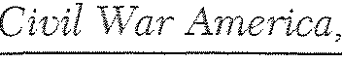

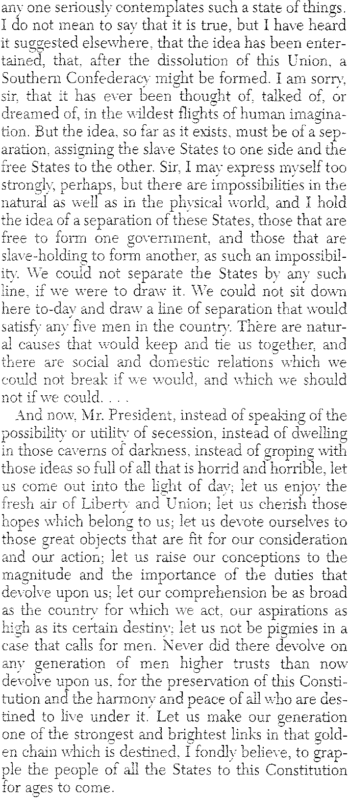

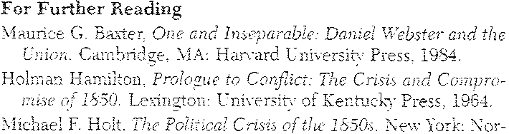
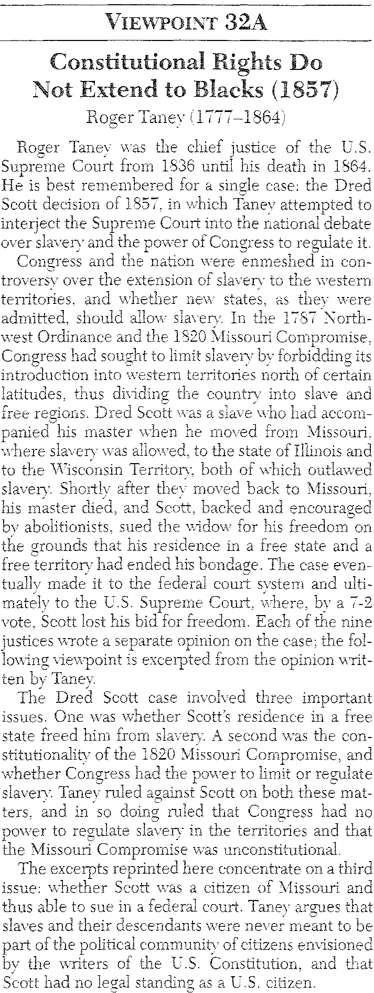
ton. 198:3

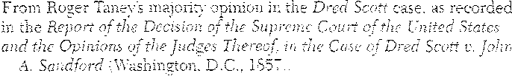

F
69

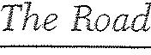
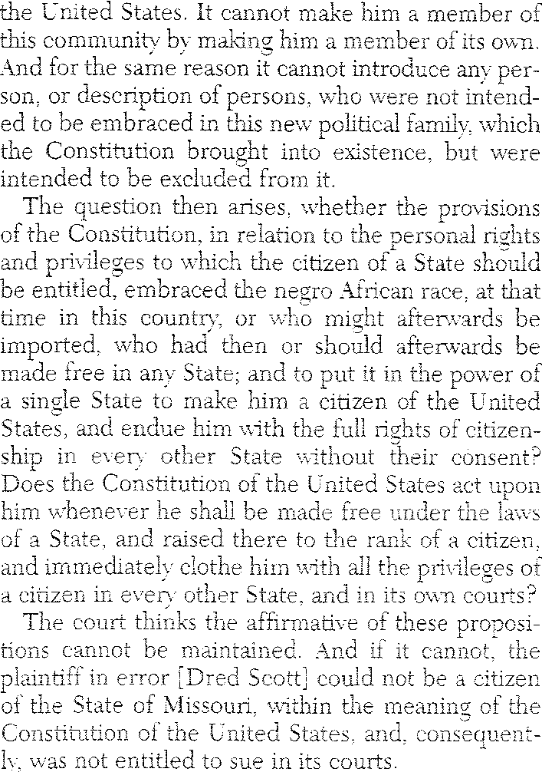
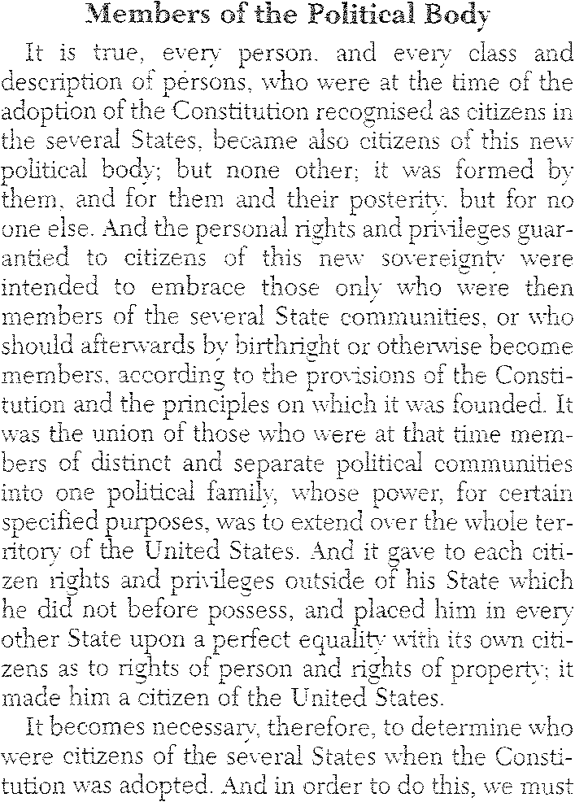

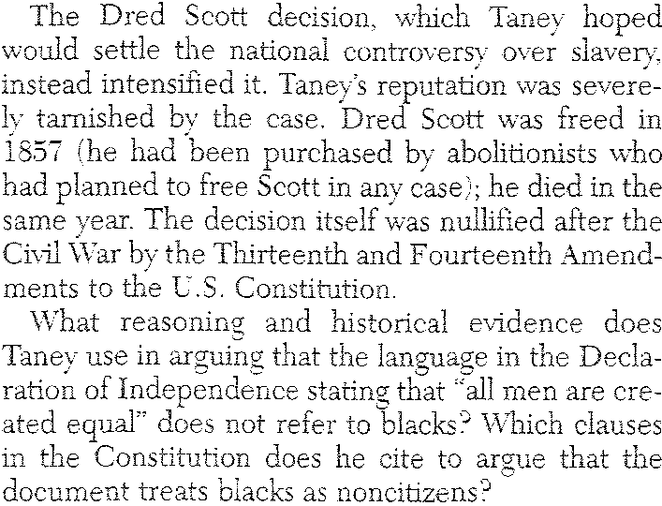

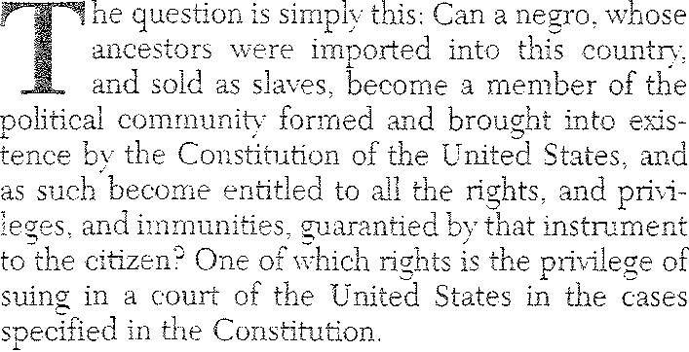

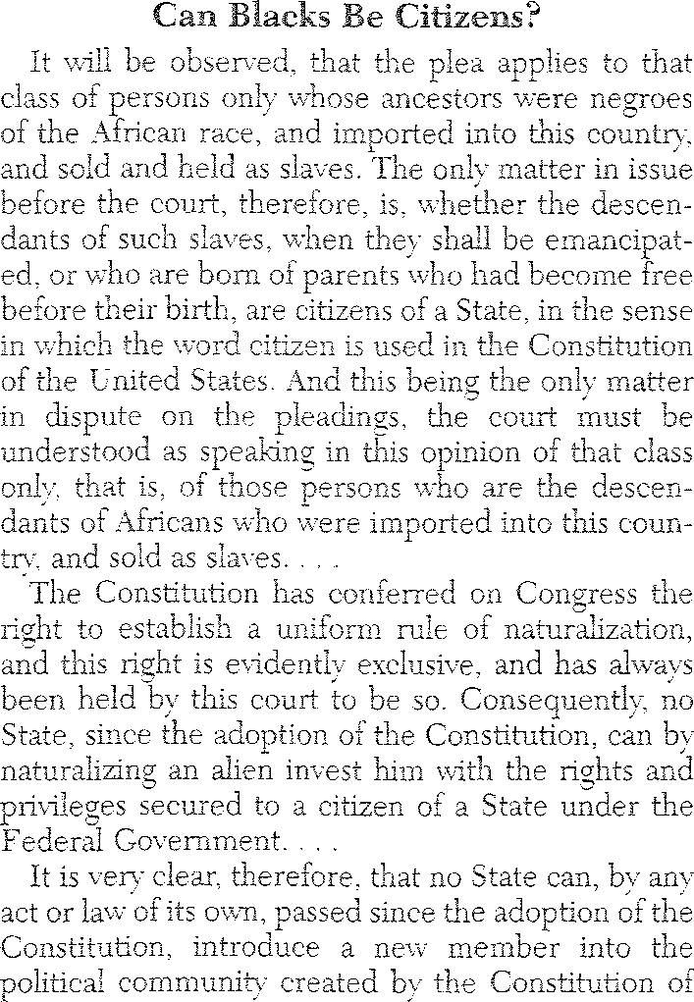
70

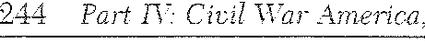
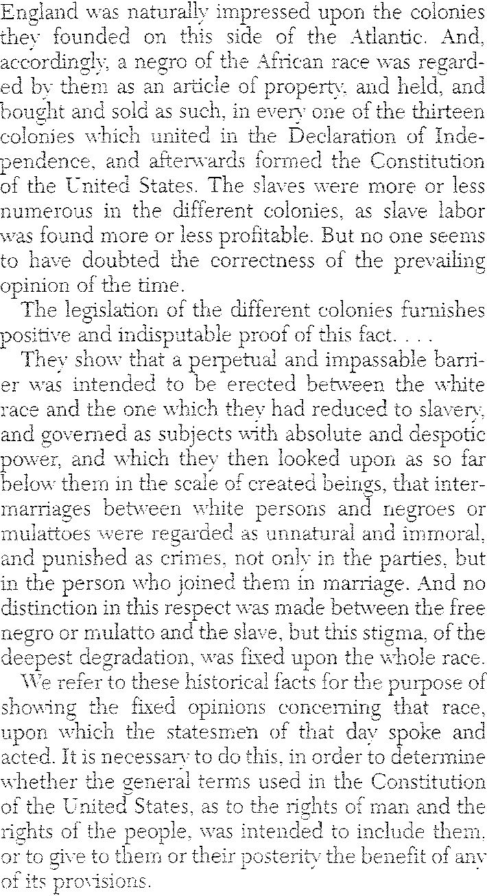
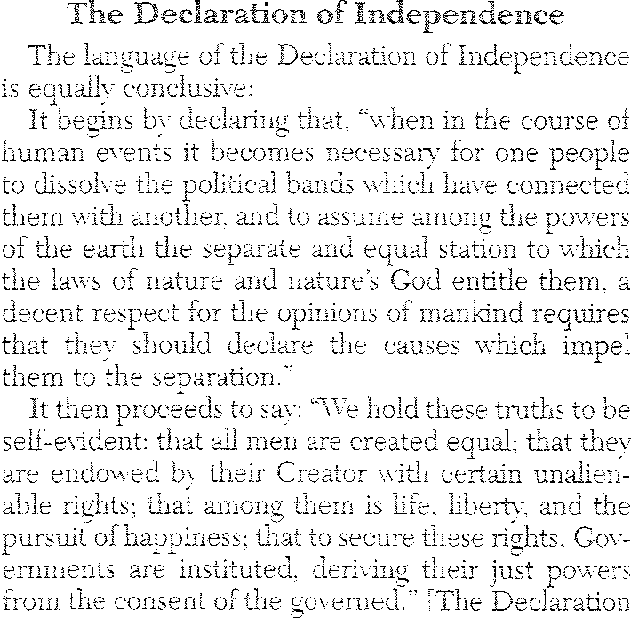

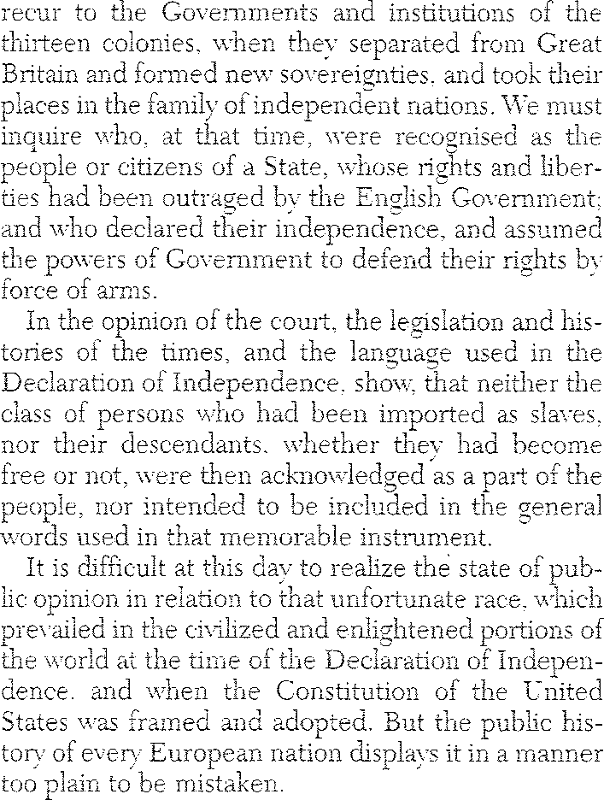

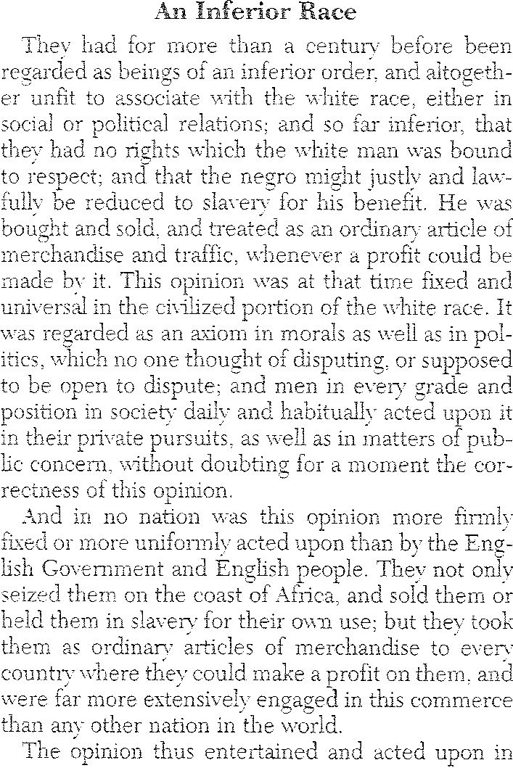
71

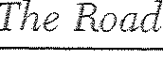
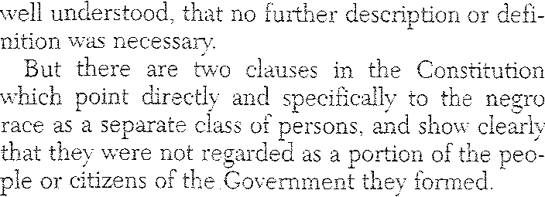
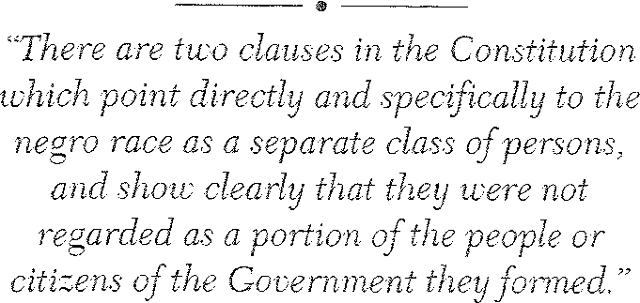
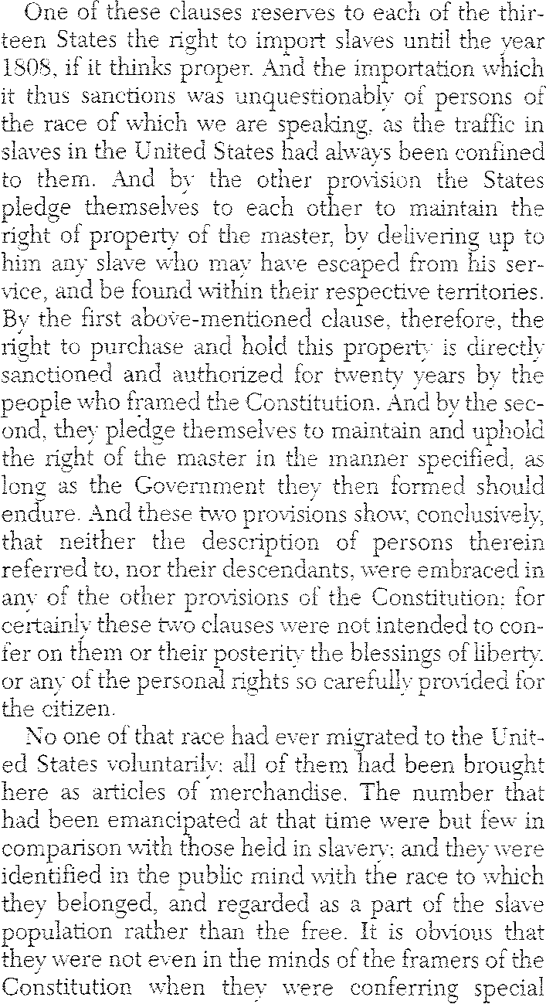

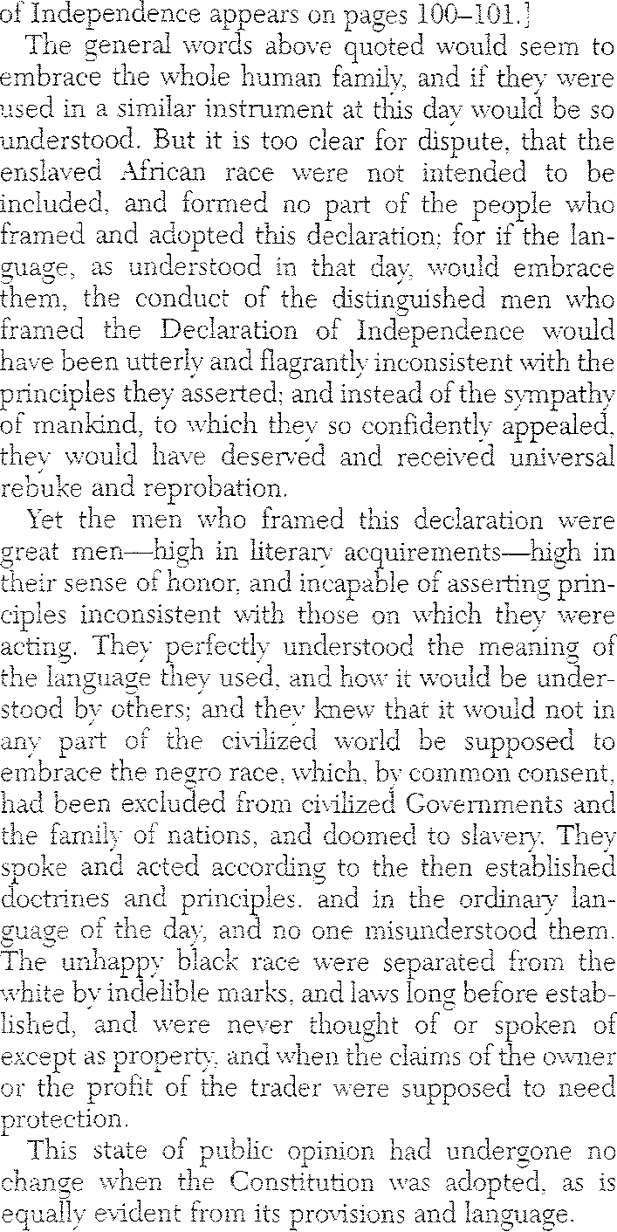

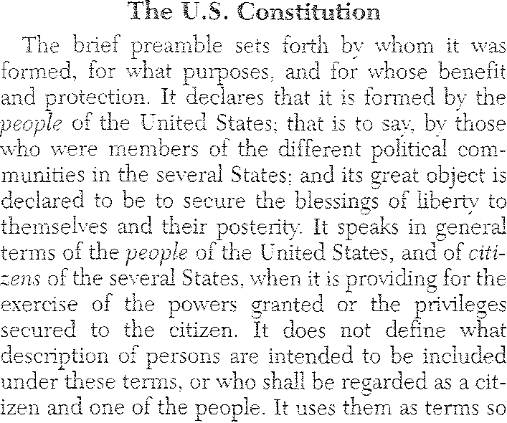
72
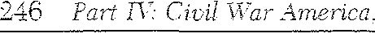
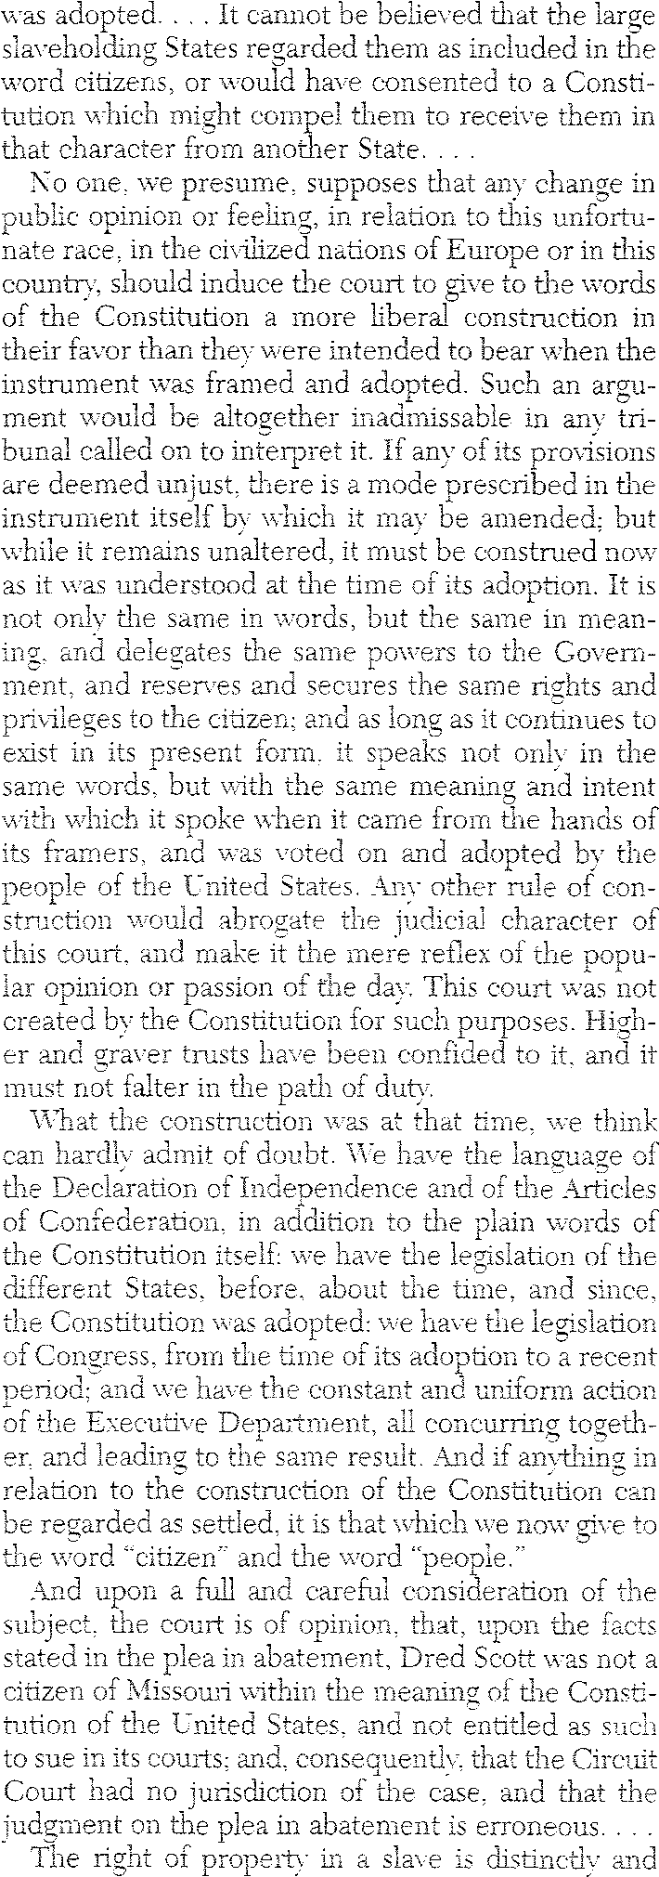

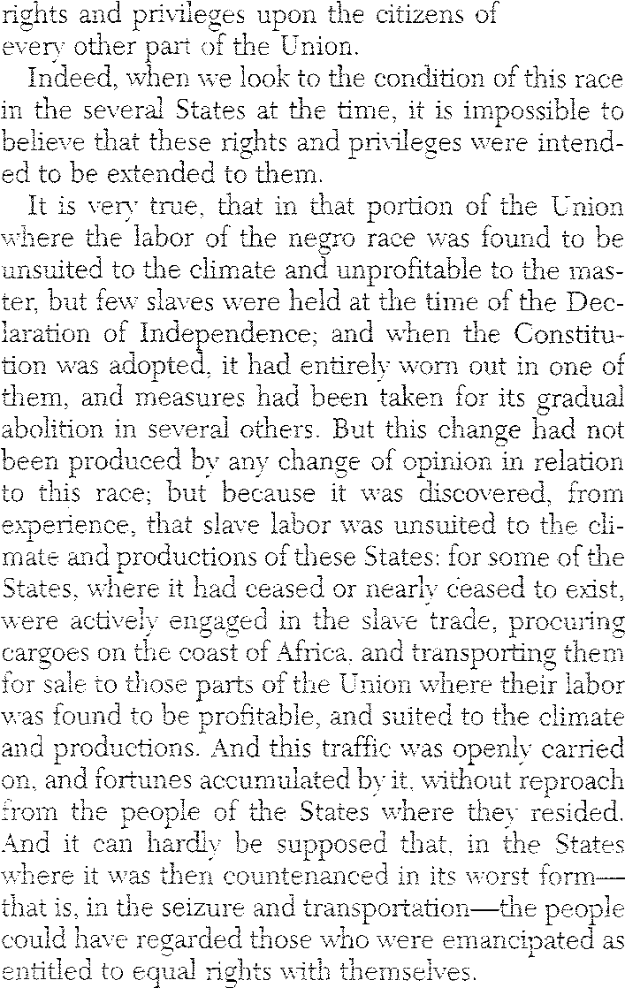
a State in

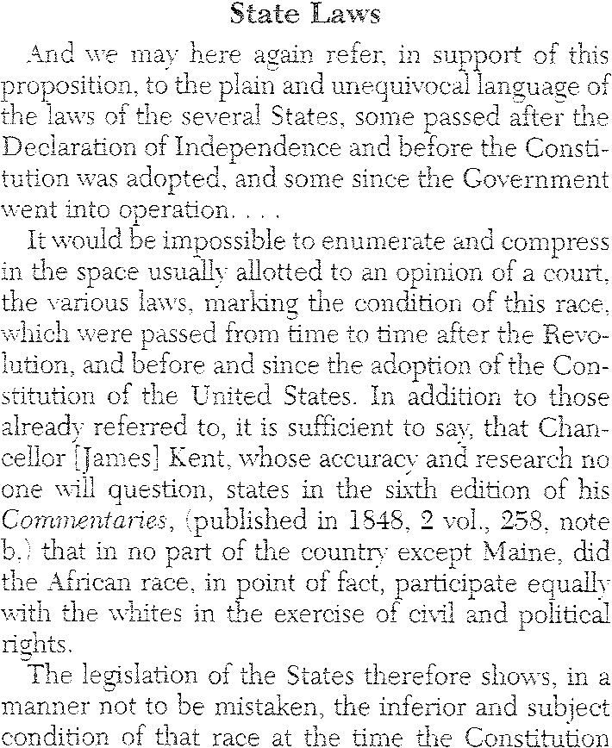
73

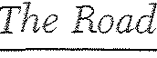
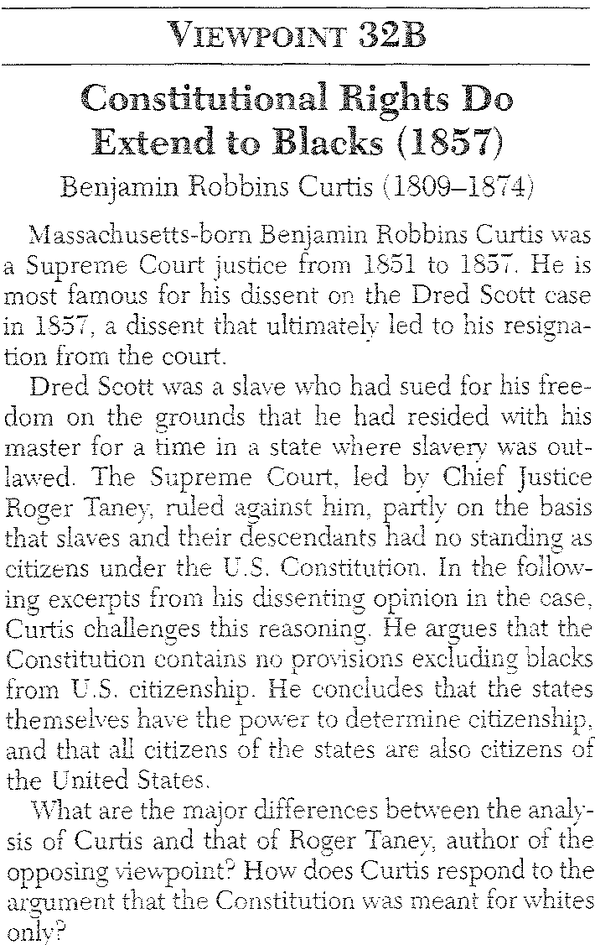
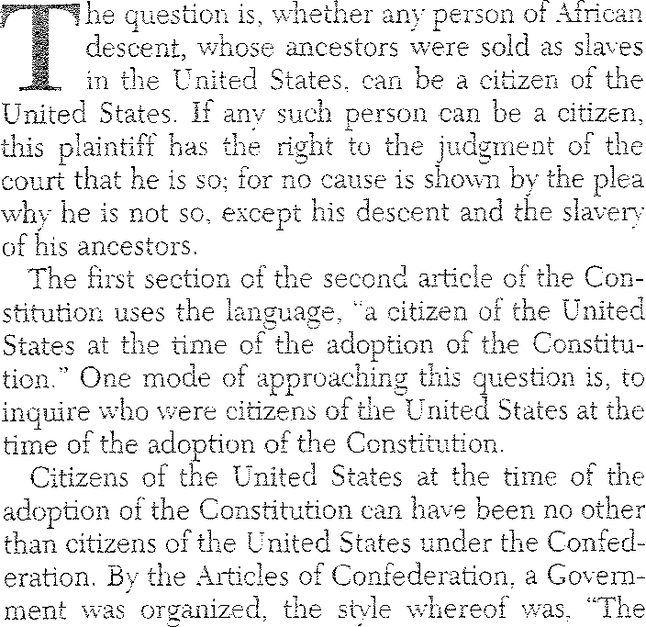
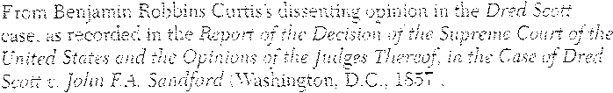

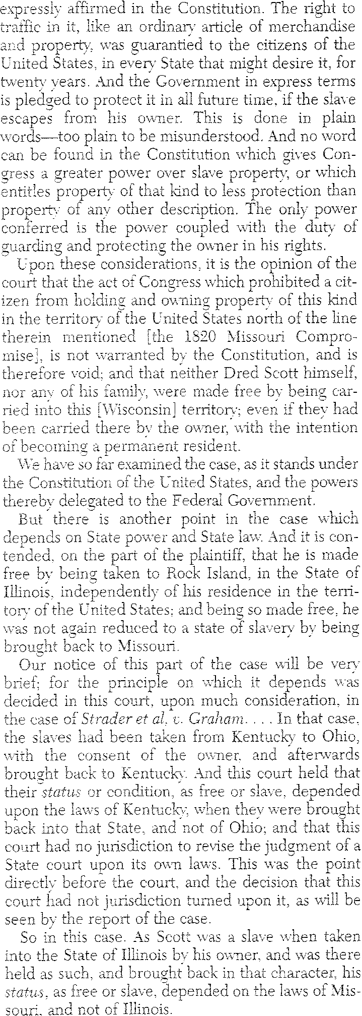
74

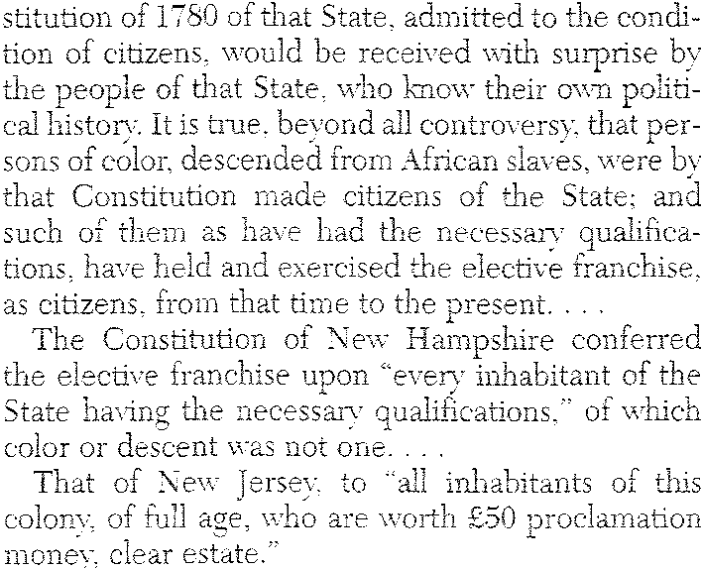
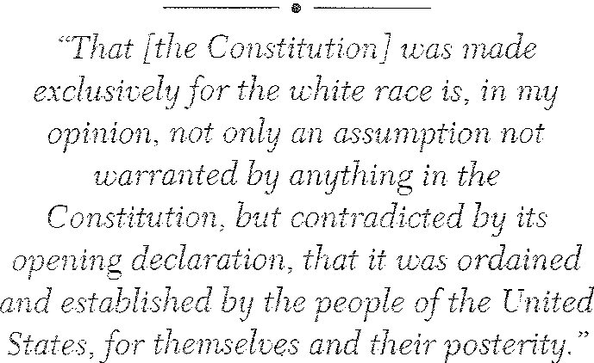
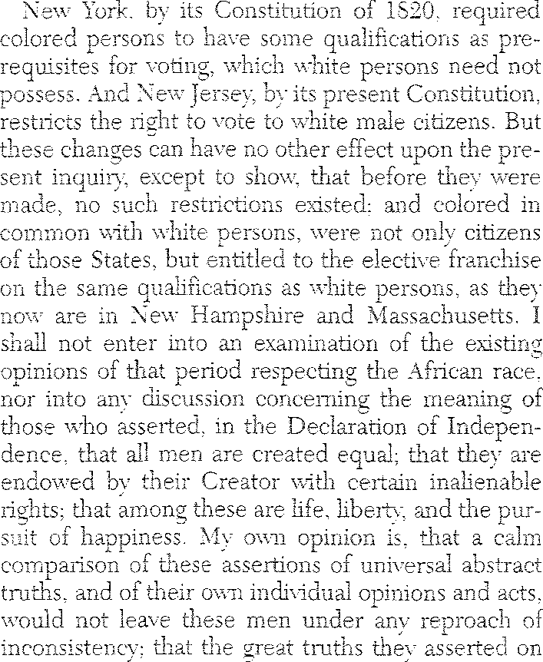

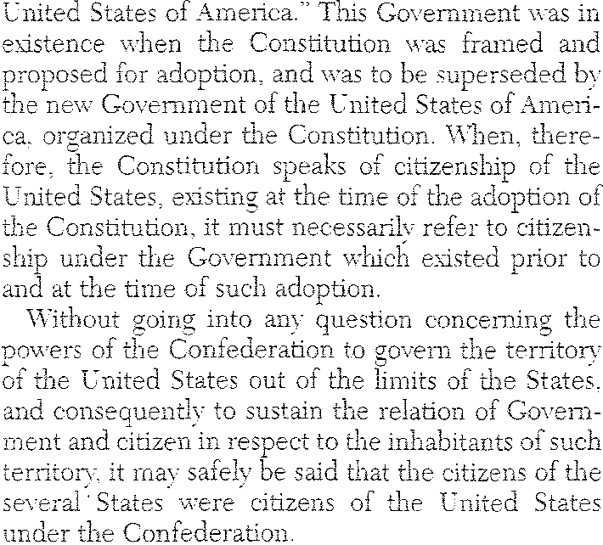

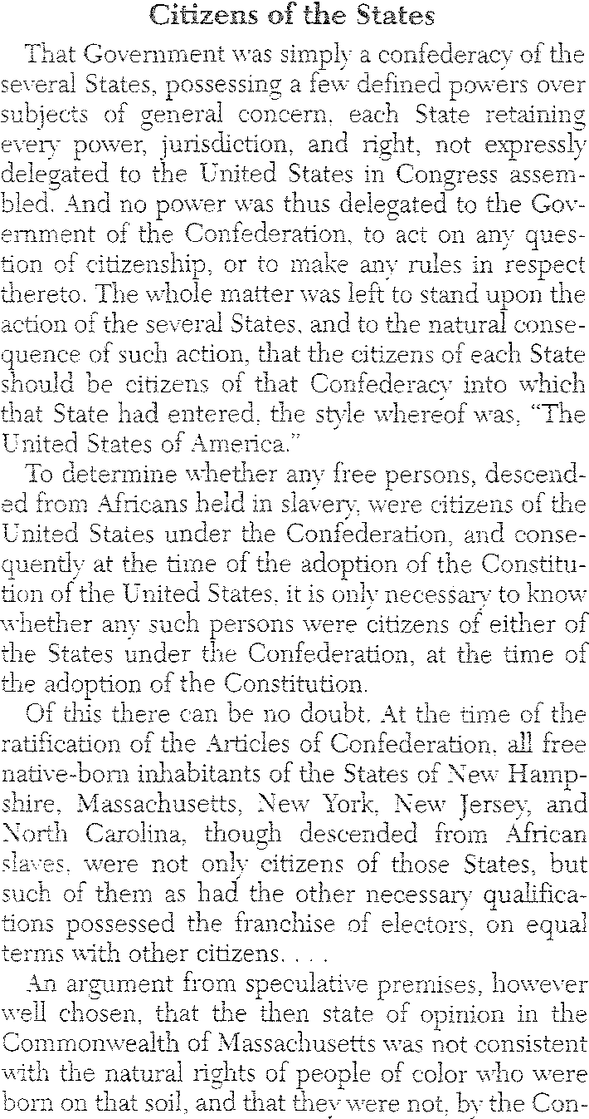
75

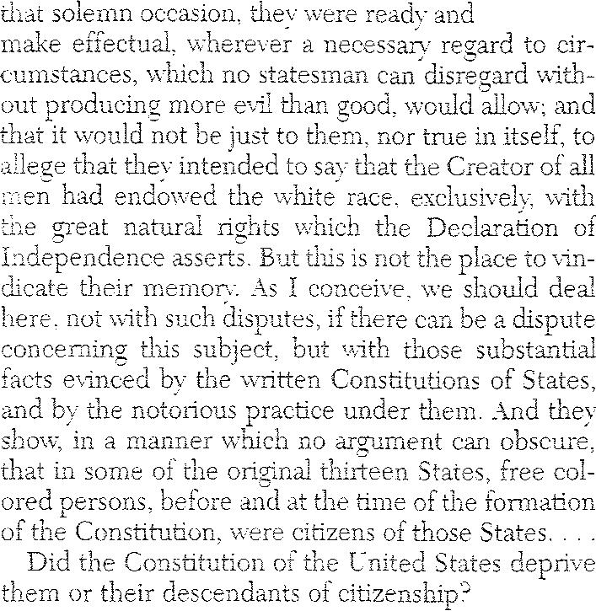
anxious to

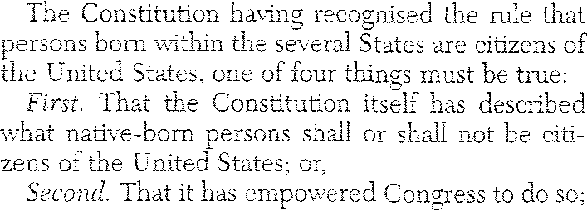
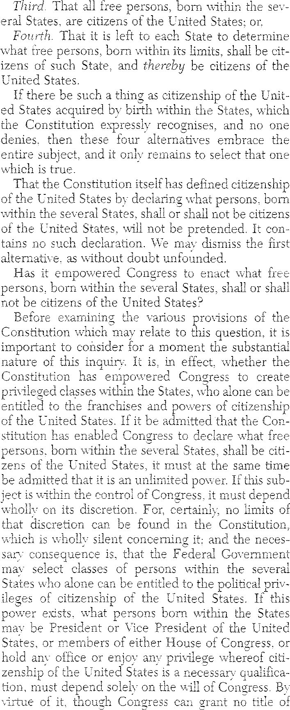
0,-,

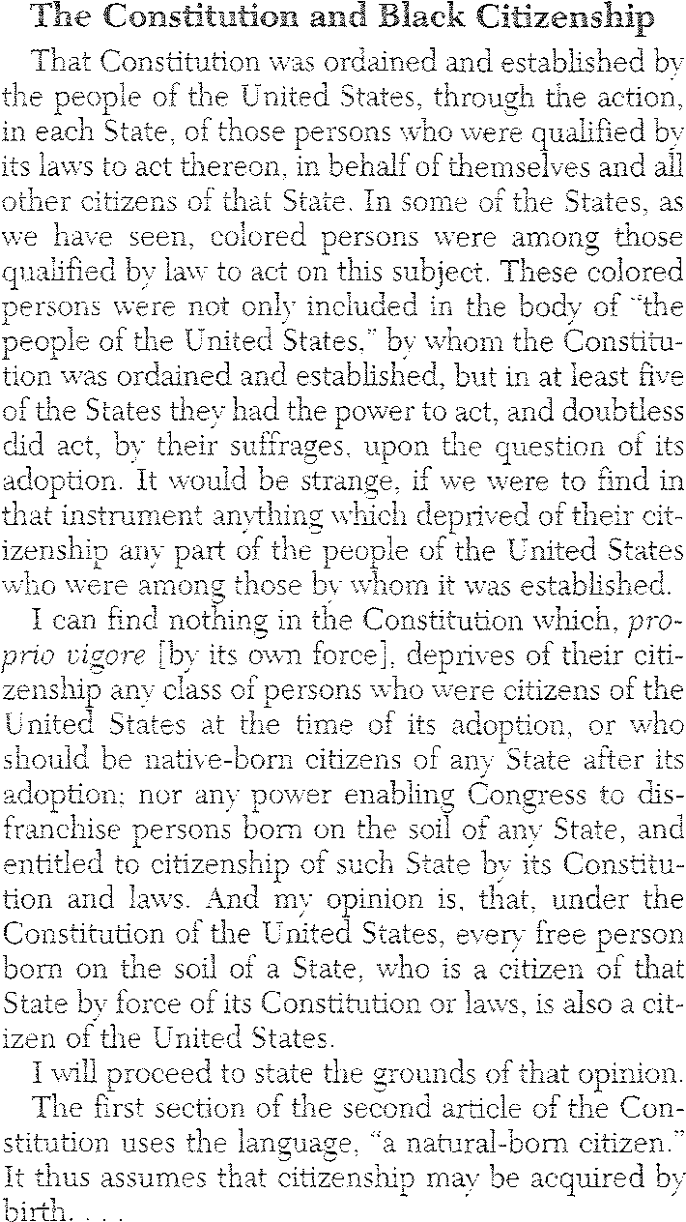
76
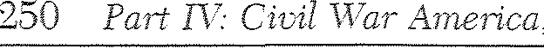
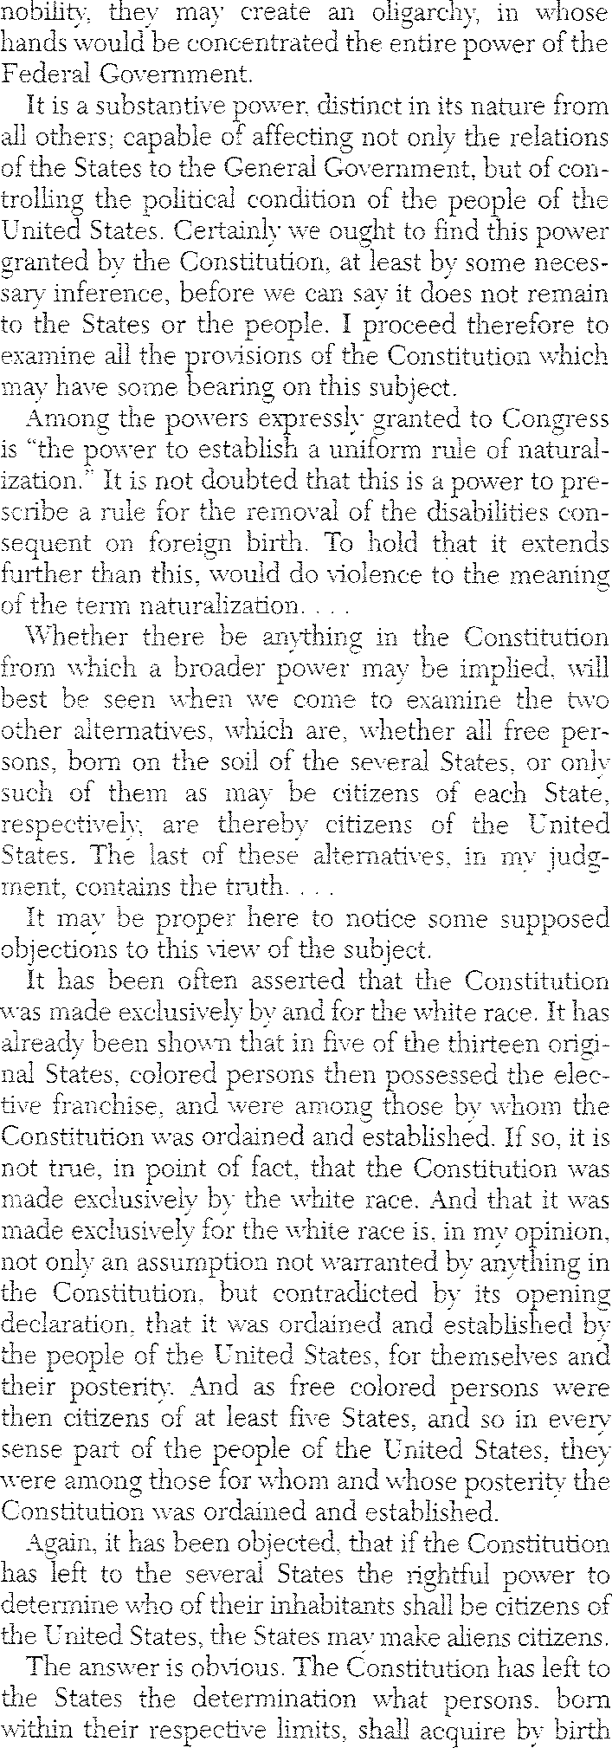
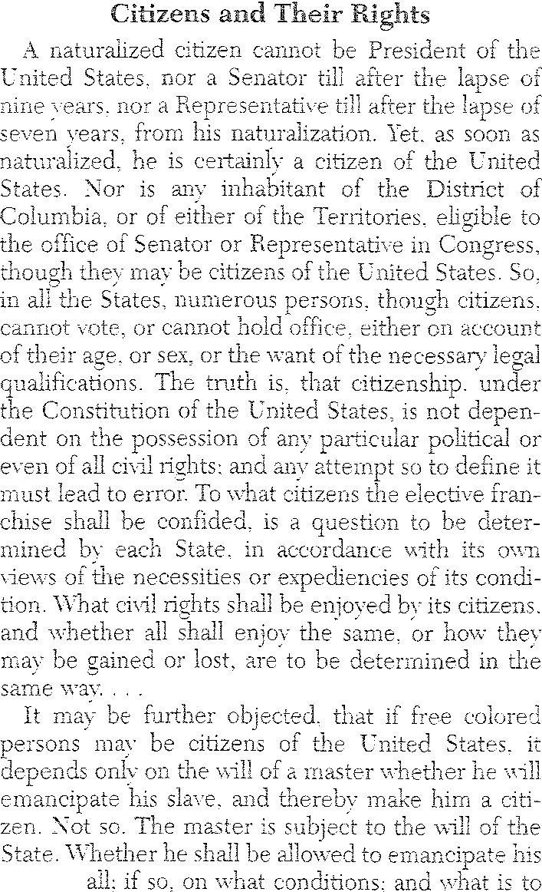

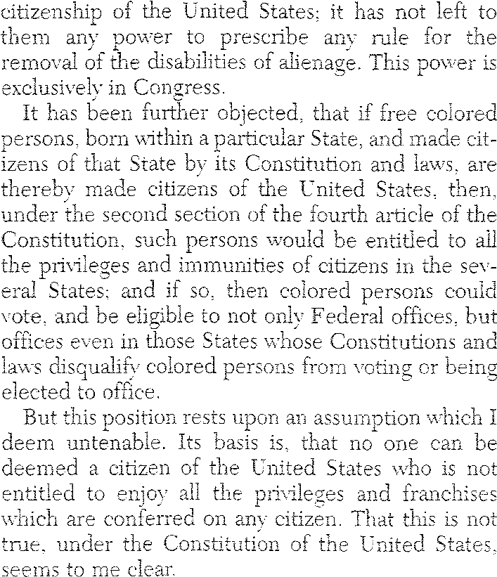

at
77

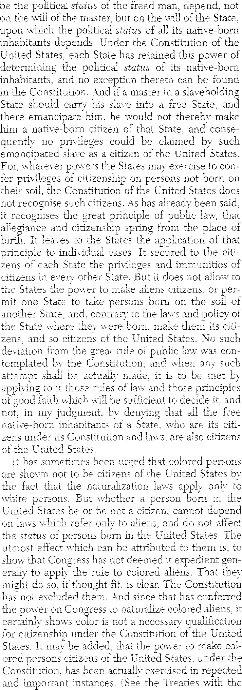
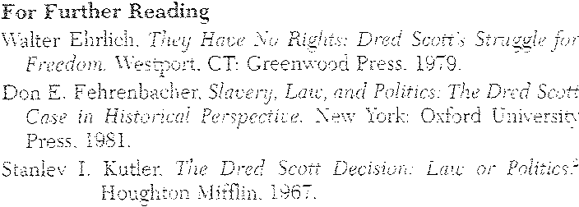

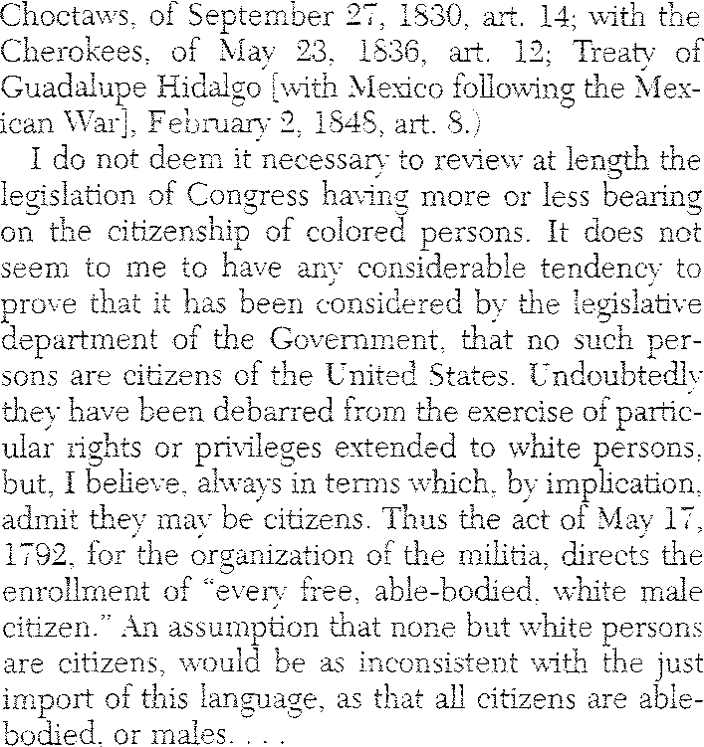

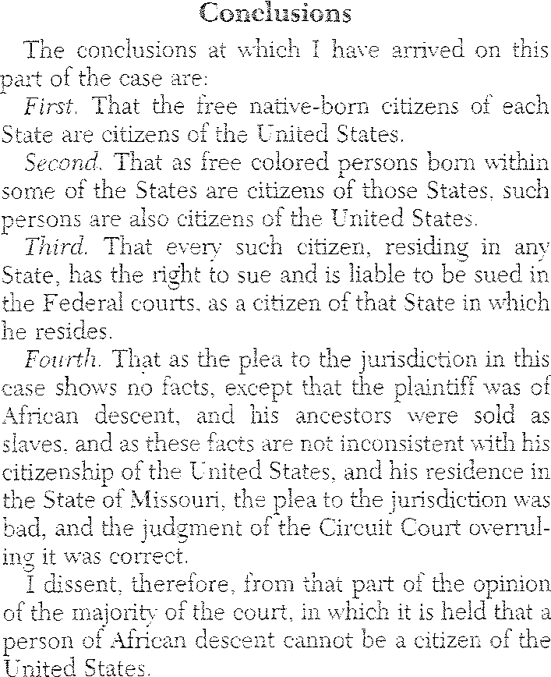

I.
Boston:

78

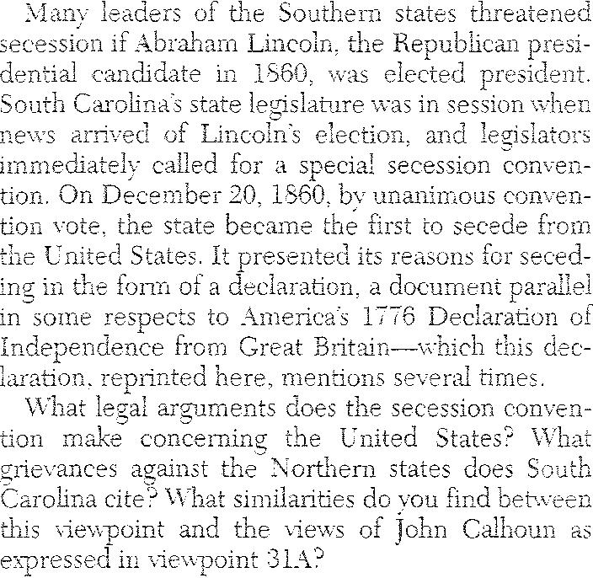
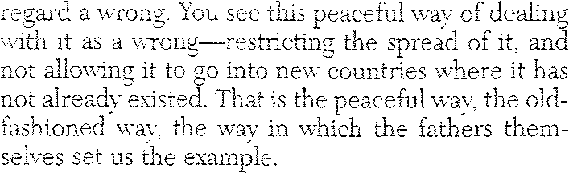

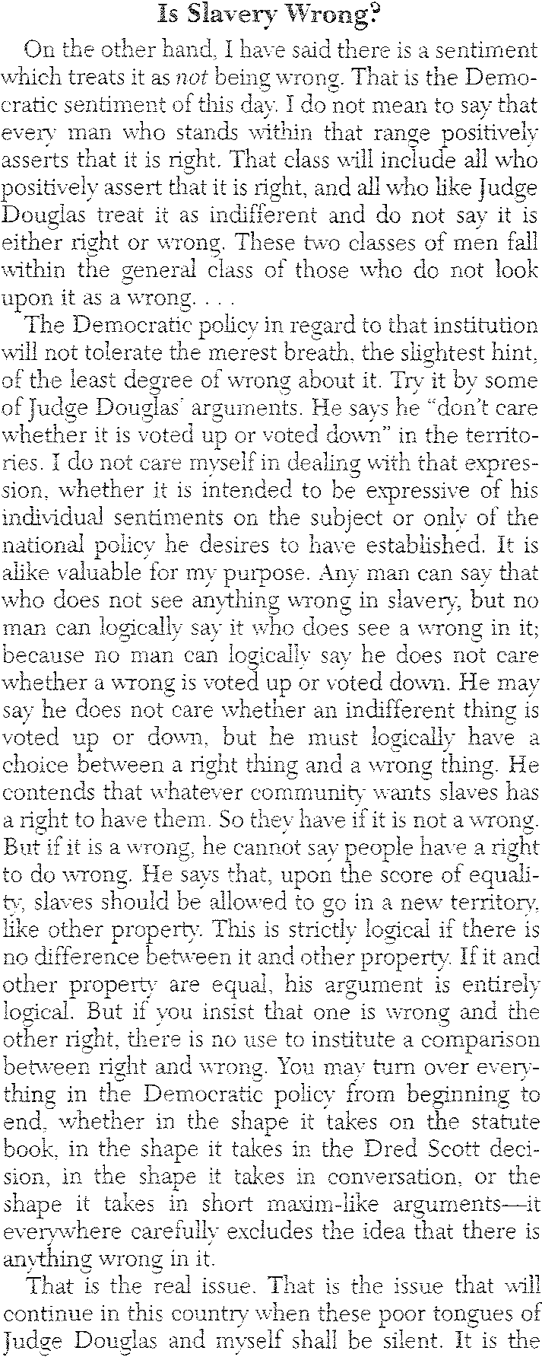
79
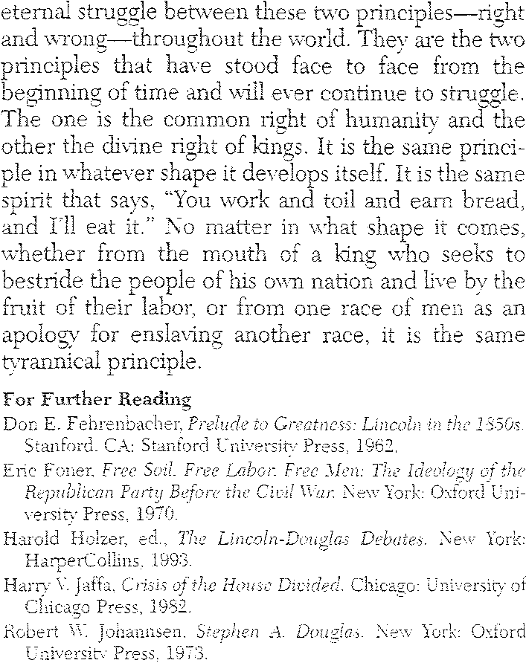
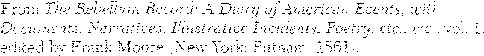
80
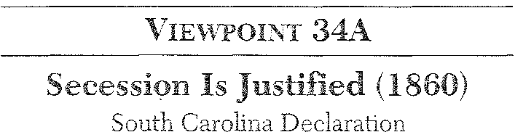
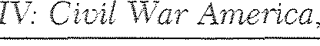
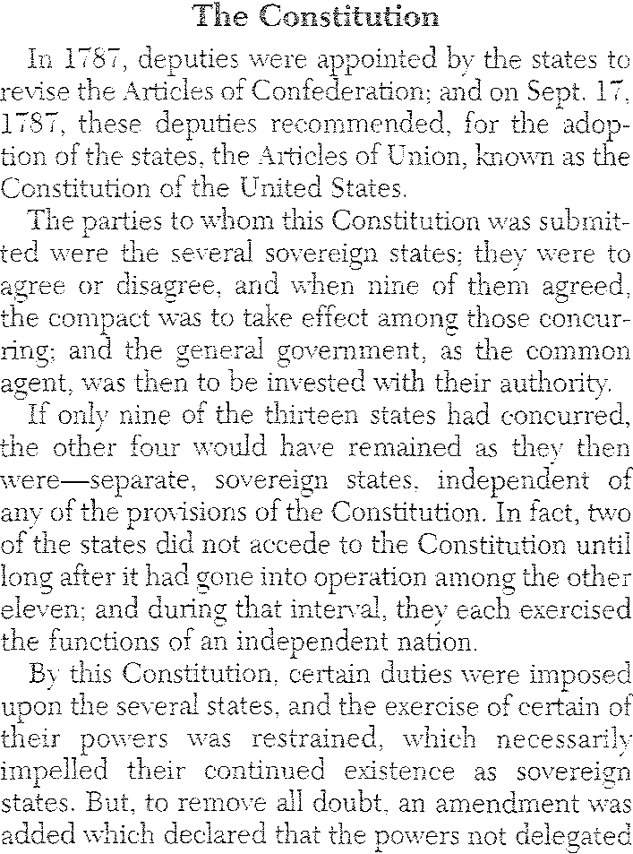

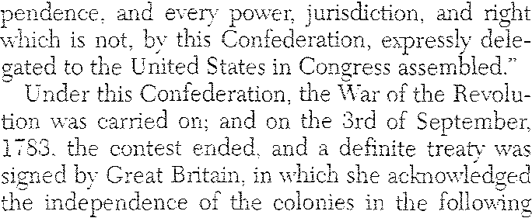
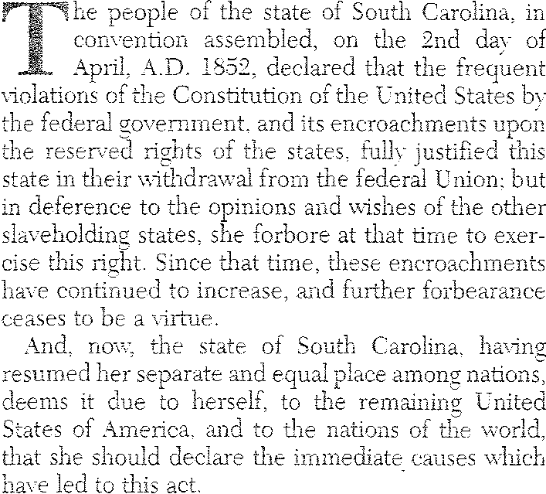
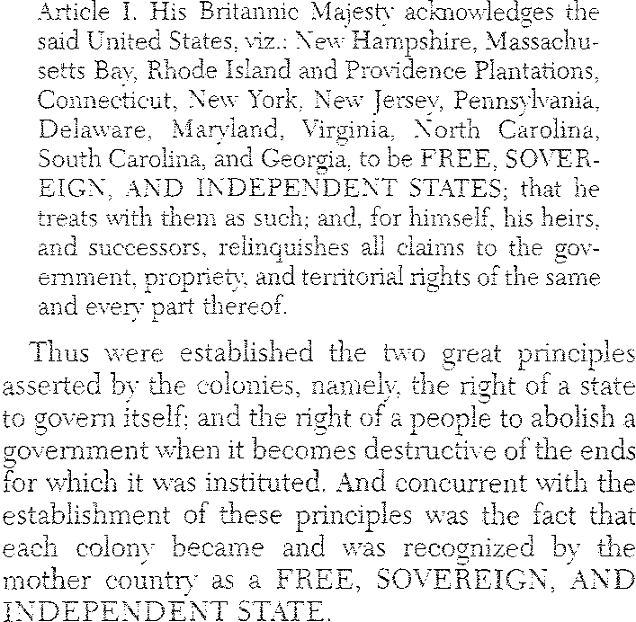
terms:

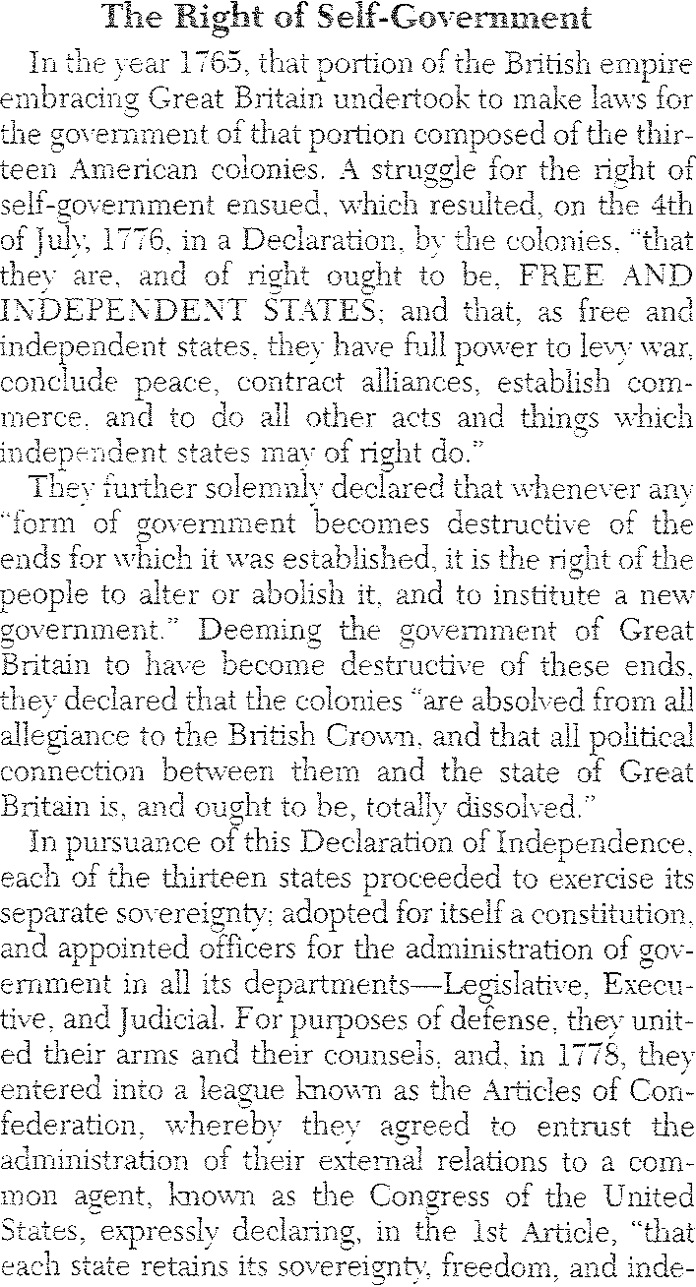
81

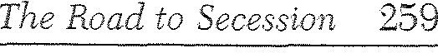
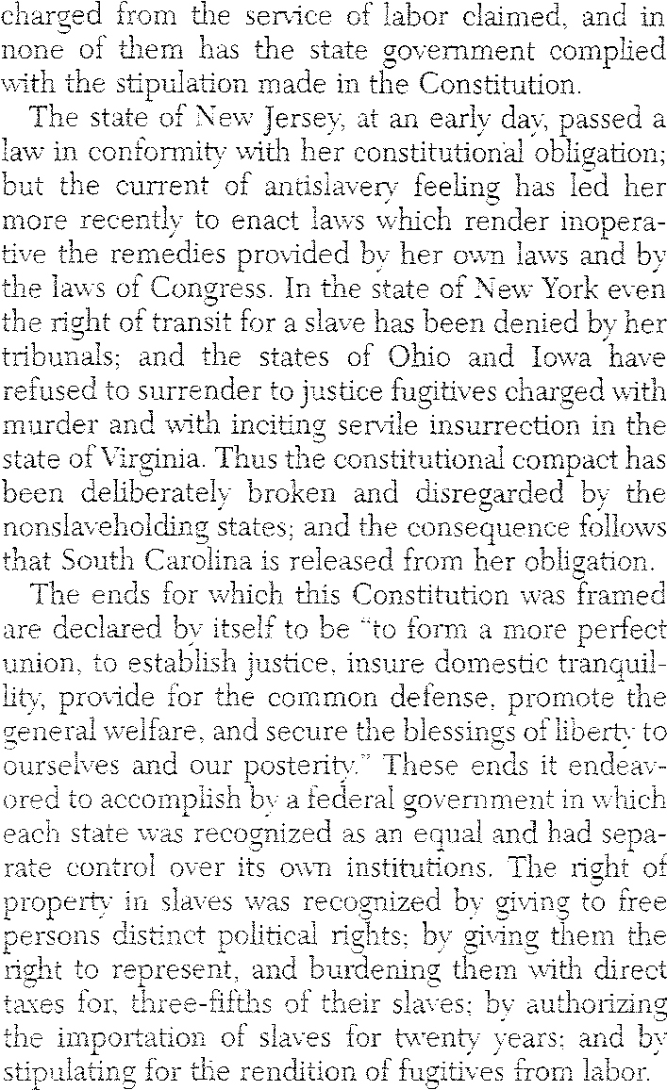
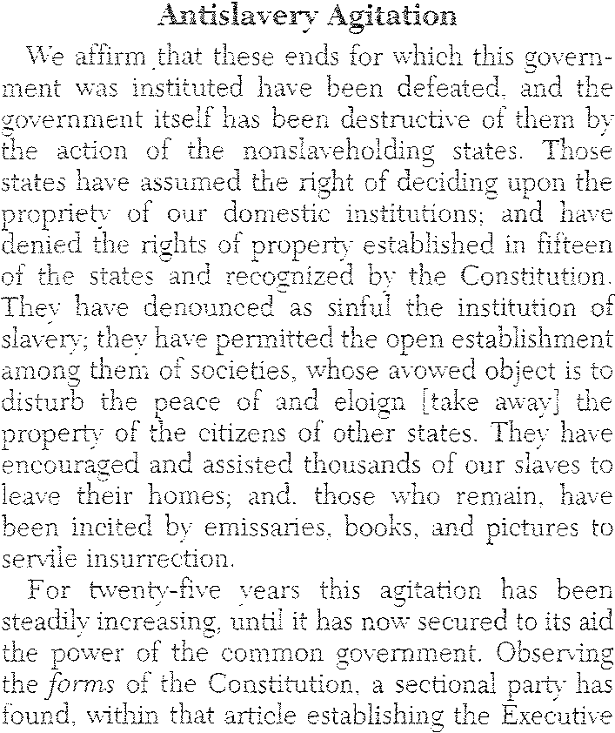
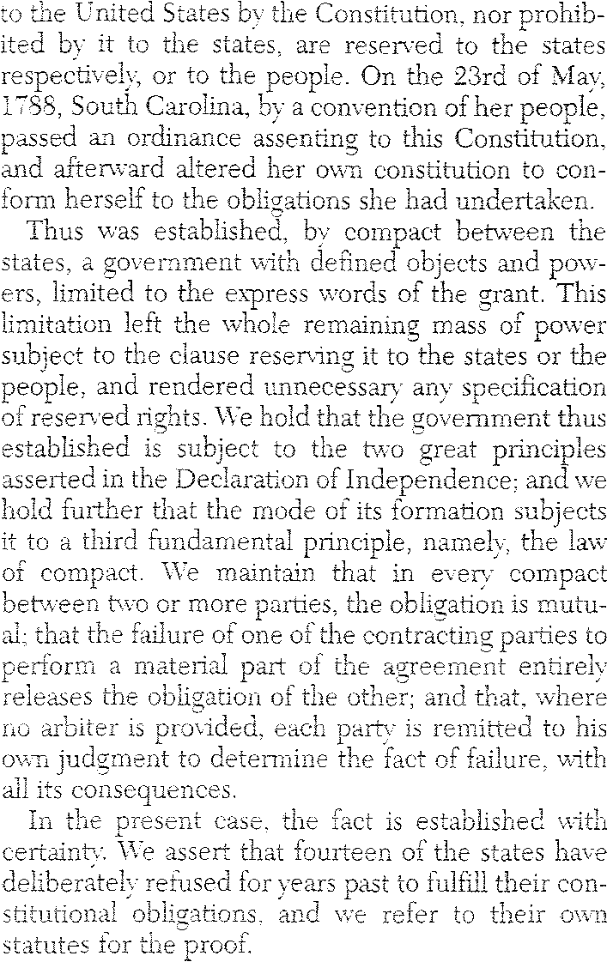

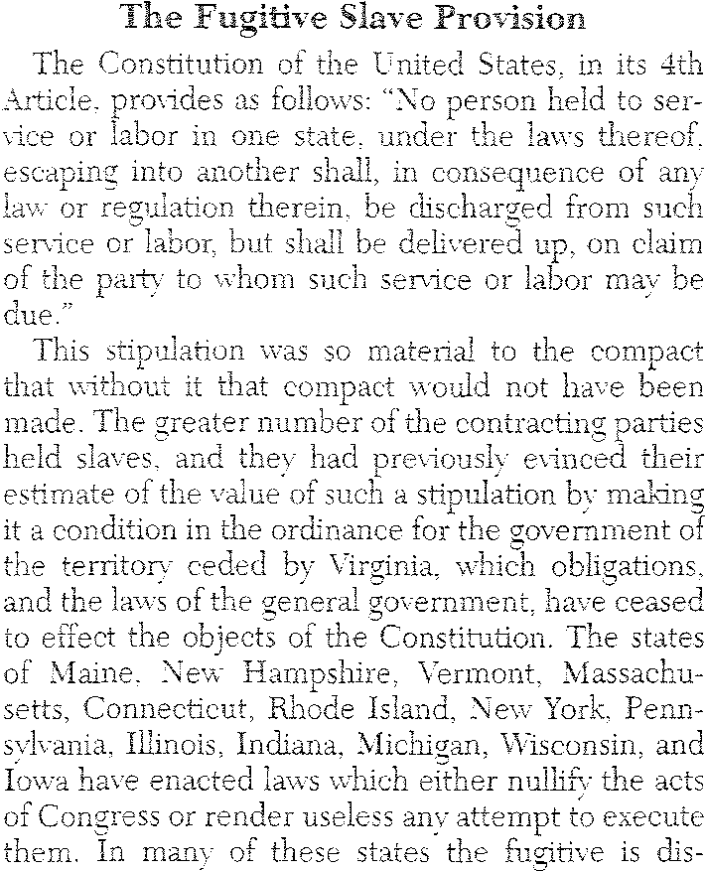
82

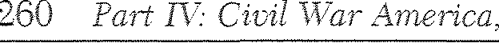
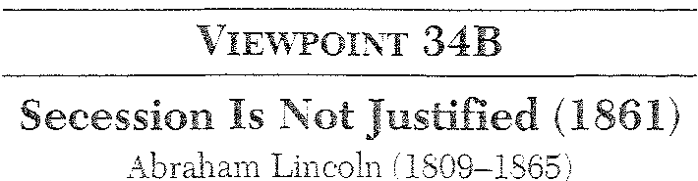
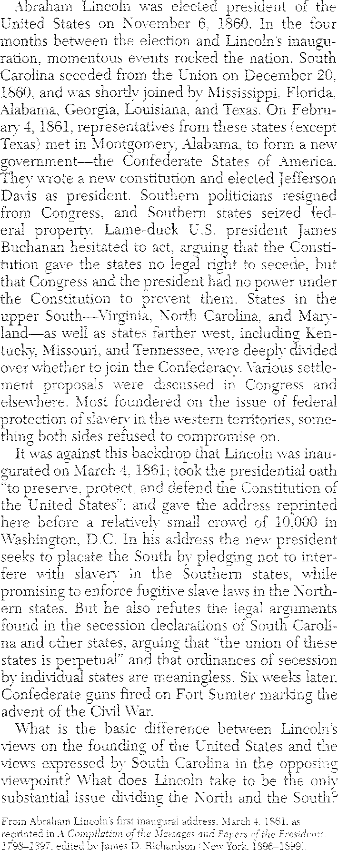

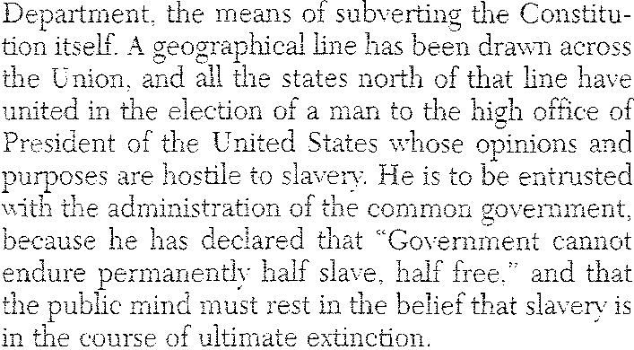

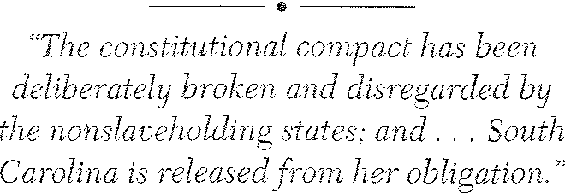

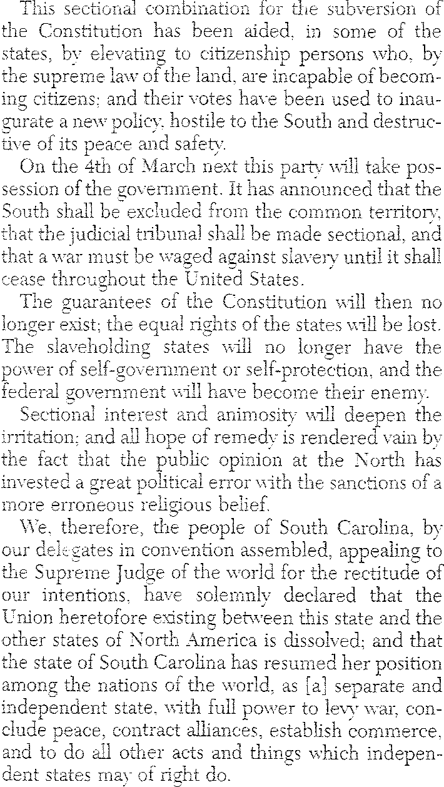
83

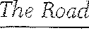

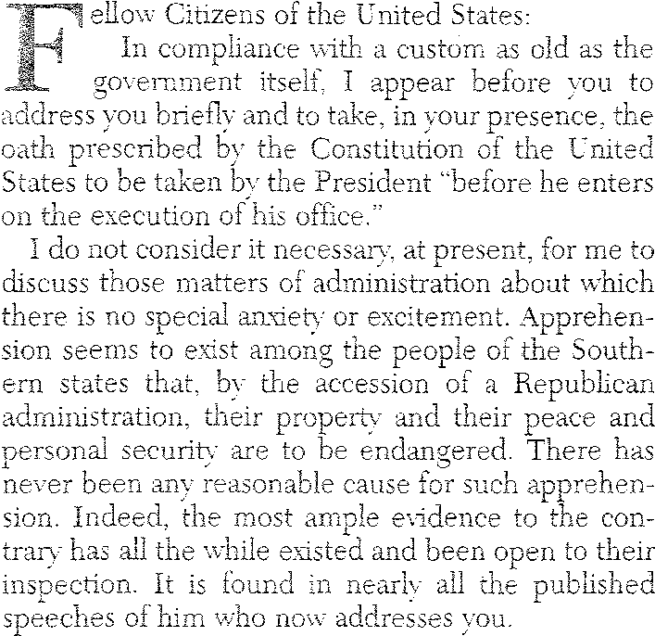
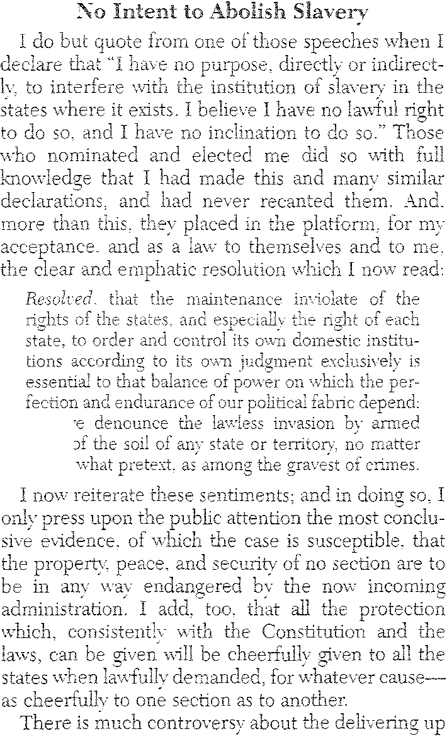
to 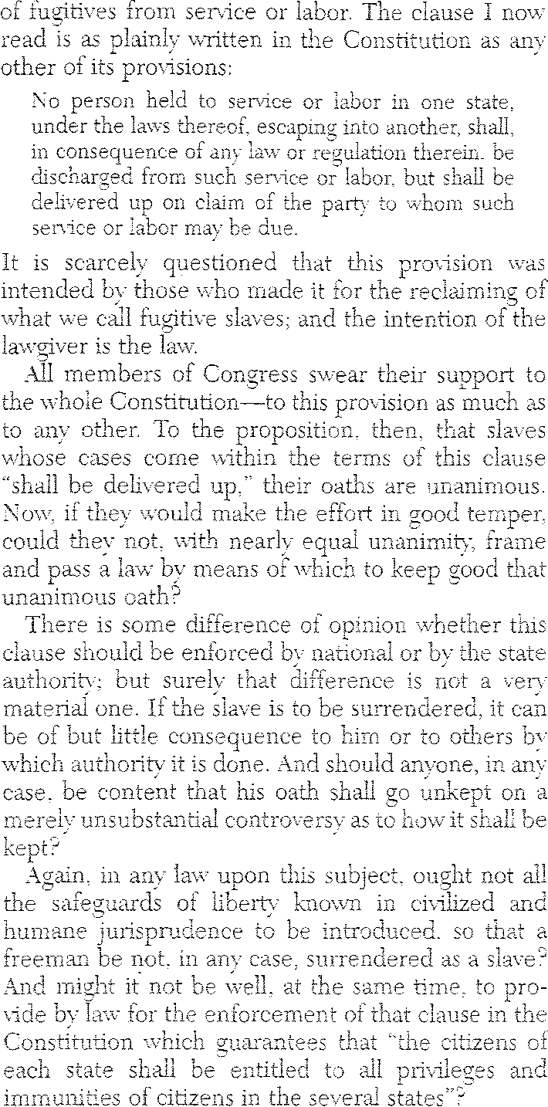

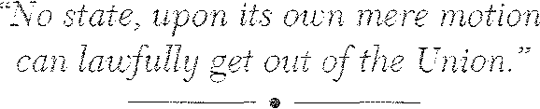
and we denounce the lawless force of
under

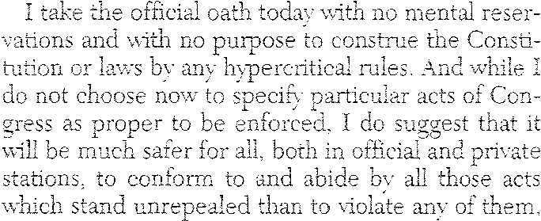
84

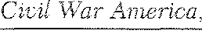
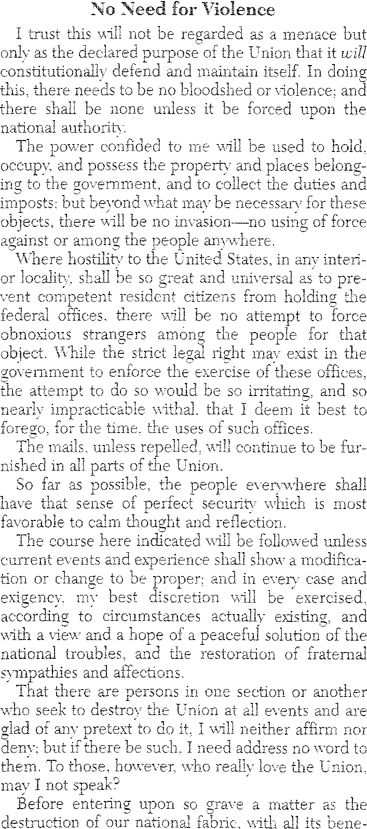

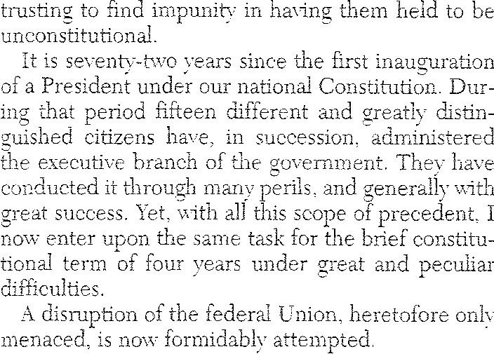
to circumstances.
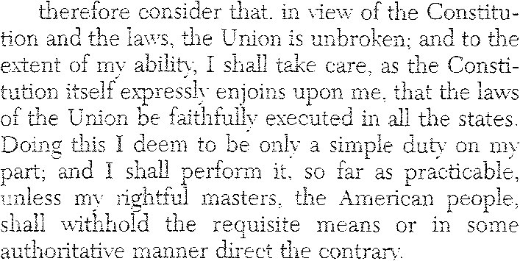
I

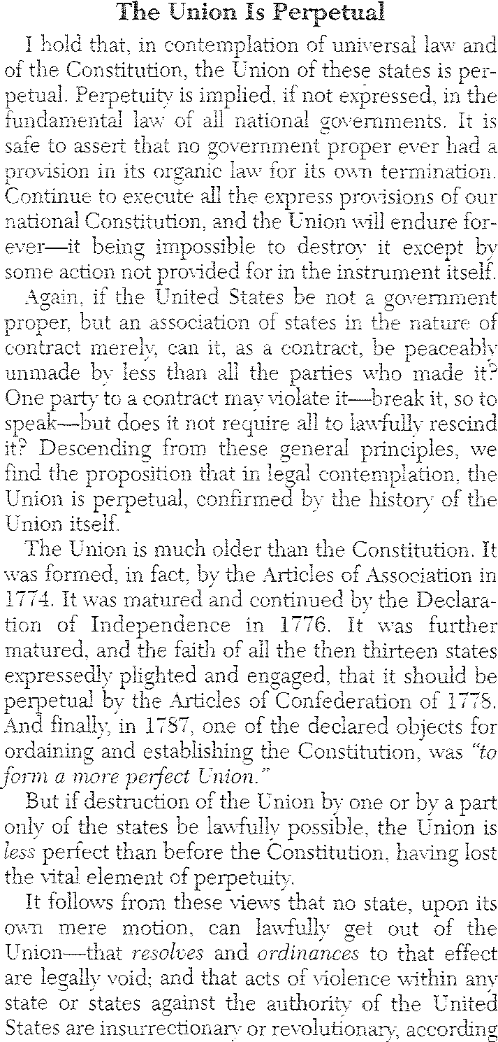
85

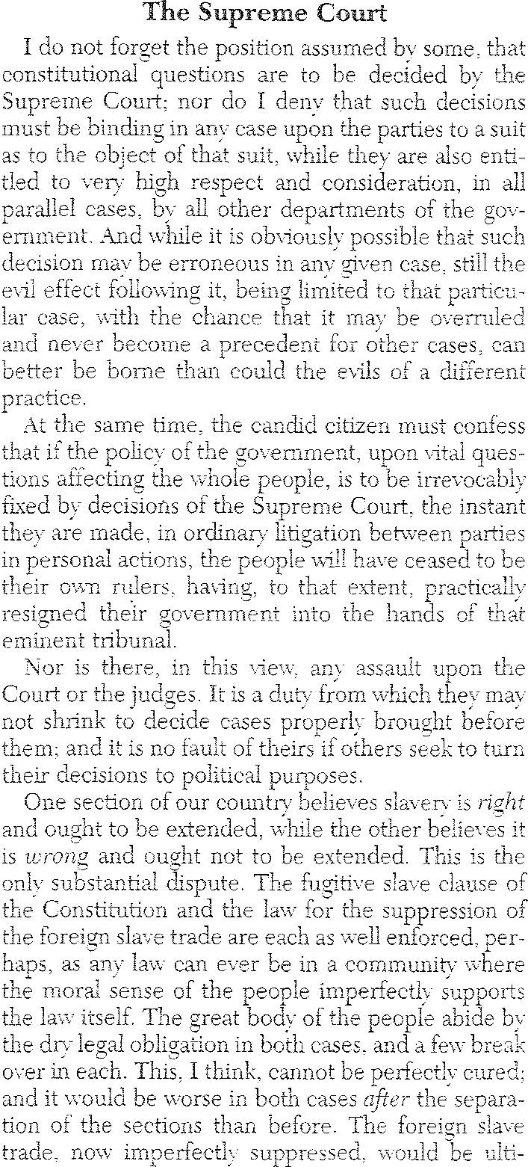
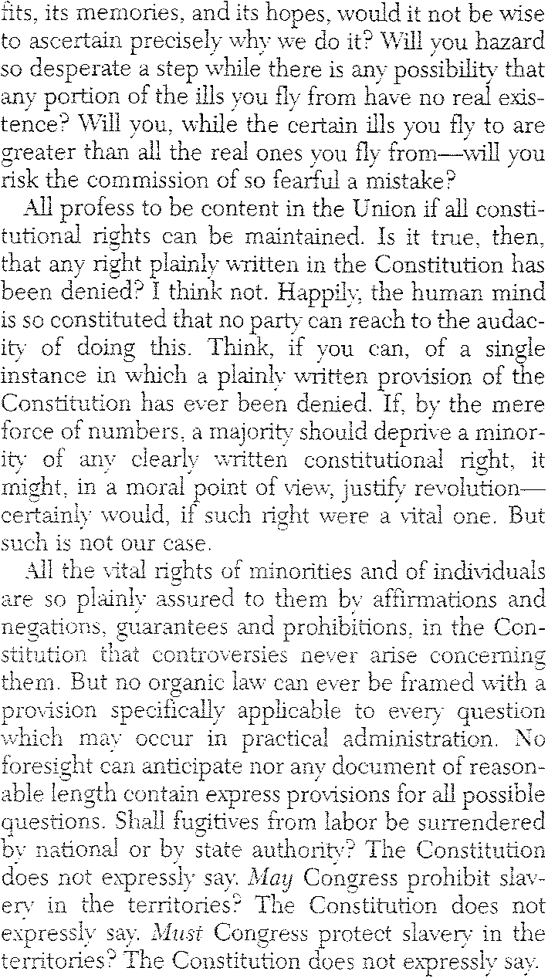
secession?
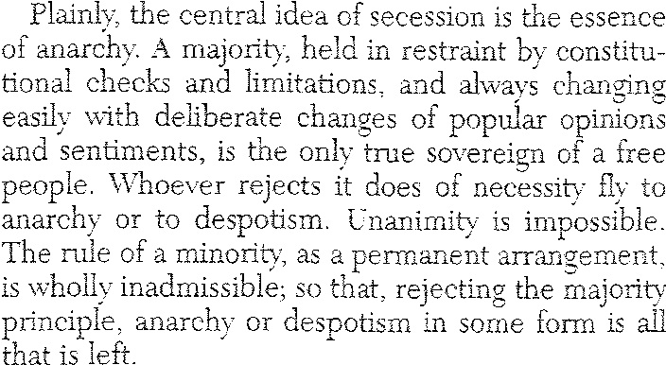

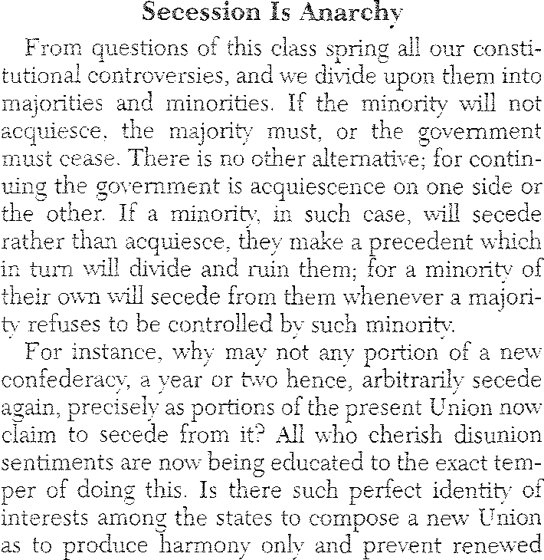
86

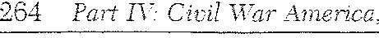
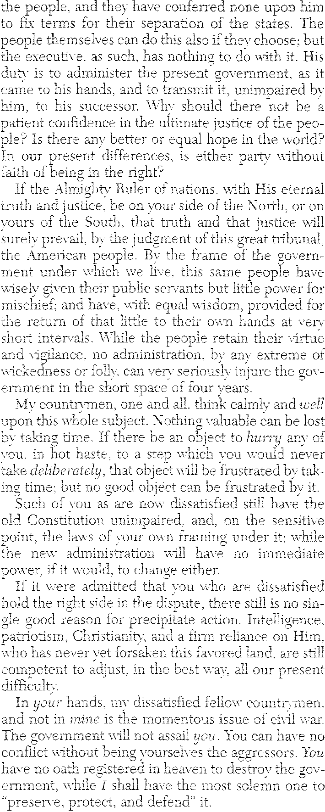
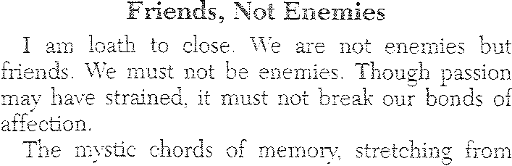

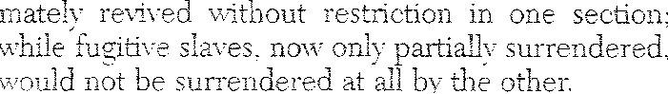

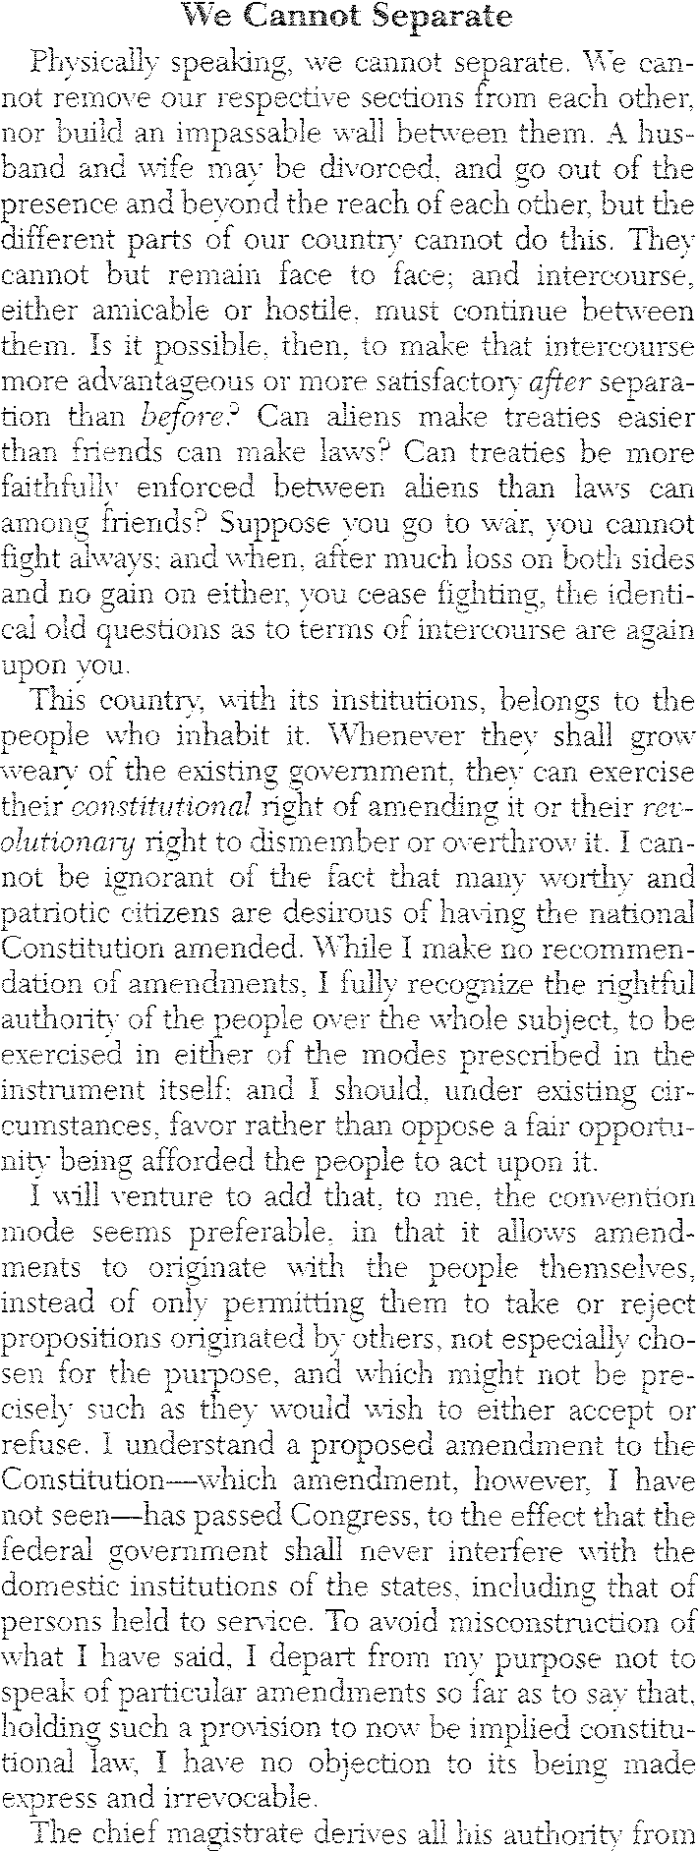
87

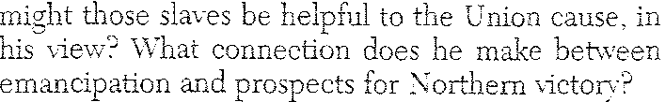

Beacon Press, 1968.
Secession lo0ement. !\ew York:

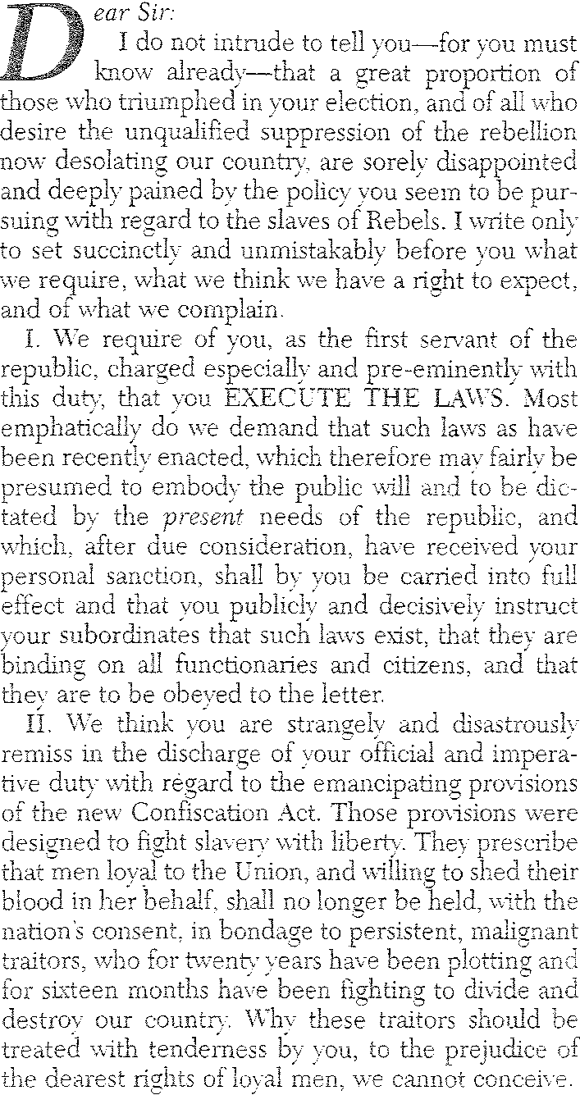
South. 1·'360-1661. Boston:

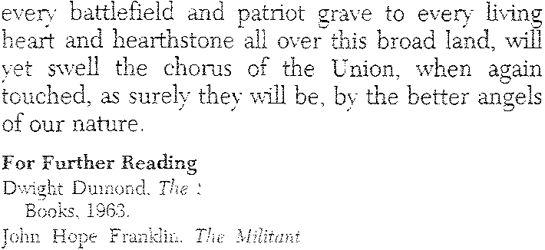
D<Fid Crisis. !\ew York:
1976.
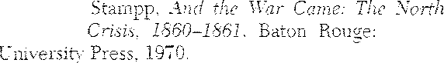
Kenneth .\L
&

the

Secession
Louisiana State

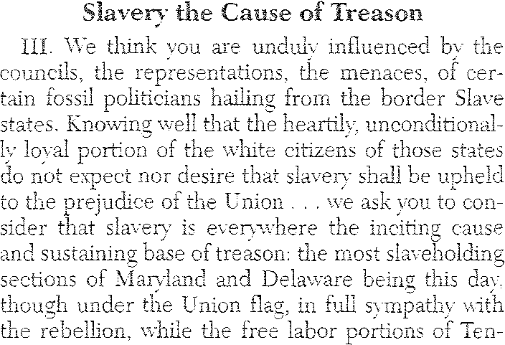

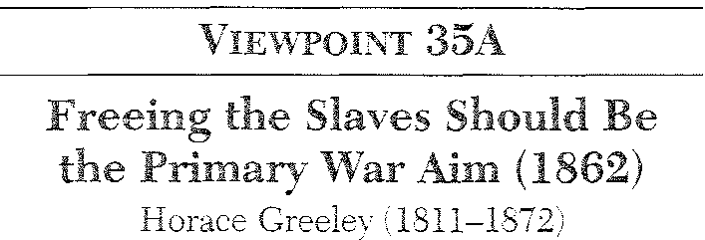

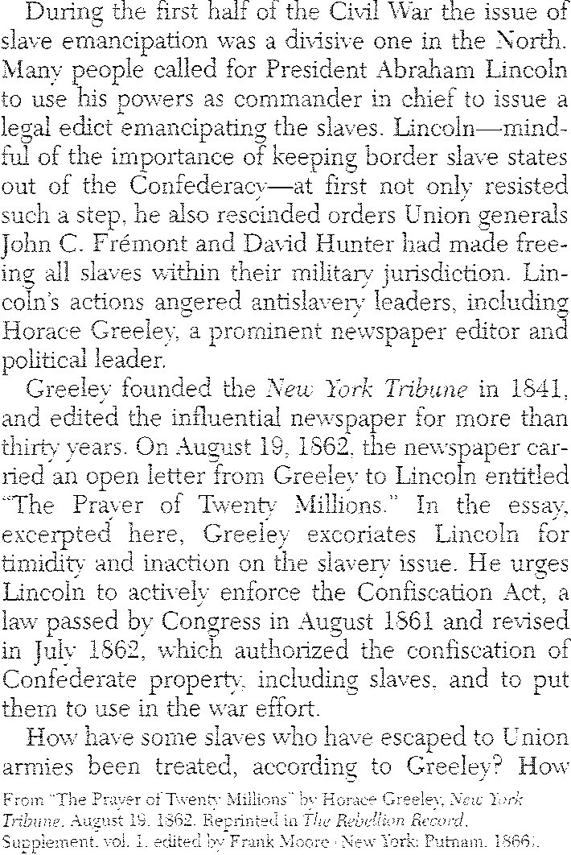
88

190 · January 21, 1861
89

I had hoped this summer to have had an opportunity to see you and Mrs. Pierce and to have shown to you our children. Mrs. Davis was sorely disappointed when we turned Southward without seeing you, I believe she wrote to Mrs. Pierce in explanation of the circumstances which prevented us from executing our cherished plan of a visit to you when we should leave West Point.
Mrs. Davis joins me in kindest remembrance to Mrs. Pierce and the
expression of the hope that we may yet have you both at our country home. Do me the favor to write to me often, address Hurricane P.O. Warren County, Missi.
May God bless you is ever the prayer of your friend
]EFFN, DAVIS

Speech in U.S. Senate(FarewellAddress) (PJD)

JANUARY 21, 1861
)> I rise, Mr. President, for the purpose of announcing to the Senate that
-u
c
I I have satisfactory evidence that the State of Mississippi, by a solemn
Vl
90
January 21, 1861 · 191

justifiable cause, and I approve of her act. I conferred with her people before that act was taken, counseled them then that if the state of things which they apprehended should exist when the convention met, they should take the action which they have now adopted.
I hope none who hear me will confound this expression of mine with the advocacy of the right of a State to remain in the Union, and to disregard its constitutional obligations by the nullification of the law. Such is not my theory. Nullification and secession, so often con­ founded, are indeed antagonistic principles. Nullification is a remedy which it is sought to apply within the Union, and against the agent of the States. Itis only to be justified when the agent has violated his con­ stitutional obligation, and a State, assuming to judge for itself, denies the right of the agent thus to act, and appeals to the other States of the Union for a deCision; but when the States themselves, and when the people of the States, have so acted as to convince us that they will not regard our constitutional rights, then, and then for the first time, arises the doctrine of secession in its practical application.
A great man who now reposes with his fathers, and who has been often arraigned for a want of fealty to the Union, advocated the doc­

N
..0

Vl
I
ordinance of her people in convention assembled, has declared her
separation from the United States. Under these circumstances, of course my functions are terminated here. It has seemed to me proper, how­ ever, that I should appear in the Senate to announce that fact to my as­ sociates, and I will say but very little more. The occasion does not invite me to go into argument; and my physical condition would not permit me to do so if it were otherwise; and yet it seems to become me to say something on the part of the State I here represent, on an occa­ sion so solemn as this.
It is known to Senators who have served with me here, that I have for many years advocated, as an essential attribute of State sovereignty, the right of a State to secede from the Union. Therefore, if I had not believed there was justifiable cause; if I had thought that Mississippi was acting without sufficient provocation, or without an existing ne­ cessity, I should still, under my theory of the Government, because of my allegiance to the State of which I am a citizen, have been bound by her action. I, however, may be permitted to say that I do think she has
trine of nullification, because it preserved the Union. It was because of his deep-seated attachment to the Union, his determination to find some remedy for existing ills short of a severance of the ties which bound South Carolina to the other States, that Mr. Calhoun advocated the doctrine of nullification, which he proclaimed to be peaceful, to be within the limits of State power, not to disturb the Union, but only to be a means of bringing the agent before the tribunal of the States for their judgment.
Secession belongs to a different class of remedies. It is to be justi­ fied upon the basis that the States are sovereign. There was a time when none denied it. I hope the time may come again, when a better comprehension of the theory of our Government, and the inalienable rights of the people of the States, will prevent any one from denying that each State is a sovereign, and thus may reclaim the grants which it has made to any agent whomsoever.
I therefore say I concur in the action of the people of Mississippi, believing it to be necessary and proper, and should have been bound

192 · January 21, 1861
91

by their action if my belief had been otherwise; and this brings me to the important point which I wish on this last occasion to present to the Senate. It is by this confounding of nullification and secession that the name of a great man, whose ashes now mingle with his mother earth, has been invoked to justify coercion against a seceded State. The phrase "to execute the laws," was an expression which General Jackson ap­ plied to the case of a State refusing to obey the laws while yet a mem­ ber of the Union. That is not the case which is now presented. The laws are to be executed over the United States, and upon the people of the United States. They have no relation to any foreign country. It is a perversion of terms, at least it is a great misapprehension of the case, which cites that expression for application to a State which has with­ drawn from the Union. You may make war on a foreign State. If it be the purpose of gentlemen, they may make war against a State which has withdrawn from the Union; but there are no laws of the United States to be executed within the limits of a seceded State. A State find­ ing herself in the condition in which Mississippi has judged she is, in
)> which her safety requires that she should provide for the maintenance
-u
c
Vl of her rights out of the Union, surrenders all the benefits, (and they
I
w are known to be many,) deprives herself of the advantages, (they are known to be great,) severs all the ties of affection, (and they are close
0
Vl and enduring,) which have bound her to the Union; and thus divesting
I
herself of every benefit, taking upon herself every burden, she claims to be exempt from any power to execute the laws of the United States within her limits.
I well remember an occasion when Massachusetts was arraigned
before the bar of the Senate, and when then the doctrine of coercion was rife and to be applied against her because of the rescue of a fugi­ tive slave in Boston. My opinion then was the same that it is no . Not in a spirit of egotism, but to show that I am not influenced in my opin­ ion because the case is my own, I refer to that time and that occasion as containing the opinion which I then entertained, and on which my present conduct is based. I then said, if Massachusetts, following her through a stated line of conduct, chooses to take the last step which separates her from the Union, it is her right to go, and I will neither vote one dollar nor one man to coerce her back; but will say to her,
92
January 21, 1861 · 193

God speed, in memory of the kind associations which once existed between her and the other States.
It has been a conviction of pressing necessity, it has been a belief that we are to be deprived in the Union of the rights which our fathers bequeathed to us, which has brought Mississippi into her present de­ cision. She has heard proclaimed the theory that all men are created free and equal, and this made the basis of an attack upon her social institutions; and the sacred Declaration of Independence has been invoked to maintain the position of the equality of the races. That De­ claration of Independence is to be construed by the circumstances and purposes for which it was made. The communities were declaring their independence; the people of those communities were asserting that no man was born-to use the language of Mr. Jefferson-booted and spurred to ride over the rest of mankind; that men were created equal-meaning the men of the political community; that there was no divine right to rule; that no man inherited the right to govern; that there were no classes by which power and place descended to families, but that all stations were equally within the grasp of each member of the body-politic. These were the great principles they announced; these were the purposes for which they made their declaration; these were the ends to which their enunciation was directed. They have no reference to the slave; else, how happened it that among the items of arraignment made against George III was that he endeavored to do just what the North has been endeavoring of late to do-to stir up in­ surrection among our slaves? Had the Declaration announced that the negroes were free and equal, how was the Prince to be arraigned for stir­ ring up insurrection among them? And how was this to be enumerated among the high crimes which caused the colonies to sever their connec­ tion with the mother country? When our Constitution was formed, the same idea was rendered more palpable, for there we find provision made for that very class of persons as property; they were not put upon the footing of equality with white men-not even upon that of paupers and convicts; but, so far as representation was concerned, were discriminated against as a lower caste, only to be represented in the numerical proportion of three fifths.
Then, Senators, we recur to the compact which binds us together;

194 · January 21, 1861
93

we recur to the principles upon which our Government was founded; and when you deny them, and when you deny to us the right to with­ draw from a Government which thus perverted threatens to be de­

To Alexander M. Clayton (PJDt
January 30, 1861 · 195
94

structive of our rights, we but tread in the path of our fathers when we proclaim our independence, and take the hazard. This is done not in

MY DEAR FRIEND,
JACKSON, MISSISSIPPI, JANUARY 30, 1861

hostility to others, not to injure any section of the country, not even for our own pecuniary benefit; but from the high and solemn motive of defending and protecting the rights we inherited, and which it is our sacred duty to transmit unshorn to our children.
I find in myself, perhaps, a type of the general feeling of my constitu­ ents towards yours. I am sure I feel no hostility to you, Senators from the North. I am sure there is not one of you, whatever sharp discussion there may have been between us, to whom I cannot now say, in the presence of my God, I wish you well; and such, I am sure, is the feeling of the people whom I represent towards those whom you represent. I therefore feel that I but express their desire when I say I hope, and they hope, for peaceful relations with you, though we must part. They may be mutually
)> beneficial to us in the future, as they have been in the past, if you so will Vl it. The reverse may bring disaster on every portion of the country; and if you will have it thus, we will invoke the God of our fathers, who deliv­
c
"U
I
ered them from the power of the lion, to protect us from the ravages of
Vl the bear; and thus, putting our trust in God and in our own firm hearts and strong arms, we will vindicate the right as best we may.
I
In the course of my service here, associated at different times with a great variety of Senators, I see now around me some with whom I have served long; there have been points of collision; but whatever of offense there has been to me, I leave here; I carry with me no hostile remem­ brance. Whatever offense I have given which has not been redres ed, or for which satisfaction has not been demanded, I have, Senators, in this hour of our parting, to offer you my apology for any pain which, in heat of discussion, I have inflicted. I go hence unencumbered of the remem­ brance of any injury received, and having discharged the duty of mak­ ing the only reparation in my power for any injury offered.
Mr. President, and Senators, having made the announcement which the occasion seemed to me to require, it only remains to me to bid you a final adieu.
Mr. Goodman communicated your kind message and I have in vain endeavored to form a satisfactory reply. The current of events rolls on with such rapidity that the conclusion of today may be inapplicable to the case of to-morrow.
You will have at Montgomery information in relation to the progress of the canvass in the border states which will enable you to judge of the future of the Southern confederacy. If the border slave holding states unite with us there will probably be peaceful separation and we shall have full time to organize our government. Then the civil branch of the Govt. will be the only field for useful labor. But if the cotton states are to maintain their position alone, war is probable and the military branch of the government becomes of paramount importance. If the provi­ sional government gives to the chief executive such power as the Con­ stitution gave to the President of the U.S. then he will be the source of military authority and may in emergency command the army in person. I have said enough to justifY me in stating that with the limited knowl­ edge I now possess it is not possible to decide as to what it is best to do in relation to the position I should occupy. The post of Presdt. of the provisional government is one of great responsibility and difficulty, I have no confidence in my capacity to meet its requirements. I think I could perform the functions of genl. if the Executive did not cripple me in my operations by acts of commission or omission. I write as one thinking on paper and say to you who will understand me that I would prefer not to have either place, but in this hour of my country's severest trial will accept any place to which my fellow citizens may assign me.
You have a mighty work before you. I trust your colleagues will sustain you and that God will bless your labors. I write in the midst of conversation and in great haste. As ever very sincerely your's
JEFFN, DAVIS

- Delegate from Mississippi to convention in Montgomery, Alabama, that formally created the Confederate States of America.

198 · February 16, 1861
95

ate States. I will devote to the duties of the high office to which I have been called all I have of heart, of head and of hand.
If, in the progress of events, it shall become necessary, and my ser­ vices shall be needed. in another position-if, to be plain, necessity shall require that I shall again enter the ranks as a soldier, I hope you will welcome me there.
Now, friends, again thanking you for this manifestation of your ap­ probation, allow me to bid you good night.

Speech in Montgomery, Alabama (Inaugural Address as Provisional President)· (PJD)

FEBRUARY 18, 1861 GENTLEMEN OF THE CONGRESS OF THE CONFEDERATE STATES OF AMERICA. FRIENDS AND FELLOW-CITIZENS:
Called to the difficult and responsible station of Chief Executive of
)>
-u the Provisional Government which you have instituted, I approach
c
Vl
I the discharge of the duties assigned to me with an humble distrust of w my abilities, but with a sustaining confidence in the wisdom of those who are to guide and to aid me in the administration of public affairs,
N
I and an abiding faith in the virtue and patriotism of the people.
Vl
Looking forward to the speedy establishment of a permanent gov­ ernment to take the place of this, and which by its greater moral and physical power will be better able to combat with the many difficulties which arise from the conflicting interests of separate nations, I enter upon the duties of the office to which I have been chosen with the hope that the beginning of our career as a Confederacy m,ay not be obstructed by hostile opposition to our enjoyment of the separate existence and independence which we have asserted, and, with the blessing of Providence, intend to maintain. Our present condition,

'On February 9, 1861, the delegates in Montgomery chose a provisional president,JD, and a provisional vice president, Alexander H. Stephens of Georgia. They would serve for one year. In the fall voters in the Confederate States would elect a president and vice president for the six-year term set forth in the Confederate Constitution. In that electionJD and Stephens were unopposed.
96
February 18, 1861 · 199

achieved in a manner unprecedented in the history of nations, illus­ trates the American idea that governments rest upon the consent of the governed, and that it is the right of the people to alter or abolish governments whenever they become destructive of the ends for which
they were established.
The declared purpose of the compact of Union from which we have withdrawn was "to establish justice, insure domestic tranquillity, provide for the common defense, promote the general welfare, and se­ cure the blessings of liberty to ourselves and our posterity"; and when, in the judgment of the sovereign States now composing this Confed­ eracy, it had been perverted from the purposes for which it was or­ dained, and had ceased to answer the ends for which it was established, a peaceful appeal to the ballot-box declared that so far as they were concerned, the government created by that compact should cease to exist. In this they merely asserted a right which the Declaration of In­ dependence of 1776 had defined to be inalienable; of the time and oc­ casion for its exercise, they, as sovereigns, were the final judges, each for itself. The impartial and enlightened verdict of mankind will vin­ dicate the rectitude of our conduct, and He who knows the hearts of men will judge of the sincerity with which we labored to preserve the Government of our fathers in its spirit. The right solemnly proclaimed at the birth of the States, and which has been affirmed and reaffirmed in the bills of rights of States subsequently admitted into the Union of 1789, undeniably recognize in the people the power to resume the au­ thority delegated for the purposes of government. Thus the sovereign States here represented proceeded to form this Confederacy, and it is by abuse of language that their act has been denominated a revolu­ tion. They formed a new alliance, but within each State its govern­ ment has remained, the rights of person and property have not been disturbed. The agent through whom they communicated with foreign nations is changed, but this does not necessarily interrupt their inter­
national relations.
Sustained by the consciousness that the transition from the former Union to the present Confederacy has not proceeded from a disregard on our part of just obligations, or any failure to perform every consti­ tutional duty, moved by no interest or passion to invade the rights of

200 · February 18, 1861
97
98

others, anxious to cultivate peace and commerce with all nations, if we may not hope to avoid war, we may at least expect that posterity will acquit us of having needlessly engaged in it. Doubly justified by the absence of wrong on our part, and by wanton aggression on the part of others, there can be no cause to doubt that the courage and pa­ triotism of the people of the Confederate States will be found equal to any measures of defense which honor and security may require.
An agricultural people, whose chief interest is the export of a com­
modity required in every manufacturing country, our true policy is peace, and the freest trade which our necessities will permit. It is alike our interest, and that of all those to whom we. would sell and from whom we would buy, that there should be the fewest practicable re­ strictions upon the interchange of commodities. There can be but little rivalry between ours and any manufacturing or navigating com­ munity, such as the Northeastern States of the American Union. It must follow, therefore, that a mutual interest would invite good will and kind offices. If, however, passion or the lust of dominion should
)> cloud the judgment or inflame the ambition of those States, we must I prepare to meet the emergency and to maintain, by the final arbitra­ w ment of the sword, the position which we have assumed among the nations of the earth. We have entered upon the career of indepen­
Vl
-u
c
w
Vl dence, and it must be inflexibly pursued. Through many years of con­ troversy with our late associates, the Northern States, we have vainly endeavored to secure tranquillity, and to obtain respect for the rights to which we were entitled. As a necessity, not a choice, we have re­ sorted to the remedy of separation; and henceforth our energies must be directed to the conduct of our own affairs, and the perpetuity of the Confederacy which we have formed. If a just perception of mutual interest shall permit us peaceably to pursue our separate political ca­ reer, my most earnest desire will have been fulfilled. But, if this be denied to us, and the integrity of our territory and jurisdiction be as­ sailed, it will but remain for us, with firm resolve, to appeal to arms and invoke the blessings of Providence on a just cause.
I
As a consequence of our new condition and with a view to meet an­ ticipated wants, it will be necessary to provide for the speedy and effi­ cient organization of branches of the executive department, having

February 18, 1861 · 201

special charge of foreign intercourse, finance, military affairs, and the postal service.
For purposes of defense, the Confederate States may, under ordi­ nary circumstances, rely mainly upon their militia, but it is deemed advisable, in the present condition of affairs, that there should be a well-instructed and disciplined army, more numerous than would usually be required on a peace establishment. I also suggest that for the protection of our harbors and commerce on the high seas a navy adapted to those objects will be required. These necessities have doubt­ less engaged the attention of Congress.
With a Constitution differing only from that of our fathers in so far as it is explanatory of their well-known intent, freed from the sectional conflicts which have interfered with the pursuit of the general welfare, it is not unreasonable to expect that States from which we have recently parted may seek to unite their fortunes with ours under the government which we have instituted. For this your Constitution makes adequate provision; but beyond this, if I mistake not the judgment and will of the people, a reunion with the States from which we have separated is nei­ ther practicable nor desirable. To increase the power, develop the re­ sources, and promote the happiness of a confederacy, it is requisite that there should be so much of homogeneity that the welfare of every por­ tion shall be the aim of the whole. Where this does not exist, antago­ nisms are engendered which must and should result in separation.
Actuated solely by the desire to preserve our own rights and promote our own welfare, the separation of the Confederate States has been marked by no aggression upon others and followed by no domestic convulsion. Our industrial pursuits have received no check. The cul­ tivation of our fields has progressed as heretofore, .and even should we be involved in war there would be no considerable diminution in the production of the staples which have constituted our exports and in which the commercial world has an interest scarcely less than our own. This common interest of the producer and consumer can only be interrupted by an exterior force which should obstruct its trans­ mission to foreign markets-a course of conduct which would be as unjust toward us as it would be detrimental to manufacturing and commercial interests abroad. Should reason guide the action of the

99
100

)>
"U
c
Vl
I
w
.!>.

Vl
I
202 · February 18, 1861

Government from which we have separated, a policy so detrimental to the civilized world, the Northern States included, could not be dic­ tated by even the strongest desire to inflict injury upon us; but other­ wise a terrible responsibility will rest upon it, and the suffering of millions will bear testimony to the folly and wickedness of our ag­ gressors. In the meantime there will remain to us, besides the ordinary means before suggested, the well-known resources for retaliation upon the commerce of an enemy.
Experience in public stations, of subordinate grade to this which your kindness has conferred, has taught me that care and toil and dis­ appointment are the price of official elevation. You will see many er­ rors to forgive, many deficiencies to tolerate, but you shall not find in me either a want of zeal or fidelity to the cause that is to me highest in hope and of most enduring affection. Your generosity has bestowed upon me an undeserved distinction, one which I neither sought nor desired. Upon the continuance of that sentiment and upon your wis­ dom and patriotism I rely to direct and support me in the perfor­ mance of the duty required at my hands.
We have changed the constituent parts, but not the system of our Government. The Constitution formed by our fathers is that of these Confederate States, in their exposition of it, and in the judicial con­ struction it has received, we have a light which reveals its true meaning.
Thus instructed as to the just interpretation of the instrument, and
ever remembering that all offices are but trusts held for the people, and that delegated powers are to be strictly construed, I will hope, by due diligence in the performance of my duties, though I may disap­ point your expectations, yet to retain, when retiring, something of the good will and confidence which welcome my entrance into office.
It is joyous, in the midst of perilous times, to look around'upon a
people united in heart, where one purpose of high resolve animates and actuates the whole-where the sacrifices to be made are not weighed in the balance against honor and right and liberty and equality. Obstacles may retard, they cannot long prevent the progress of a movement sanc­ tified by its justice, and sustained by a virtuous people. Reverently let us invoke the God of our fathers to guide and protect us in our efforts to perpetuate the principles which, by his blessing, they were able to vin-
February 20, 1861 · 203

dicate, establish and transmit to their posterity, and with a continuance of His favor, ever gratefully acknowledged, we may hopefully look for­ ward to success, to peace, and to prosperity.

To Francis W Pickens (PJD)'

MONTGOMERY, ALABAMA, FEBRUARY 20, 1861 MY DEAR SIR
Many thanks for your kind expressions and cheering <-associa­
tions-> assurances. Their is enough in my situation to discourage one more confident than myself, to suggest the apprehension that he would most disappoint his most sanguine friends-
!hope provision will this day be made for Executive departments
and thus enable us to put in train the work of preparation for the du­ ties of the hour. As soon as possible I will in compliance with your wish send an Engineer of Military skill and examine and report on the condition of Charleston harbour. and its works of defence and offence-! am prepared for the criticism which the rash often bestow upon necessary caution, but if success follows and the blood of the brave be thus saved, I will be more than content to have the censure which in the meantime may be encountered. My mind has been for sometime satisfied that a peaceful solution of our difficulties was not to be anticipated, and therefore my thoughts have been directed to the manner of <-making-> rendering force effective-We are poorly prepared for war and have but little capacity for speedy repair of past neglect. Valor is ours and the justice of our cause will nerve the arm of our Sons to meet the issue of-unequal conflict, but we must seek to render the inequality as small as it can be made. I hope to hear from you often and fully, and that you will pardon any failure, which the pressure of public engagem nts may create on my side of the corre­ spondence. Your very interesting letter addressed to me at Jackson reached me at that place, very truly Your friend
(SIGNED) ]EFFN DAVIS

- Governor of South Carolina.

